Africa’s Public Expenditure on Adaptation

Final Report

28 October 2017

CLIMATE SCRUTINY | 

Africa’s Public Expenditure on Adaptation

Contents

SUMMARY i
1 Introduction 1
1.1 The Africa Public Expenditure on Adaptation Project 1
1.2 Literature on the Adaptation Gap 2
1.3 African Engagement in Global CC Policy 4
1.4 Method and Report Structure 6
2 Potential Economic Impact 8
2.1 Main Impact Pathways 8
2.2 Types of Impact 9
2.3 Maximum Potential Impact by Pathway 12
2.4 Country Variations 15
2.5 Overall Impact by Country 23
3 Adaptation Expenditure 24
3.1 Definitions and Sources 24
3.2 Screening for CC Expenditure 26
3.3 Classification and Effectiveness in Reducing FL&D 27
3.4 The Contribution of Expenditure to Adaptation 29
4 Adaptation Gap 33
4.1 The Adaptation Gap 33
4.2 Reducing the Adaptation Gap 35
5 Conclusions 38
5.1 Managing the Reduction of the Adaptation Gap 38
5.2 Further Analytical Work on Africa’s Adaptation Gap 40
Annex 1 Status of National CC Related Strategy Documents 1
Annex 2 Global Maps of Exposure to CC 1
Annex 3 Equations for Calculation the Adaptation Gap 4

Figures

Figure 1 Exposure Indices by Country ii
Figure 2 Potential Impact by Country iii
Figure 3 Adaptation Expenditure (%GDP, unweighted and weighted by ABS%) iv
Figure 4 Adaptation Gap v
Figure 5 CC Impact Assessment 6
Figure 6 Comparison of Different Vulnerability Indices 17
Figure 7 Flood Risk Maps 18
Figure 8 Drought Risk Maps 18
Figure 9 Rainfall Variability Maps 19
Figure 10 Combined Vulnerability Indices by Country 20
Figure 11 Broad Sectoral Composition (%GDP, most recent year) 21
Figure 12 Maximum Potential Reduction in sectoral GDP 22
Figure 13 Potential Impact by Country 23
Figure 14 Level of Detail at Which Public Expenditure Used by Country 26
Figure 15 Total Unweighted Expenditure Making a Contribution to Adaptation 26
Figure 16 The Sectoral Composition of Unweighted Expenditure 27
Figure 17 Adaptation Expenditure (%GDP, unweighted and weighted by ABS%) 30
Figure 18 Weighted Expenditure Related to CC by Sector (% of GDP, most recent year) 31
Figure 19 Weighted CC Expenditure Trends 2010-16 for BOOST Countries (%GDP) 32
Figure 20 Adaptation Gap 34
Figure 21 Sectoral Adaptation Gap at the pan-African Scale 35

Tables

Table 1 Impact Pathways and Influence of CC Dimensions i
Table 2 Options for Reducing the Adaptation Gap at the African Level v
Table 3 Types of Climate Change Mainstreaming 2
Table 4 Summary of Headline Conclusions from Key Sources of Analysis (USDbn and %GDP) 3
Table 5 Key Events in African CC Initiatives 4
Table 6 Impact Pathways and Influence of CC Dimensions 9
Table 7 Estimates of GFDRR Post Disaster Needs Assessment (%GDP in one year) 9
Table 8 Growth Adjustment Factors 12
Table 9 EACC Estimates of the Economic Cost of CC (%GDP in one year) 12
Table 10 Examples of Staple Crop Yield Evidence from FAOSTAT (kg/ha, 2004-14) 13
Table 11 Reviews of Evidence on CC Impact on Crop Yields 13
Table 12 Standard Default ABS% and CC% Scores 28
Table 13 Indicative Overview of Public Expenditure on Climate Change 30
Table 14 Results from CPEIRs in Africa (in % GDP) 31
Table 15 Adaptation Gap for Africa as a Whole 33
Table 16 Typical Strategic Scenario for Reducing the Adaptation Gap 37

Boxes

Box 1 Adaptation Gap for ‘Climavia’ 7
Box 2 The Distilled Growth Approach to Estimating Growth Impact 10
Box 3 Climate Change Impact Assessment 29

Abbreviations

AAGR Africa Adaptation Gap Report
ABS% Adaptation Benefit Share
ACPC Africa Climate Policy Centre
AEO Africa Economic Outlook
AfDB Africa Development Bank
AGN African Group of Negotiators to the UNFCCC and Kyoto Protocol
APEA Africa Public Expenditure on Adaptation
ASCC African Strategy for CC
BCR Benefit Cost Ratio
CAADP Comprehensive Africa Agriculture Development Programme
CABRI Collaborative Africa Budget Reform Initiative
CBA Cost Benefit Analysis
CC Climate Change
CC% CC relevance weight
CCFF CC Financing Framework
CCIA CC Impact Assessment
CGE Computable General Equilibrium
CPEIR CC Public Expenditure and Institutional Review
CRED Centre for Research on the Epidemiology of Disasters
DALY Disability Adjusted Life Year
DGA Distilled Growth Analysis
DRM Disaster Reduction & Management
EAC East African Community
EACC Economics of Adaptation to CC
ECA Economic Commission for Africa
EM-DAT CRED International Disaster Database
FL&D Full Loss & Damage
FNC 1st National Communication to UNFCCC
GCAP Global Climate Adaptation Partnership
GCF Green Climate Fund
GCM Global Circulation Model
GDP Gross Domestic Product
GFDRR Global Facility for Disaster Reduction and Recovery
GHG Greenhouse Gas
IAM Integrated Assessment Model
IGAD Intergovernmental Authority on Development
I&FF Investment and Financial Flows
IAM Integrated Assessment Model
INDC Intended NDC
IPCC Intergovernmental Panel on CC
IRCCS IGAD Regional CC Strategy
L&D Loss and Damage
LDC Least Development Country
MRV Measurement, Reporting & Verification
NAP National Adaptation Plan
NAPA National Adaptation Programme of Action
NDC Nationally Determined Contribution
NEPAD New Partnership for Africa’s Development
NPV Net Present Value
ODA Official Development Assistance
ODI Overseas Development Institute
PDNA Post Disaster Needs Assessment
REC Regional Economic Community
SCF UNFCCC Standing Committee on Finance
SNC 2nd National Communication to UNFCCC
SOE State Owned Enterprise
SREX Special Report on Extreme Events (IPCC)
TNC 3rd National Communication to UNFCCC
UNFCCC UN Framework Convention on CC
UNSNA UN System of National Accounts
WRI World Resources Institute

SUMMARY

UNDP Ethiopia are coordinating a review of the adaptation gap across all Africa countries in collaboration with the African Climate Policy Centre at the UN Economic Commission for Africa. The analysis has been done by Climate Scrutiny and Mokoro. The adaptation gap is estimated by comparing the potential impact of climate change (i.e. the impact without taking adaptation into account) with the expected adaptation benefits from current levels of public adaptation expenditure. The gap is the part of the potential impact that is not avoided as a result of adaptation expenditure. This review estimates the adaptation gap for Africa as a whole to be 80%. This should be considered an initial estimate. The review provides a framework for more detailed national analysis, informing national strategies for reducing the gap and monitoring the progress of these strategies.

Potential Economic Impact
Pathways. The estimate of potential economic impact in Africa is based on the following impact ‘pathways’ and climate change (CC) dimensions.

Table 1 Impact Pathways and Influence of CC Dimensions
Impact Pathway | Main CC Dimensions
Impact Pathway | Heat | Flood | Drought | Storm | Varia-  bility | Annual Rain | Sea  level
Loss and damage to crops
Productivity of crops
Productivity for livestock, fisheries, forestry
Electricity losses (gaps, cooling/distribution losses ..)
Water supply losses
Reduced biodiversity
Infrastructure damage and maintenance needs
Coastal loss and damage and salinity
Labour productivity and health burdens

Types of Impact. The analysis incorporates three different types of impact.

- Loss and damage (L&D) arising from specific climate events. Estimates are based mainly on historical data on L&D, often related to public expenditure on compensation and relief.
- Wider impacts, or full loss and damage (FL&D) include the impact on productivity arising from trends in the CC dimensions. Evidence is reported mainly as the impact that would happen when moving instantaneously from current climate to a projected future climate (eg in 2050).
- Growth effects occur because some of the impact in one year will lead to reduced capital and labour productivity, thus limiting growth. There is limited empirical evidence on growth effects for Africa, but a simple model and international evidence give some indications.

Maximum Potential Impact. Ideally, the analysis of potential impact should be done separately for each country, using the most appropriate evidence. The APEA study has not had the resources to do this. Instead, it uses pan-African evidence to estimate the maximum potential impact of CC for each pathway, for a country with the worst exposure to CC dimensions, using the following evidence.

- For agriculture, the analysis relies on 4 meta-reviews, covering over 100 research papers that show likely changes in yields arising from CC in Africa. This is ‘ground-truthed’ by analysis of annual variations in yields. Similar evidence is used for livestock, fisheries and forestry, although the evidence is less strong for these pathways.
- For energy supply and infrastructure loss and damage, there is some evidence for Africa, but it is also necessary to look wider afield to international evidence on CC impact.
- For water supply, the effects of more variable rainfall patterns are theoretical.
- For health, evidence relies on WHO research on climate sensitive diseases and a UNDP report on labour productivity and heat stress.

The above evidence base uses many different CC scenarios. Where several sources of evidence are used, the APEA work uses the results for mid-range CC scenarios, typically equivalent to the RCP2.6 scenario in the IPCC Fifth Assessment Report (AR5) or the B1 scenario in IPCC AR4.

Country Variations in Impact. The potential impact in each country is assessed by adjusting maximum potential impact by the evidence on variations between countries in exposure and sensitivity to CC.

Exposure. Exposure to the key dimensions of CC is reflected in indices relating to the severity of expected occurrence of the main CC dimensions. The figure below provides a summary of indices of exposure to CC risks. For each CC dimension, the maximum score is 1. The indices are calculated from 17 different sources, including 5 for overall vulnerability, 3 for flood, 4 for drought, 4 for rainfall variability and 1 for heat stress.

Figure 1 Exposure Indices by Country
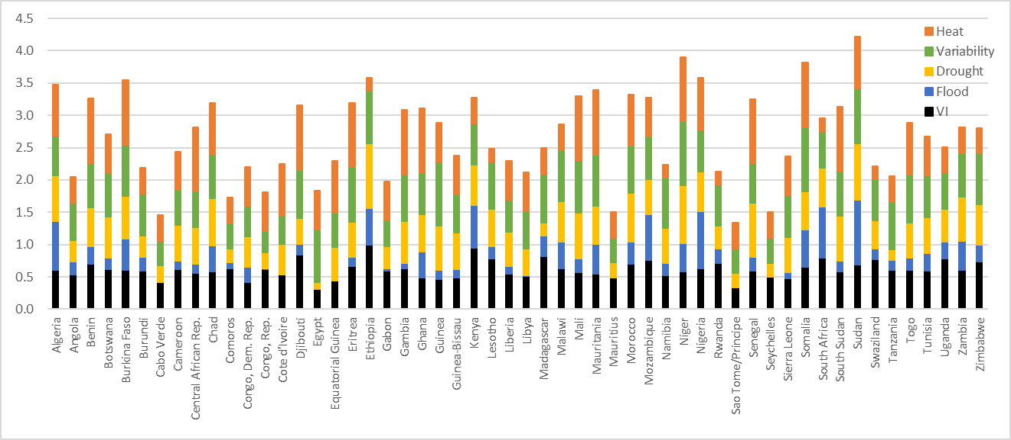

Sensitivity. Sensitivity to the CC dimensions is based on the sectoral composition of GDP (taken from national accounts) and the level and vulnerability of assets that may be affected by CC (based on global registers of road, energy and urban assets).

Potential Impact. The potential impact of CC for each country is estimated by multiplying: a) the base values for the country (ie the sectoral GDP or the assets); b) the maximum Africa-wide potential impact on the base; c) the sensitivity of the base value to each CC dimension; and d) the exposure index for that CC dimension for the country concerned. Figure 2 presents the potential impact for four main pathway groups, shown as the loss of GDP that would happen if a country moved instantaneously from current to 2050 climate conditions. GDP effects are dominant for most countries, though other pathways are also significant. 18 countries have a potential impact of over 4% of GDP.

Figure 2 Potential Impact by Country
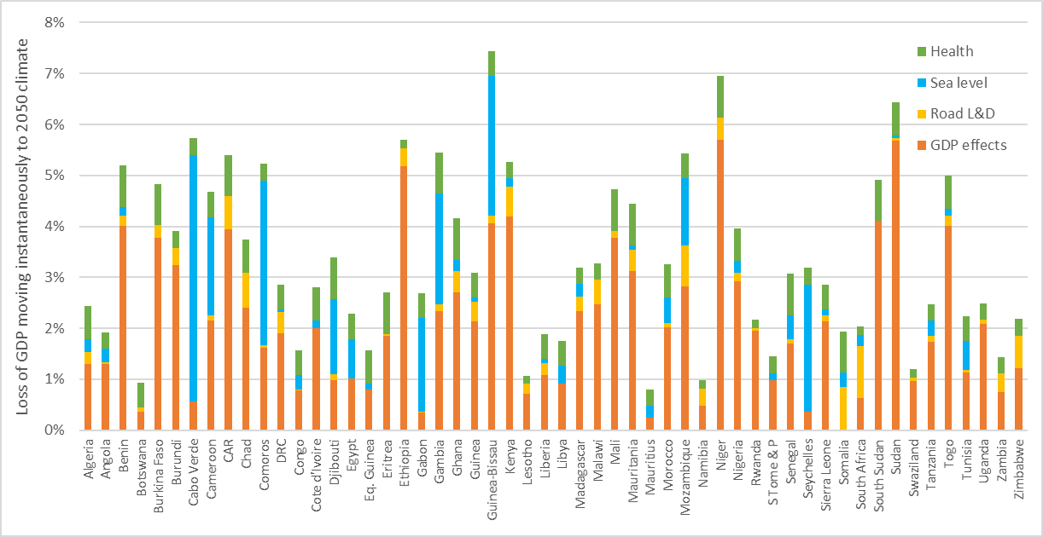

Growth Effects. Figure 13 presents the GDP loss from a theoretical instantaneous change to 2050 climate, but there will also be an impact on growth. Neoclassical growth models assess this by incorporating a CC damage function. The APEA analysis uses a conversion factor that converts instantaneous FL&D to the NPV of FL&D after taking growth effects into account. It uses the Distilled Growth Analysis (DGA) which suggests that the factor is between 2 and 4, depending on the proportion of reduced GDP that affects capital and labour productivity, rather than being is absorbed by a temporary fall in consumption. Thus, for example, Nigeria, with a theoretical instantaneous loss of 4% of GDP for 2050 climate conditions would see the NPV of GDP to 2050 fall by 8% to 16%, depending on the extent to which capital and labour productivity were affected.

Adaptation Expenditure
The Effectiveness of Adaptation Expenditure. Most adaptation expenditure is primarily development expenditure that provides good benefits with current climate conditions. As climate changes, these development benefits increase and this increase is the adaptation benefit, reducing the impact of CC. The share of the adaptation benefit in total benefits (ABS%) can be estimated using CC Impact Appraisal (CCIA), which estimate benefits with and without taking CC into account, using conventional appraisal methods, which range from rapid and qualitative methods to Cost Benefit Analysis. For example, if the frequency of droughts gradually doubles by 2050, then the average annual benefits from expenditure that responds to drought (eg new crop varieties, new farm practices or changes in crops) will gradually become twice as high by 2050 and the total benefits over the period will be 50% higher with CC than without. This 50% increase in benefits is the adaptation benefit.

There is a growing international library of CCIA evidence and this is used to provide default ABS% values for 22 types of adaptation expenditure. This CCIA evidence is based mainly on ex-ante appraisal and not ex-post evaluation of actual performance. To avoid underestimating the adaptation gap, the analysis assumes that actual performance is 25% below expected performance. The ABS% gives an indication of the NPV of the adaptation benefits. In order to compare adaptation benefits with potential impact up to 2050, a conversion factor is required to estimate the adaptation benefits that are experienced only up to 2050, assuming that adaptation expenditure will remain at a constant % of GDP.

Adaptation Expenditure. Estimates of adaptation expenditure are provided by classifying the most recent public finance data. Actual expenditure data is preferred to budget data, if it is available. For the 10 countries, data is available from BOOST initiative. Data has also been found on the internet for a further 24 countries. For most countries, expenditure is limited to the central level, although local level expenditure is available for South Africa and Kenya. No separate work has been done to assess the level of expenditure by development partners that is outside the budget. This is beyond the scope of this review, although it would be a key task if the analysis of the adaptation gap were extended to more detailed country work.

Figure 3 presents estimates of adaptation expenditure. The bars present the ‘raw expenditure’ regardless of the sector and the diamonds present the expenditure, weighted by ABS%, which eliminates the tendency for raw expenditure to be dominated by a few large spending items that have only small adaptation contributions (eg roads and primary health). Ideally, the estimate of ABS% requires details on public expenditure to be available at a level of detail that is at least 1 level below a ministry (eg department), and, ideally, two levels below (eg division, programme or project). For 7 of the countries, data has been limited to ministerial level (Chad, Ethiopia, the Gambia, Guinea, Madagascar, Somalia, South Sudan) which limits the accuracy of the analysis.

Figure 3 Adaptation Expenditure (%GDP, unweighted and weighted by ABS%)
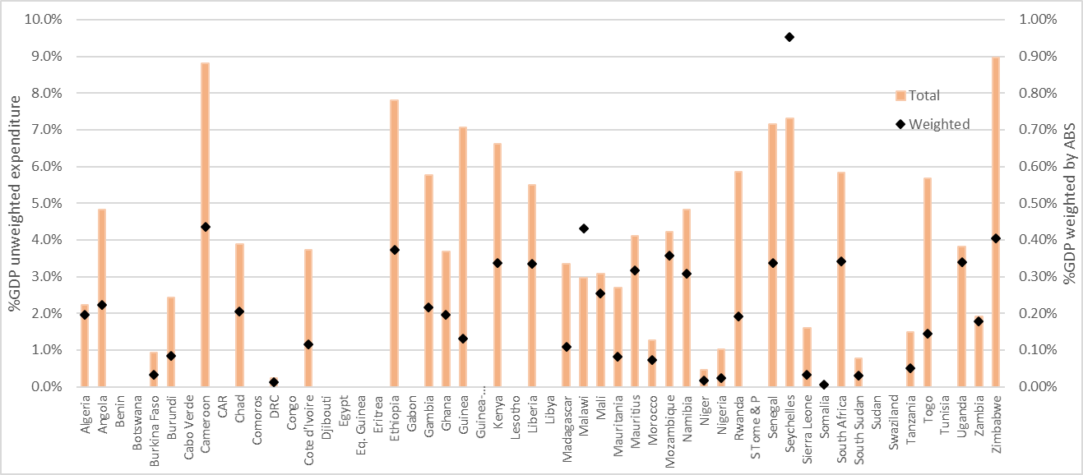

The BOOST expenditure dataset makes it possible to analyse trends over time. Most of the countries have shown an increase in weighted adaptation expenditure, when expressed as a % of GDP, although trends are not smooth suggesting that a few key projects may dominate expenditure.

The Adaptation Gap
Results. The adaptation gap compares the NPV of expected adaptation benefits with the potential economic impact of CC with no adaptation, also expressed as the NPV of the difference in GDP streams. Figure 20 summarises the results. Key conclusions from the analysis are as follows.

- Firstly, it should be borne in mind that most of the data is for budgets rather than actual expenditures, which are significantly lower than budgets in many African countries.
- For Africa as a whole, the estimated adaptation gap is about 80%. So the current level of adaptation expenditure will reduce the potential economic impact of CC by about 20%. African countries are, therefore, already making a major contribution to adaptation.
- The adaptation gap is greater than 90% in nine countries. Most of these countries face major exposure and sensitivity to CC risks as well as fiscal challenges.
- Countries that have reduced the potential impact of CC by more than 20% include those: exposed to low CC risks (eg Liberia, Namibia, Zimbabwe); with high expenditure (eg Ethiopia, Gambia, Zambia); and with lower risk and good expenditure (eg Rwanda, Senegal, Uganda).

Figure 4 Adaptation Gap
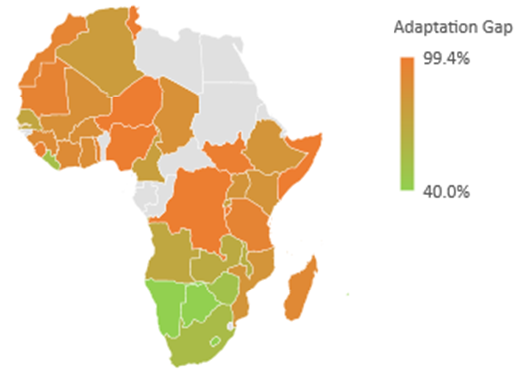

Reducing the Adaptation Gap. Table 2 presents a typical strategic response to close the adaptation gap and suggests that the three main elements of the strategy (ie increasing the size and effectiveness of public adaptation expenditure, accessing international adaptation finance and expanding private sector adaptation) are each roughly similar in their potential contribution. Country level strategies will vary depending on the CC threat, current adaptation expenditure, the potential of the private sector and prospect for support from international partners.

Table 2 Options for Reducing the Adaptation Gap at the African Level
Strategic Response to Reducing the Adaptation Gap | % of Needs
Residual gap that cannot be cost effectively addressed by adaptation | 33%
Existing public adaptation expenditure | 20%
There will be scope in most countries to increase adaptation spending by: a) growing public expenditure as a % of GDP; b) prioritising adaptation expenditure; and c) improving spending efficiency with reforms, especially in key adaptation sectors. | 8%
Improving the design of expenditure can raise adaptation benefits without extra costs. This can be facilitated by improved use of CCIA, adjusted to national practices. | 4%
International climate finance could raise as much as $15bn for Africa, if she receives the same share of adaptation funding commitment as she does ODA. | 15%
Private sector, which is already engaged in adaptation as part of routine activities | 10%
Remaining gap | 10% - 40%

Introduction

The Africa Public Expenditure on Adaptation Project
The Africa Public Expenditure on Adaptation (APEA) project involves a desk review of the available evidence on public expenditure devoted to adaptation to climate change (CC) in Africa. The work is commissioned by UNDP Ethiopia, with technical input from Mokoro and Climate Scrutiny.

Objectives of the APEA. The Africa Public Expenditure on Adaptation (APEA) project aims to:

- provide some initial estimates of the current spending on adaptation by African governments and international partners
- assess the extent to which current and projected funding meets the adaptation challenge
- inform African Governments’ decision-making on how to measure, report and verify (MRV) their climate expenditure, as part of the fulfilment of Paris Agreement obligations

The Draft Report. The Draft Report presents the results of the analysis and draws some conclusions. It is intended as a consultation draft. The APEA review is a short study with 49 days of input. Given the patchy nature of the evidence, it cannot produce definitive conclusions on the potential impact of CC or of the adequacy of the response. Rather, it aims to clarify and illustrate the methodology with the best evidence that is easily available so that this can be used as a framework for further practical work. It aims to bridge the work already done by UNEP on the adaptation gap and the various international initiatives associated with mainstreaming CC into national planning and budgeting, including, in particular, the initiatives associated with: the National Adaptation Plan (NAP) process; CC Public Expenditure and Institutional Reviews (CPEIRs); and CC Financing Frameworks (CCFFs).

The APEA work is taking place at a crucial moment in the global response to CC. The Paris Declaration has created a clear structure for international cooperation and has cemented the international commitment to devote USD 100bn per year to CC by 2020, originally made at the 15th Conference of the Parties (COP15) at Copenhagen in 2009. An early scoping of the feasibility of this commitment was made by the High Level Advisory Group on Climate Finance, which suggested that it was achievable, if all sources of finance are taken into account, including those from the private sector flows and some innovative new instruments (HLAG Nov 2010). A recent review of prospects for international commitments, using the OECD definitions, suggested that public commitments are likely to reach USD 67bn by 2020 (OECD 2016).

Whilst the progress with climate finance is encouraging, there are still some huge challenges.

- Firstly, there is still ongoing international debate over how to define adaptation finance. Although the OECD has a working definition, there are concerns that this is too subjective. The Standing Committee on Finance (SCF) of the United National Framework Conference on Climate Change (UNFCCC) is still debating the measurement, reporting and verification (MRV) of CC finance (SCF 2016). And the Green Climate Fund (GCF) is trying to clarify the criteria for selecting adaptation projects, with concerns expressed in GCF minutes and in a series of assessments on websites such as Nature (Sanjay Kumar), Climate Home (Saleemal Huq) and World Finance.
- Secondly, the latest evidence of the pace of recent CC suggests that the likely outcomes will be worse than the targets of a rise of 1.5 to 2ºC, which have generally been used to assess the needs for climate finance. Most analysis uses the working assumption that the level of impact is roughly proportional to the rise in temperature, although new climate science is also drawing attention to the possibility that, with rises of more than 2ºC, there are much more serious risks of stepping over thresholds that will create more dramatic change.
- Thirdly, whilst there is universal agreement about the importance of mainstreaming, there is still debate about exactly what this should mean and a number of different interpretations, including those listed in the table below.

Table 3 Types of Climate Change Mainstreaming
Technical mainstreaming | Assumes that it is sufficient for policy to be integrated but finance to be separate.
Budget mainstreaming | Budgets cover both development and climate finance, but projects are separate.
Matching mainstreaming | Climate and development finance are provided separately but blended to co-finance initiatives.
Full mainstreaming | No separate source of climate finance. Countries increase development finance with adaptation contributions and ensure that it is designed with full knowledge of the implications of CC for effectiveness.

The APEA study aims to contribute to the groundwork that will help countries address these challenges and judge the right levels of climate expenditure and the most appropriate approaches to mainstreaming.

Literature on the Adaptation Gap
There are five main strands of international work that cover the full range of analysis required to estimate the Adaptation Gap.

Integrated Assessment Models (IAMs). Economic modelling has been used for 15 years to assess how CC is likely to affect economic growth and how public expenditure will then moderate that impact. Most of the work is global in scope although some also includes regional breakdowns. Results are reported in the academic literature, but have also been used in some influential policy reports, including the Stern Review and the World Bank Economics of Adaptation to CC (EACC) (Stern 2006, Nordhaus 2007, World Bank 2010, ClimateCost undated).

Climate Change Financing Frameworks (CCFFs). CC Financing Frameworks (CCFFs) have been produced in Asia, building on the work on CC Public Expenditure and Institutional Reviews (CPEIRs). The CCFF work is also closely related to work on budget coding and on the National Adaptation Plan (NAP) process, which supports local capacity to integrate CC into planning and budgeting.

CCFF work has been completed, or is underway, in 7 countries (Afghanistan, Bangladesh, Cambodia, Indonesia, Nepal, Pakistan and in several Indian States) (UNDP 2016 (forthcoming)). Other countries have also undertaken work on some of the elements of a CCFF (Bhutan, Philippines, Thailand, Vietnam and several Pacific Island States). Most, but not all, of the countries have started by doing a Climate Change Public Expenditure and Institutional Review (CPEIR) and then moved to on to CCFF work. CCFFs have, so far, been limited to the countries covered by this review, but many other countries have completed CPEIRs.

The UNEP Africa Adaptation Gap Reports. UNEP have produced two global Adaptation Gap Reports (UNEP 2014, UNEP 2016) and two reports that follow the same methodology and are applied to Africa, the first Africa’s Adaptation Gap Report in 2013 (AAGR) and the second (AAGR2) in 2015, with technical input from Climate Analytics (UNEP 2013, UNEP 2015). AAGR2 focused on the extent to which African countries themselves can close the Adaptation Gap. The report included case studies for Ethiopia, Ghana, South Africa and Togo. Key conclusions from AAGR2 include the following.

- It is important the international partners and climate institutions meet international commitments on funding for adaptation.
- Recent experience in Africa suggests that CC is happening faster than expected and will have serious impacts, especially on agriculture and coastal flooding arising from sea level rise. Crop yields are likely to fall by between 5% and 20% in most regions of Africa.
- The estimates of adaptation costs are USD 50bn per year by 2050 for Africa assuming a 2ºC CC scenario (and about 1% of GDP by 2100). For other CC scenarios, the adaptation costs are roughly proportional to the change in temperature.
- About two thirds of the full damage cannot be addressed by adaptation, even if all cost-effective adaptation is funded.
- Current levels of international adaptation funding for Africa are USD 1-2bn per year.
- UNEP defines the adaptation gap as the gap in funding, rather than the gap in reducing FL&D. The two are related by the effectiveness of expenditure in reducing FL&D, which needs explicit analysis.
- The GCF could play a critical role in bridging the gap in funding, with commitments to provide 50% of funding to adaptation and 50% of this to Least Developed Countries (LDCs). However, access is likely to be competitive and sensitive to governance issues.

Investment and Financial Flows (I&FF). UNDP has developed a programme of work on Investment and Financial Flows (I&FF), building on earlier work by UNFCCC (UNDP , UNFCCC 2007). Results are available at http://www.undpcc.org/en/financial-analysis/results. The I&FF work is different to other methods in that the classification of finance is based on consistency with policy documents. The I&FF analysis suggested that immediate adaptation needs in Africa are 1-2bn USD/year and this rises to 7-10bn USD/year by 2030.

UNEP AdaptCost. The AdaptCost Project reported in 2010, reviewing the evidence available on adaptation costs, concluding that financing needs for Africa are likely to be 5-30 USDbn/year in the near future, rising to 20-60 USDbn/year during 2020-30. The report referred to IAM analysis, which suggested that the NPV of GDP with CC between now and 2050 is likely to be between 1.5% and 4.0% lower than without CC. Adaptation expenditure is reported to have a BCR of 3.8, which is very high. Adaptation is reported as being capable of addressing only 50% of market-based FL&D and only 30% of total FL&D, including social and environment costs. The AdaptCost report quotes UNFCCC estimates of adaptation needs of 12-28bn USD/year. Specific estimates for coastal level adaptation increase from an estimated 1.6bn USD/year in 2030 to 7.5bn USD/year in 2050.

Table 4 Summary of Headline Conclusions from Key Sources of Analysis (USDbn and %GDP)
 | Area | Ref Year | FL&D  (NPV) | CC Spending  Annual Needs | Current Spending | Adaptation Gap¹
IAM (eg Stern) | Global | 2050 | 5 %GDP
CCFFs | Asia | 2050 | 10-20 %GDP | 5-10 %GDP |  | 80-95%
UNEP AGRs | Africa | 2050 |  | $50bn | $1-2bn | 96-98%
I&FF |  | 2030 |  | $7-10bn
AdaptCost | Africa | 2030 | 1.5-4 %GDP | $20-60bn  1.1-3.2 %GDP
¹ the UNEP AGR expresses the adaptation gap as the additional spending needed to meed target levels of adaptation spending, whilst the CCFFs express the gap as the amount of FL&D not addressed by adaptation spending. The two approaches are closely related with reduction in FL&D determined by the adaptation spending times the effectiveness of the spending in reducing FL&D

African Engagement in Global CC Policy
The key African initiatives related to CC are summarised in the table below.

Table 5 Key Events in African CC Initiatives
1992 | Formation of the African Group of Negotiators (AGN) to the UNFCCC and the Kyoto Protocol.
1994 | Regional Economic Communities of Africa started integrating CC into their strategies and plans.
2001 | The New Partnership for Africa’s Development (NEPAD) includes CC as one of the priority sectors.
2003 | NEPAD endorses the Comprehensive Africa Agriculture Development Programme (CAADP) in Maputo, with a strong emphasis on sustainability and a commitment to devote at least 10% of public investment to agriculture by 2008, although this has now been relaxed.
2006 | The global Nairobi Framework on CC and Nairobi Work Programme is agreed with special emphasis of capacity building for CC, including in selected African countries.
2007 | African Monitoring of the Environment for Sustainable Development (AMESD) programme established to support monitoring of sustainable development
2008 | The African Union (AU) Assembly agrees the Algiers Declaration that defines how to reach a common African voice on UNFCCC negotiations.
2008 | The AU Tunis Declaration describes the modalities for developing an African Panel on CC.
2009 | Statement of the African Ministerial Conference on the Environment (AMCEN), to develop a comprehensive platform and framework for African CC programmes.
2010 | The African Ministerial Conference on Meteorology (AMCOMET) calls for further progress on climate science in Africa.
2010 | The Tunis Roundtable on the Economics of Adaptation reviewed the evidence on the economics of adaptation and strategic policy responses and urgent investment priorities.
2010 - | African Climate Centres are formed to act as Regional Climate Centre of the WMO. These include: the African Centre for Meteorological Applications for Development (ACMAD); the Agro-meteorology and Hydrology Regional Centre (AGRHYMET); the Intergovernmental Authority on Development (IGAD) Climate Prediction and Application Centre (ICPAC); and the SADC Climate Prediction Centre, which superseded the SADC Drought Monitoring Centre (DMC)
2011 | East African Community (EAC) CC Masterplan produced, with 8 pillars and a budget of USD 34m for management in the short term and USD 2.1bn for investment in the long term.
2011 | First Draft African Strategy on CC prepared under the coordination of the AUC, with participation from Member States, RECs, UN agencies and other partners.
2011 | The ClimDev Africa programme is launched by the UN Economic Commission for Africa (ECA), the AU Commission (AUC) and the African Development Bank (ADB), including: the formation of the African Climate Policy Centre (ACPC) at ECA; the CC Desertification and Control Unit (CCDU) at AUC; and the ClimDev Special Fund (CDSF), managed by ADB.
2013 | AU Agenda 2063 and its 1st 10 Year implementation Plan refer strongly to CC, including referring to SDG13, which relates to CC.
2014 | The African Risk Capacity (ARC) is created as a Specialised Agency of the AUC to provide insurance for extreme weather.
2014 | Draft African Union Strategy on CC prepared by the African Ministerial Conference on the Environment.
2015 | ECA Vision 2050 includes strong sections on CC, in the context of SDG13.
Source: Draft African Strategy on CC, with some recent additions

Pan-African CC Policy. Other key documents on pan-African policy debates/statements related to CC include the following:

- In 2014, the African Union prepared a draft African Strategy on CC (ASCC). The strategy was coordinated by the CC and Desertification Unit (CCDU) of the AU as part of the preparations for a common African approach to 2009 COP15 in Copenhagen. The ASCC refers to three estimates of FL&D, based on work by the Global Facility for Disaster Reduction and Recovery (GFDRR). The figures are not entirely clear but appear to suggest annual figures of 3.9% of GDP for Djibouti, 3.5% of GDP for Kenya and 1.3% of GDP for Uganda, during periods of drought. The ASCC defines 4 pillars (governance, mainstreaming, research and cooperation), 35 goals covering all sectors and 173 actions to deliver these goals, plus a further 12 goals associated with managing the ASCC and 52 actions to deliver these operational goals.
- A workshop of the Climate Parliament, UNDP and the Pan-African Parliament in August 2014, considered issues of ‘Mainstreaming Sustainable Energy Access in Africa’ and recommended that: renewable energy (RE) is mainstreamed into national development strategies; that countries develop gender sensitive RE programmes; and that countries devote at least 1% of the national budget to promoting RE (Pan African Parliament 2014).

Regional Policies. In addition to the pan-African response, regional coordination bodies have also been engaged in CC policy.

- In 2011, COMESA, EAC and SADC produced a Programme of CC Adaptation and Mitigation in the Eastern and Southern Africa Region, building on a framework established in 2009, sometimes referred to as the Africa Climate Solution or the African Climate Initiative (COMESA, EAC et al. 2011). This aimed to present a united position to help discussions in the UNFCCC and to unlock international resources, with total costs of USD 134m. The programme stresses the importance of CAADP and Climate Smart Agriculture (CSA). The Programme has 7 objectives, each of which has between 2 and 3 results. Each result is achieved through up to 8 activities. Six key African institutions are charged with coordinating implementation, in addition to a range of existing ‘complementary actions’.
- The Intergovernmental Authority on Development (IGAD) in Eastern Africa contains 8 member states and established the Climate Prediction and Applications Centre (ICPAC) in 2014. ICPAC produced the IGAD Regional CC Strategy (IRCCS) in 2016, although this is not yet available on the internet. ICPAC also produces 10 day, monthly and seasonal climate predictions and runs a range of projects responding to climate related change and disasters.
- In 2014, the League of Arab States, which has 10 out of 20 members in Africa, produced a Pan-Arab Renewable Energy Strategy 2030, in collaboration with the International Renewable Energy Association (IRENA) in 2014. The strategy reviewed the current status of RE and defined 16 actions, of which 7 are considered short term priorities (IRENA 2014).
- The Nile Basin Initiative (NBI) produced a brief CC Strategy in 2013, with 5 objectives, 4 guiding principles and 5 outcomes and 8 priority outputs.

National Policies. Annex 1 reviews the status of national policies relating to CC for the 54 countries in Africa. Key conclusions from the annex include the following.

- National Adaptation Programmes of Action (NAPAs) have been produced by 35 of the countries and have been a powerful tool for introducing countries to CC. Most of these were in the period 2006-2009, although there are a few countries that have produced NAPAs more recently.
- All countries have Intended Nationally Determined Contributions (INDCs), prepared as part of their participation in the Paris Agreement. These INDCs are converted into NDCs when countries ratify the Paris Agreement and 38 of the countries have now done this.
- The National Communications to UNFCCC include assessments of vulnerability and of greenhouse gas (GHG) emissions. 49 countries have produced a First National Communication (FNC) to the UNFCCC, mostly in the period 2000-2005. 45 countries have produced a Second National Communication (SNC), mostly in the period 2010-2015. Since 2014, 11 countries have produced their Third National Communication (TNC).
- 21 countries have produced a CC Strategy and/or Plan. The scope and approach to these has been very varied. Three of these are called a National Adaptation Plan (NAP), although the NAP process often supports strategies and plans that are not explicitly called a NAP.
- In addition, 11 countries have national strategies or plans for cross-sectoral issues that are closely related to CC, including disaster management, water and green growth. In most cases, there are additional to CC strategies.
- Many countries have sectoral strategies and plans for key CC sectors, including: agriculture, forestry, environment and energy.
- 12 of the countries have participated in one of the 5 main programmes investigating the economic impact of CC and/or the climate finance response (ie CPEIR, EACC, GFDRR, GCAP and I&FF)

Method and Report Structure
The method used for estimating the adaptation gap is described in the figure below. Chapter 2 describes the steps on the left of the flow chart in the figure below, and concludes with an estimate of the potential economic impact. Chapter 3 presents the steps on the right of the flow chart and concludes with an estimate of the reduction in potential economic impact. Chapter 4 then estimates the adaptation gap, on the basis of the previous two chapters.

Figure 5 CC Impact Assessment
Reduction in CC damage
Global/regional CC projections
(T, P, flood, drought, variability, sea level)
Economic structure (sector GDP, assets)
Global/region average damage by sector/asset
Local evidence on effectiveness
Default global/ regional values for effectiveness
Effectiveness
Adaptation Gap
Projected CC damage
(%GDP instantaneous change to 2050)
Spending by sector/sub-sector/programme
(past budget, CC Action Plans)
Local exposure index
Conversion Factor A
Conversion Factor B
NPV of impact to 2050
NPV of adaptation to 2050

The box below illustrates this with an example from a fictional country.

Box 1 Adaptation Gap for ‘Climavia’
Climavia is a fictional African country which illustrates the way in which the adaptation gap can be estimated. Although the country is hypothetical, the figures are typical of African countries.

- Sectoral vulnerability analysis suggests that, if Climavia moved instantaneously from current to the projected climate for 2050, GDP would be 4% lower, including: 2% loss in agriculture, from lower productivity and drought and flood losses; 1.2% from lower labour productivity associated with heat; and 0.8% from loss and damage to infrastructure, including urban, roads and energy infrastructure.
- The growth effects of the full loss and damage (FL&D) over the period to 2050 are estimated using an economic model which estimates GDP from a production function based on capital (physical and financial) and labour. The combined effect of this analysis is that the Net Present Value of GDP to 2050 is 8% lower when CC is taken into account than when it is not. This is significantly higher than the values of 2-5% that are often found in international modelling work, because more detailed sectoral impacts are taken into account.
- Total public expenditure amounts to 25% of GDP, of which 5% makes a contribution of some sort to adaptation. Analysing the types of expenditure suggests that, on average, the Benefit Cost Ratio (BCR) is 2.0 without taking CC into account and 2.2 when CC is taken into account. The extra 0.2? units of benefit are the adaptation benefits (ie the reduction in FL&D).
- The adaptation benefits therefore amount to 1% of GDP, which is 12.5% of the expected FL&D, which reducing the NPV of GDP by 8%. The adaptation gap is therefore 87.5% of FL&D.
- The gap can be analysed for each sector using the same methods, identifying the FL&D in the sector and the expenditure and implications of CC for benefits. This suggests that the gap in natural resource sectors is higher than in other sectors.
- Strategies for closing the gap involve: a) improving the CC sensitivity of existing expenditure; b) focusing the growth in expenditure in CC sensitive programmes and departments; c) switching from direct expenditure to incentives/regulations that encourage private CC expenditure; and d) targeted use of international CC funds. A review suggests that there is a ‘residual gap’ of 30% of FL&D that cannot be addressed by cost-effective expenditure.

Potential Economic Impact
This chapter reviews the potential impact of CC on a country. Ideally, this includes economic, social and environmental impact, although the initial focus is on economic impact and on any social and environmental impacts that can be valued. The impact includes immediate loss and damage (L&D) from specific climate events and longer term effects from climate trends. It also considers the impact on economic growth.

The analysis identifies 9 main pathways of potential impact, which are roughly associated with the most vulnerable sectors and sub-sectors of a country. In some pathways, the main impact is immediate L&D, whilst in others the impact is mainly on assets and, hence, on economic growth.

The impact is normally assumed to be determined by three factors: exposure to CC, sensitivity to CC and adaptive capacity. This chapter reviews the first two factors and the further work on adaptation expenditure reviews the adaptive capacity.

Main Impact Pathways
Pathways. The main pathways of CC impact are as follows.

- Agriculture is affected both by L&D from extreme events and by changing productivity from more rainfall variability and temperature. This can affect potential yields as well as losses related to less predictable seasons and higher pest and disease threats. There will also be growth effects, if land and other assets are damaged and if farmers are forced to reduce savings and investment.
- Fisheries are affected by changes in species composition, which can lead to less productive fisheries, as ecosystems evolve. The way in which this evolution happens is usually complex and specific to each ecosystem and it is difficult to generalise or to apply scientific evidence from one ecosystem to another.
- Forest ecosystems also change in ways that are similar to crops and are vulnerable to major discontinuities that reduce productivity. But forest incomes are less tied to particular species than farmers, so the impact is likely to be smaller than for crops.
- Electricity supply will suffer increased cooling, transmission and distribution losses with higher temperature. This will result in reduced value added from electricity supply.
- Water supply will be less secure and will become more expensive, either requiring extra investment in improved infrastructure and management for public supplies or higher costs for households and businesses in accessing water when public supplies fail.
- Construction will become more expensive because of the need to accept higher repair and rehabilitation costs. This will reduce value added from construction. It may be partly reduced by adaptation in design (or ‘proofing’) to prevent these extra costs.
- Transport may incur extra costs, if services are to be maintained whilst also reducing GHG emissions. There may also be savings, since energy saving investments are often profitable.
- Coastal areas will be affected by more frequent flooding and storm damage and by problems arising from salinity, as a result of sea level rise. This will degrade capital assets and reduce productivity, unless expenditure on adaptation is able to provide protection.
- Human health will be affected by rising temperatures and unusual weather patterns, which will lead to a heightened threat from climate sensitive diseases and lower labour productivity, especially for manual work.

These pathways are summarised in the table below.

Table 6 Impact Pathways and Influence of CC Dimensions
Impact Pathway | Main CC Dimensions
Impact Pathway | Heat | Flood | Drought | Storm | Varia-  bility | Annual Rain | Sea  level
Loss and damage to crops
Productivity of crops
Productivity for livestock, fisheries, forestry
Electricity losses (gaps, cooling/distribution losses ..)
Water supply losses
Reduced biodiversity
Infrastructure damage and maintenance needs
Coastal loss and damage and salinity
Labour productivity and health burdens

Types of Impact
Qualitative Impact. Many climate change documents provide qualitative descriptions of the nature of vulnerability to CC. This applies to the standard documents prepared by countries (ie NAPAs, FNC/SNC/TNCs and INDCs/NDCs) as well as to national CC strategies, policies and action plans. Some of these sources provide occasional evidence of the scale of the potential impact, but this is often limited to partial reports of easily available evidence, which often relates to bio-physical impacts (eg on yields, probabilities, people affected …), without comprehensive valuation.

Impact of Specific Climate Events. A first type of impact is from the immediate effects of extreme climate events (ie mainly floods and droughts), especially through loss of income and physical damage. Estimates of this impact often include some economic valuation, partly because the estimates are often used to lobby for financial assistance from national or international relief funds. This is the type of impact that is most frequently referred to by the term loss and damage (L&D). There are international moves to coordinate the response to L&D through the Warsaw Convention of the UNFCCC. These also aim to extent the definition of L&D to broader impacts, although the extent of this broader scope is still not clear.

The Global Facility for Disaster Reduction and Recovery (GFDRR) produces regular assessments of Post Disaster Needs Assessment (PDNA) and Stories of Impact (SoI). These have covered at least 4 African countries and the results are summarised in the table below. These figures affect the results of one disaster. The total annual average L&D is estimated by defining different severities of event and summing, for all severities, the cost of one event divided by the frequency of that event.

Table 7 Estimates of GFDRR Post Disaster Needs Assessment (%GDP in one year)
Country | Year of PDNA | Disaster | Year of Disaster | Estimated cost  (%GDP in 1 year)
Djibouti | 2014 | Drought | 2008-11 | 3.9%
Kenya | 2012 | Drought | 2008-11 | 3.5%
Nigeria | 2013 | Flood | 2012 | 1.5%
Uganda | 2012 | Drought | 2010/11 | 1.5%

Impact of Climate Trends. A second important type of impact comes from trends towards more variable rainfall and a gradual rise in temperature and sea levels. It may also include trends in total rainfall, although there are only a few regions where the evidence on this is strong. To distinguish between this and the impact of extreme events, this is termed full L&D (FL&D). In theory, FL&D also aims to capture social and environmental impact, although this is more difficult to capture in practice.

Impact on Growth. Finally, FL&D also has an impact on growth, which occurs because FL&D reduces capital assets and labour productivity, either directly through damage or indirectly through reduced incomes and savings and, hence, investment.

This chapter has so far considered only the implications of moving instantaneously from current climate conditions to a projected future climate. The chapter has assumed that this projected future state is a scenario that occurs in 2050, based on mid-range IPCC scenarios (ie the RCP2.6 scenario from the IPCC AR5 or the B1 scenario in IPCC AR4). This involves an increase in temperature of roughly 2ºC and a doubling of the frequency of rainfall variability, including floods, droughts, storms and other extreme events. The analysis suggests that, for most countries, the potential loss in GDP arising from an instantaneous change to 2050 conditions would be between 2% and 5%, although a few countries are higher and a few are lower. For the whole continent, the loss of GDP from this instantaneous change would be about 3.2%.

It is also necessary to consider what happens in the years between now and 2050. The 3.2% loss for Africa as a whole is the average annual loss and includes some losses that grow gradually and steadily over the period (eg those associated with heat stress and sea level rise) and some that vary from year to year (eg those associated with flood, drought and rainfall variability). The 3.2% loss is the average annual loss and actual losses are likely to vary from zero to at least 5% in the worst years. As a first approximation, it is reasonable to assume that the average annual losses of moving instantaneously to a new climate will increase in a linear fashion.

Growth Effects. There is a long and detailed literature on the economic impact of CC. Most of this literature uses neoclassical economic growth models that estimate GDP from a production function based on labour, capital and other factors, usually disaggregated by economic sector and, sometimes, by socio-economic group. These models assume that the impact of CC on GDP is greater than suggested by an estimate of instantaneous change because part of the loss in one year results in a loss in labour or capital, which affects production in the next year. This could happen either if the loss caused by CC was directly affecting labour or capital assets or because it reduced incomes, with households and enterprises choosing to reduce investment, rather than consumption. Given the low levels of income across Africa, it seems likely that the large majority of loss caused by CC will either be directly in the form of lost assets or labour or will result indirectly in reduced assets, as a result of reduced investment.

Box 2 The Distilled Growth Approach to Estimating Growth Impact
These growth effects can be modelled using the Distilled Growth Approach (DGA) which reduces neoclassical models to their essentials (Climate Scrutiny 2017). The DGA comprises a 7 line spreadsheet that reflects the following key relationships.

Production GDP = aK bL (1 – cFL&D) where K = capital/assets, L = labour
Investment K = K_{t-1} – dK_{t-1} + sGDP – (1-c)FL&D where d = depreciation, s = savings rate
Damage FL&D = gT where T is change in temperature

a and b are constants calibrated based on recent growth experience
c is the proportion of FL&D that reduces income, so (1-c) is the reduction in capital/assets
g comes from the sectoral evidence on FL&D

The DGA provides projections of growth paths with and without CC, which allows estimates to be made of the difference in absolute GDP in 2050, after growth effects have been taken into consideration. For example, if it is assumed that the average annual loss of GDP from instantaneous change to 2050 climate is 3.2%, and that 50% of each successive annual average loss in GDP results in a loss of labour or capital assets, then the absolute GDP in 2050 will be 19.2% lower than Business as Usual (BAU, or the situation without CC), instead of the 3.2% lower. In fact, given the low levels of income in Africa, it seems likely that the squeeze on investment will be much higher. If 80% of the successive annual average loss of GDP feeds through into reduced assets, then the GDP in 2050 will be 25.4% lower than BAU. Thus, for an African country that expects to grow by 5% a year, GDP will be only 3.7 times higher by 2050, instead of 5 times higher with BAU.

Discounting. The Adaptation Gap is estimated by comparing the expected adaptation benefits with the potential FE&D without adaptation. The adaptation benefits are based on CC Impact Appraisal (CCIA) which estimates the extent to which the net benefits of a programme increase when adaptation is taken into account (Climate Scrutiny 2017). In practice, the methods used for estimating the adaptation benefits are varied and will often involve rapid and partially qualitative estimation. (In this rapid overview for all African countries, the benefit estimation has relied heavily on a standard international reference table which is based on more detailed CCIA work.) However, they are all based on the concept of a Benefit Cost Ratio (BCR), which gives an estimate of the value of benefits, relative to costs. This assessment involves comparing future projections of benefits and costs, typically over a period of 20 to 30 years.

The analysis of benefits and costs has to take into consideration the fact that households, enterprises, governments and societies give a higher preference to income in the current year, compared to income in future years. This occurs for various reasons, including the expectation that incomes will improve with time, especially if current income is invested, and the realisation that individuals or enterprises may no longer exist. In impact appraisal, this time preference is addressed through the use of discounting, with the value of future incomes being discounted by dividing by (1+DR)^t, where DR is a discount rate and t is the number of time periods (ie usually years). There is a long and detailed debate in the economic literature about the appropriate level of DR, which may be linked to interest and savings rates and to the opportunity cost of capital, or the average return on investment. This study assumes a DR of 5%, in real terms. The sum of future values, after discounting, is the Net Present Value (NPV).

Most planning systems adopt practices that ensure that public expenditure gives healthy benefits, that are significantly higher than the costs. The practices may involve some economics or may rely more on qualitative assessment. But, in economic terms, this equates to requiring BCRs that are significantly higher than 1. In fact, when the procedures involve economic analysis, the minimum threshold is often set at around 1.5 (which equates to an Internal Rate of Return, or IRR, of roughly 15%) and average BCRs are probably around 2.

CCIA delivers an estimate of the CC Benefit Share (CCBS), or the share of the total net benefits that are associated with adaptation and mitigation. This is composed of an Adaptation Benefit Share (ABS%) and a Mitigation Benefit Share (MBS). Typical levels for the CCBS vary greatly from sector to sector, but are normally in the range of 1% to 30%.

Growth Adjustment Factor. In order to be comparable with the estimate of adaptation benefits, the estimation of the Adaptation Gap thus needs to be expressed in terms of the NPV of the FL&D. The following table shows the various ways in which the economic impact can be reported and very different levels of impact and the importance of stating clearly the basis of the GDP impact.

Table 8 Growth Adjustment Factors
 | Reduction in GDP
 | c=50% | c=80%
Instantaneous change from now to 2050 | 3.2% | 3.2%
Absolute GDP in 2050, after taking growth into account | 19.2% | 25.4%
Drop in NPV of GDP growth paths to 2050, after growth effects | 7.8% | 10.2%
Growth Adjustment Factor | 2.4 | 3.2
Note: c = proportion of income loss affecting future labour/capital

The table above shows that growth effects suggest a much more serious impact on African GDP than is suggested by looking simply at the instantaneous change and ignoring the way that this will gradually impact on growth. The Growth Adjustment Factor (GAF) is the extent to which the NPV of lost GDP over the period to 2050 is higher than the loss suggested by the evidence on instantaneous change. It allows for an easy conversion from the evidence on instantaneous change to full economic impact. The level of the GAF is sensitive to the assumptions on the extent to which average annual losses will affect future labour and capital supply (ie the assumed level of the variable ‘c’). In Africa, given the need to protect the low levels of consumption, the level of ‘c’ is likely to be high. The analysis in this report assumes a GAF of 3.

The World Bank Economics of Adaptation to CC studies included 3 country case studies from Africa, as described in the table below. The analysis was based on sectoral evidence on impacts incorporated into Computable General Equilibrium (CGE) models built separately for each country.

Table 9 EACC Estimates of the Economic Cost of CC (%GDP in one year)
Country | Drop in NPV of GDP to 2050 | Comparative static GDP 2050
Ethiopia | 2% - 8% | 4% - 16%
Ghana | 2.5% - 5% | 5% - 10%
Mozambique | 2.5% | 5.2%
Note: FL&D is in terms of the NPV of GDP up to 2050 – some assumptions are required to convert EACC figures to this measure

Maximum Potential Impact by Pathway

Agriculture
The estimation of the Adaptation Gap considers the sectoral impacts in different countries, based on indices of the relative exposure and sensitivity of the country to the risks. These are applied to a range of maximum potential impact, which are taken from the international literature, with particular reference to literature relating to Africa.

Annual Variations in Actual Yield. Figures for the historical trends in yields provide powerful ground truthing for other methods when combined with scenarios of how existing exposure to adverse climate conditions is likely to change in the future (eg using the conclusions in the SREX report). Yields usually show an underlying upward trend arising from investments and improvement in farm practices. A potential yield line can be estimated by drawing a line between highest yield in the first and second half of the period. The difference between actual and potential yields may be caused by a number of factors, but climate variability will be by far the most important cause. Disease burdens may also be important, but these are strongly linked with climate. Some variations may also be caused by political and economic factors and years where these are considered important should ideally be excluded from the analysis. Data on average country yield does not pick up the full variability within a country, but is a reasonable first estimate and is available for most African countries on the FAOSTAT website. The table below summarises an example of this evidence.

Table 10 Examples of Staple Crop Yield Evidence from FAOSTAT (kg/ha, 2004-14)
 | Crop | Max yield | Min yield | Average loss² | Crops in GDP | Loss of GDP
Ethiopia | Maize | 3,421 | 1,613 | 30.4% | 14.0% | 4.3%
Ghana | Maize | 1,887 | 1,499 | 18.8% | 16.8% | 3.2%
Morocco¹ | Wheat | 2,164 | 615 | 32.2% | 5.8% | 1.9%
Mozambique¹ | Maize | 1,202 | 509 | 32.3% | 12.4% | 4.0%
Senegal | Millet | 811 | 464 | 20.9% | 5.1% | 1.1%
Tanzania | Maize | 1,625 | 1,007 | 19.7% | 15.6% | 3.1%
¹ For Morocco and Mozambique no data have been found for the contribution of crops to agricultural GDP and the table assumes that 50% of agricultural GDP is crops, which is typical for Africa
² ‘loss’ is the average extent to which actual yields are below potential, defined as the line between the highest yield in the first half of the period and the highest in the last half of the period

Simulation Models and Ricardian Analysis. There have been many studies looking at the impact of CC on agricultural production using models of crop response to temperature and rainfall and Ricardian analysis that uses geographical differences as a proxy for likely changes in climate. There are at least 30 such studies applicable for Africa. There have been a number of recent reviews of the above sources of evidence, which aim to compare a wide range of research to reach a consensus. Most of the studies involve simulation, but some also cover Ricardian analysis. Three recent studies have reviewed a large number of studies for different regions, including Southern Africa (Zinyengere, Crespo et al. 2013), West Africa (Sultan and Gaetani 2016) and East Africa (Adhikari, Nejadhashemi et al. 2015), and these are consistent with other global reviews (Knox, Hess et al. 2012). These reviews show that the results depend on the local situation and the extent to which crops are near their temperature thresholds, but that, in many cases, yield drops of between 10% and 20% are likely by mid-century. The table below summarises the potential impact on crop yields of moving instantaneously to a future climate.

Table 11 Reviews of Evidence on CC Impact on Crop Yields
Source | Conclusions
(Adhikari, Nejadhashemi et al. 2015) | Review of 7 sources for East Africa, by 2090s, yields down by: 6-13% for maize, 1-14% rice, 8-20% wheat and 16-33% sorghum
(Knox, Hess et al. 2012) | Global review of 52 papers. In Africa yield reductions by 2050s of: 17% for wheat, 5% maize, 15% sorghum and 10% millet
(Sultan and Gaetani 2016) | Review of 30 crop modelling studies for West Africa with great variation in results, including many with positive impact
(Zinyengere, Crespo et al. 2013) | Review of 19 studies for Southern Africa, end century yield drops of: 18% for maize, all crops average of 11-14%
(Jalloh, Nelson et al. 2013) | IFPRI’s IMPACT model for West Africa. Yield down by 2050 by 5-25% for most crops across coastal countries (and higher in Togo, Benin parts of Nigeria), with some gains in sahel countries

The above sources provide good and consistent evidence of the potential impact on yields and of the variation of this impact amongst different countries. This is complemented by various specific case studies that consider the effects of particular processes. For example, the Climate Scrutiny Guide to FL&D reviews experience with CCFF work and suggests that rainfall variability reduces crop yields by 5-10% by 2050 and that crop losses related to pests and disease increase by up to 1% average annual loss of crop GDP by 2050. For livestock, the guide suggests that productivity will be reduced by up to 5% by 2050 and fisheries productivity can be reduced by up to 10% by 2050. The impact on forest productivity is less easy to estimate and can either increase or decrease, depending on whether water is limiting.

Growth Impacts for Agriculture. The above analysis gives evidence of what is likely to happen to productivity if climate moved instantaneously from current to future conditions. The APEA analysis assumes that this average annual reduction in productivity increases gradually over the period up to 2050. This gradual increase in impact has an effect on growth in the agriculture sector because reduced incomes lead to reduced investment and/or maintenance of assets (eg land improvement, equipment, improved livestock, new crop varieties and practices …). The extent of the growth impact depends on the dependence of the agricultural activity on assets and whether reduced incomes lead to lower consumption or lower investment. Ideally, this would be assessed by defining production functions and calibrating these production functions for each country, based on recent trends. However, this is well beyond the scope of this study and, instead, it is assumed that three quarters of the average annual FL&D feeds through into reduced assets. Using the DGA analysis described in Box 1, this suggests that the impact on the NPV of the growth path of agricultural GDP to 2050 will be about 4 times the estimated impact of moving instantaneously from current to 2050 climates.

Energy
The Climate Scrutiny FL&D Guide suggests that cooling, transmission and distribution losses are likely to rise by up to 10% by 2050, depending on the current average temperature and the increase in temperature. The value of these losses as a % of GDP depends on the electricity coverage, which is captured in the sensitivity indices and the GDP figures for the proportion of GDP associated with electricity supply. For countries that do not have separate estimates of GDP for electricity supply, an estimate is provided by using the CIA World Factbook figures for total electricity generated by country and assuming that value added is 5 c/kWh.

Hydropower is an important source of power in some African countries. The impact of CC on hydropower is complex and depends on many factors, including the water regime and the extent to which dams are multipurpose. This has not been taken into account in the APEA analysis.

Water
No evidence was found about the maximum potential impact of CC on water supply. In the absence of any evidence, it was assumed that the losses associated with more variable rainfall, and from extreme climate events would be relatively high and a figure of 15% maximum potential loss was assumed.

Infrastructure
CC will lead to more rapid degradation of national and rural roads, irrigation, water, sanitation and other infrastructure. Incorporating climate proofing into design can reduce the losses significantly, but some increase in expenditure on maintenance and rehabilitation will be required. The APEA analysis uses data on the road network to estimate the impact on infrastructure. Ideally, it would be good to add data on the vulnerability of urban infrastructure, but data on this is less easily available and this is left for more detailed country work. Some analysis of urban vulnerability is, however, included in the assessment of risk to sea level rise.

The value of road assets was estimated using evidence on the length of the road network from the CIA World Factbook and assuming that the unit cost of average roads is 200,000 USD/km, which assumes a mix of surfaced and unsurfaced roads using unit costs from (Collier et al 2013). A few countries also have motorways, which are costed at 400,000 USD/km. Using these assumptions, the capital value of the road network for Africa as a whole is about 28% of annual GDP. Normal rehabilitation costs are typically between 1% and 3% of capital investment /year and the analysis assumes that a current level of 2% will double to 4% by 2050. The average additional costs of maintaining infrastructure are therefore about 0.56% of GDP (ie 28% x 2%).

Coastal
The APEA analysis uses two main sources of evidence to assess potential economic impact of sea level rise. The main source comes from a study that uses the DIVA model to consider the vulnerability of African countries to sea level rise (Brown, Kebede et al. 2011). This considers 14 different indicators, including the impact on land, people, salinity, flooding and coastal environments. The total average annual cost to GDP over 20 years of CC is estimated to be USD 7.5bn, or about 0.34% of GDP. The countrywide variations in exposure to risk are then triangulated with the UNHABITAT analysis of the number of cities at risk from sea level rise (UN HABITAT 2010).

Health
The most importance climate sensitive diseases are diarrhoea and malaria, although CC is likely to affect most water borne diseases and many vector borne diseases. These account for over 16.8% of total Disability Adjusted Life Years (DALYs) for Africa, which equates to about 66 ‘Disability Adjusted Life Years’ per 1000 people (WHO 2008). There is limited empirical evidence of the impact of CC on these diseases, but one WHO research study suggests that malaria incidence could increase by up to 10% with CC (Caminade, Kovats et al. 2014). The WHO guideline is for the value of a DALY to be set at three times per capita GDP. However, this is the value suggested for the purposes of health planning. For economic impact appraisal it may be more appropriate to assume that the value of a DALY is equal to the per capita GDP. This suggests that the maximum impact of CC on climate sensitive diseases would be to reduce GDP by about 0.66% (ie 6.6% x 10%).

In addition to the effect on climate sensitive diseases, there is increasing interest in the impact of CC on labour productivity (HEIT 2016, UNDP 2016). The IPCC AR5 suggested that, in hot countries, heat stress could reduce labour productivity in activities that involve outdoor manual labour by as much as 20% by 2100. The impact is likely to be exponential, but a reduction in productivity of at least 5% could be expected by 2050. The range of activity affected varies greatly from country to country, but many activities related to agriculture, fisheries and forestry will be affected and these account for just over 20% of total African GDP. If a quarter of activity in these sectors were strongly affected by heat stress, then this could reduce GDP by 0.25% (ie 20% x 25% x 5%).

Country Variations
The previous section described the evidence of potential impact of CC (or FL&D) through the various pathways, reviewing the range of national and international evidence available. This section considers how this potential is reflected in each country. This is affected both by the differences in country exposure to CC and differences in the sensitivity of the country to this exposure. The analysis relies on the various sources of evidence in indices of exposure and sensitivity to estimate the extent to which each country could suffer the potential FL&D. The following chapter then considers the current efforts to build adaptive capacity through public expenditure, in order to estimate the adaptation gap.

Exposure Indices
Annex 2 presents the global maps of exposure to CC, as presented in the three key IPCC reports: the 2007 Fourth Assessment Report (AR4), the 2012 Special Report on Extreme Events (SREX); and the 2014 Fifth Assessment Report (AR5). These sources suggest the following.

- Temperatures are likely to increase across Africa by between 1.5 and 7ºC by 2100, depending on the GHG emission scenario. There is some suggestion that coastal temperature rises will be slightly lower than those inland.
- Total annual rainfall is likely to decline in the North and the South of the continent, but to increase in the Centre and East.
- The frequency of extreme wet events is likely to increase by between 20 and 100% across the continent, with the increase being especially marked in the South.
- Sea level rise around the continent is likely to be between 0.5 and 0.8m.

Key global data on exposure to extreme events includes the following. The map for Africa from each of these is presented in the first row of the figure below.

- EM-DAT is a database of extreme events that is maintained by the Centre for Research on the Epidemiology of Disasters at Leuven University. It includes some data at national, and in some cases sub-national, level although the data is in numbers of events, which makes it more difficult to use for impact analysis. This suggests that the East and South Coasts, plus the Sahara have been exposed to most climate related disasters, although some other countries have also experience large numbers of climate related disasters.
- Maplecroft produce a world CC and Environmental Risk Atlas, which reports on 26 indicators, including a composite CC Vulnerability Indicator that combines exposure, sensitivity and adaptive capacity (Maplecroft 2014). The Maplecroft Index suggests that Africa is less at risk than parts of Asia, with most African countries in the mid-risk category. The index picks out Madagascar and Mozambique as especially high risk.
- German Watch produce a Global Climate Risk Index based on extreme weather events since 1992 based on data from the Munich Re NatCatSERVICE (Harmeling and Eckstein 2014). Data is not available below national level but shows that Africa includes some highly vulnerable countries, with a concentration in Eastern and South Eastern Africa, and in the Sahel.

There have also been a number of research studies that develop composite indices of vulnerability, which are summarised in the second row of the figure below. These involve a variety of component variables, some of which include sensitivity, as well as exposure.

- FERDI. The Fondation pour les Etudes et Recherche dur le Developpement International prepared an index of physical vulnerability to CC. The index focuses on exposure to CC risks (mainly to drought and flood) and does not take into account sensitivity or adaptive capacity.
- CCAPS. The CC and African Political Stability initiative at the Strauss Centre in Texas has developed a CC Security Vulnerability Model (CSVM) which presents an index of vulnerability which includes: exposure to risk; population density; household/community resilience; and governance and political violence. The broader scope of this index explains why the map is significantly different to the maps for other indices (Busby, Smith et al. 2015).
- A research paper in 2011 produced a climate vulnerability index that combined projected exposure to CC risks, based on the results of the WorldClim climate model, with projections of population density.

The figure below shows the wide range of results achieved from different approaches to measuring vulnerability. The purpose of the figure, at this stage, is to illustrate the range of different sources that will need to be investigated, rather than to provide clear evidence on the details of each source. Although the range of results may seem diverse, some conclusions are possible.

- The maps that focus exclusively on exposure to CC risks are those from EM-DAT, PVCCI and CSVM. These suggest that E Africa and the Horn of Africa will be exposed to relatively high risks. Two out of three suggests that Mozambique and the southeast coast of South Africa will also have high risks and two also suggest that the Sahel will have high risks. There is, however, little agreement on the relative exposure to risk in central and southern Africa or to the more coastal countries of western Africa.
- The Germanwatch, Maplecroft and CVI maps include criteria that consider the sensitivity to CC risks, which are dominated by population density and hence give higher risk values for eastern and southern countries.

Figure 6 Comparison of Different Vulnerability Indices
EM-DAT Incidence of Disasters  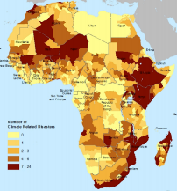  (Busby, Smith et al. 2015) | Germanwatch Climate Risk Index  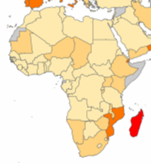  (Kreft, Eckstein et al. 2017) | Maplecroft CC Vulnerability Index  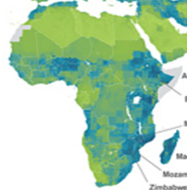  (Maplecroft 2014)
Physical Vulnerability to CC (PVCCI)  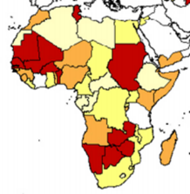  (Guillaumont and Simonet 2011) | Exposure to Climate Hazard (CSVM)  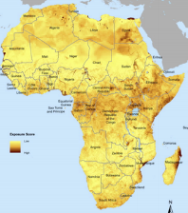  (Busby, Smith et al. 2015) | Climate Vulnerability Index (CVI)  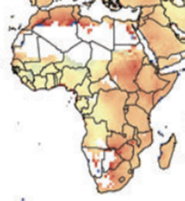  (Samson, Berteaux et al. 2011)

To provide further insight into the vulnerability, the various sources of evidence on temperature, floods and droughts have been reviewed.

Flood Risk. Most of the international work on flood risks is based on the Dartmouth Flood Observatory data which has a database going back to 1988. This data provides evidence of past flooding and does not directly provide evidence of future flooding. However, it can be combined with the evidence from SREX, which suggests that flooding in the southern half of Africa will become 80-120% more frequent, whilst flooding in the northern half will become 10-50% more frequent.

Figure 7 Flood Risk Maps
Estimated Cost of Flood Events  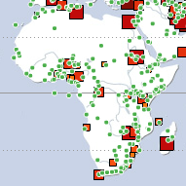  (Dartmouth Flood Observatory 2008) | Large Flood Events 2001-16  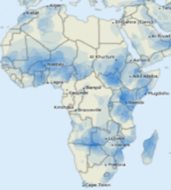  (Brakenridge 2017) | Flood Risk Distribution  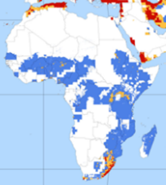  (Dilley, Chen et al. 2005)

Drought. There are a wider variety of sources looking at the current severity of drought. The first source in the figure below shows the frequency of drought hazard over recent decades. The second shows a prediction of drought frequency at the end of the Century and the third shows the change in drought severity over the last 50 years.

Figure 8 Drought Risk Maps
Drought Hazard  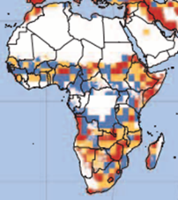  (Dilley, Chen et al. 2005) | Drought Frequency 2070-99  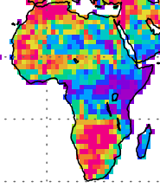  (Sheffield and Wood 2007) | Palmer Drought Severity Index – change over last 50 years  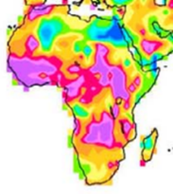  (Dai 2011)

Rainfall Variability. Direct indices of exposure to worsening variability of rainfall are difficult to find because climate models have only recently been reporting on rainfall variability. However, there is clear global evidence that rainfall variability will increase. Indices of water insecurity therefore provide a reasonable proxy for exposure to the widespread risks of worsening rainfall variability.

Figure 9 Rainfall Variability Maps
Seasonal Variability  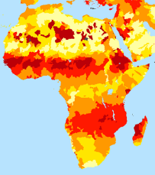  WRI AQUADUCT Water Risk Atlas | Variability Between Years  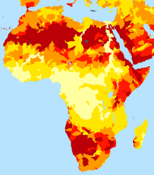  WRI AQUADUCT Water Risk Atlas | Overall Water Risk  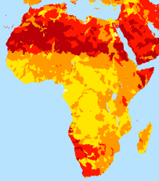  WRI AQUADUCT Water Risk Atlas
Water Security Risk Map  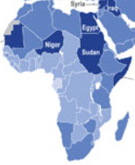  (Maplecroft 2014) | Change in Water Stress to 2025  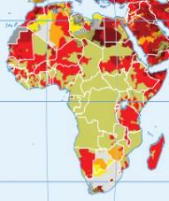  (Intelligence Community 2011) | River Basin Rainfall Variability  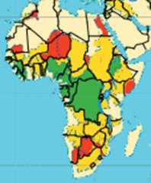  (Stefano, Duncan et al. 2010)

Sea Level Rise.

Sea Level Costs (DIVA Model)  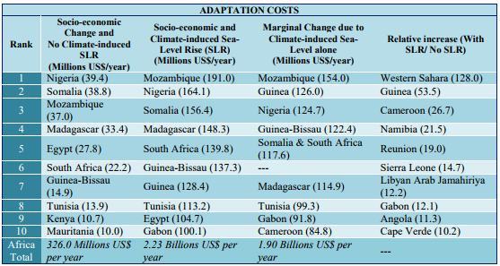  (Brown, Kebede et al. 2011) | Cities most at Risk  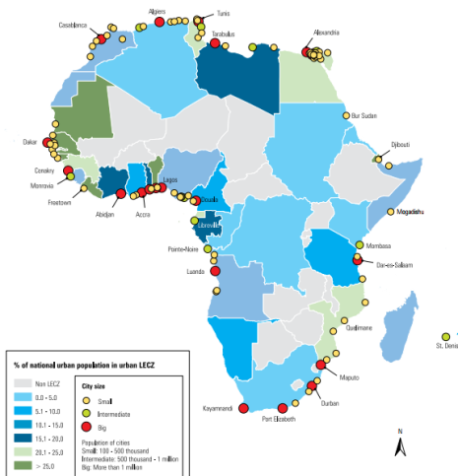  (UN HABITAT 2010) | Top 20 Cities at Risk  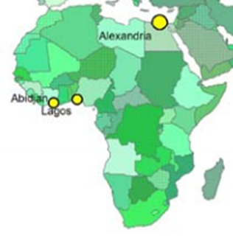  (Nicholls, Hanson et al. 2007)

Heat Stress. Recent studies have suggested that the impact of heat stress on health and labour productivity could be amongst the most serious effects arising from climate change in tropical countries.

Current Heat Stress  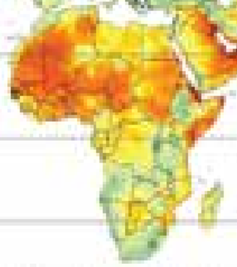  (UNDP 2016) | 2085 Hottest Months  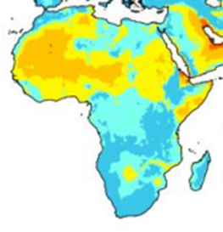  (HEIT 2016)

Overall Exposure. The sources of evidence described in the section above have been combined into five indices, one for overall vulnerability and one for each of 4 key exposure dimensions: flood, drought, rainfall variability and heat. For each of the five indices, an average of all sources was taken, weighted by the confidence in the source. The results for each index were then calculated by dividing the weighted average for the country by the maximum weighted average for all countries. This results in a range of scores between 0 and 1 for each index. Most countries that have the high total exposure combine exposure to all of the 4 dimensions (eg Sudan, Somalia and Nigeria). A few that are highly sensitive to most dimensions, but not to all (eg Ethiopia, which is less exposed to heat risks, and Niger, which is less exposed to flood risks).

Figure 10 Combined Vulnerability Indices by Country

The overall vulnerability index should, in theory, capture all the main four dimensions of exposure. This does happen, to a large extent, although there are some exceptions, where the individual exposure indices seem to be less consistent with the indices for the four dimensions (eg Lesotho, which has a high overall index but the dimensions are not high in total, and Algeria, which has an average overall index, despite having high indices for each dimension).

Sensitivity Indices
Sensitivity is dominated by the sectoral composition of economic activity and the scale of vulnerable infrastructure, including energy infrastructure that is affected by heat, roads affected by floods and extreme rainfall and urban infrastructure affected by sea level rise. This affects the various pathways described in section 2.1.

Economic Activity. Countries that have large agricultural sectors are generally more vulnerable than those that rely on industry and services, where activities can often be protected from the worst impact of CC through investments in resilience, such as flood protection and the cooling of workspaces. The structure of economic activity is captured by national accounts prepared by the statistical bureau and published in an annual statistical publication that is often available on a public website. National accounts are prepared according to a standardised UN System of National Accounts (UNSNA). There are some standard international sources for more aggregate levels of economic activity, such as the World Bank World Development Indicators which split activities into agriculture, industry and services. The UN National Accounts Main Aggregates Database provides data at a sector level, but without sub-sectoral data, for the agricultural sub-sectors or for electricity and water supply. The UN Library does provide pdf files of the sub-sectoral disaggregation, but only on a subscription basis to qualifying institutions. This is a useful starting point, but is limited in the evidence it provides about key sectors, like crops, livestock, fisheries, forestry and energy, all of which are affected differently by CC.

In order to provide more detail, the national accounts for 42 of the 54 African countries have been found, mainly on the websites of the statistics bureaux and offices. The opendataforafrica.org portal also provides some useful sources, to fill gaps.

Figure 11 Broad Sectoral Composition (%GDP, most recent year)
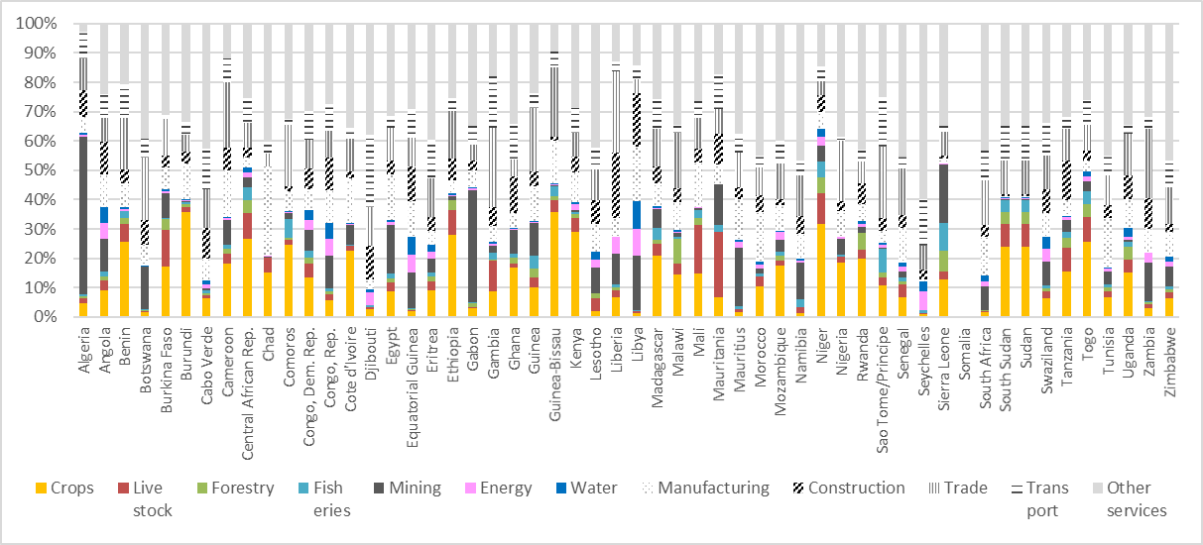
Source: National Accounts Data on Statistics Office Websites and WB World Economic Indicators

The figure above describes the composition of economic activity, which determines the immediate reduction in GDP. In addition, there are losses in assets associated with extreme weather and sea level rise.

Potential Impact by Country
The potential impact by country refers to the potential maximum impact, if adaptation measures are not taken into account. It is estimated by considering the worst case impact for each of the impact pathways, for Africa as a whole and then adjusting this to take account of the exposure and sensitivity indices for each country.

Impact on Components of GDP. The impact on the components of GDP comes through loss of productivity or the need to devote additional resources to prevent that loss. The analysis identifies 8 different GDP sectors or sub-sectors that are affected by CC. The maximum potential reduction in the GDP of the sector/sub-sector is presented in Figure 12. Agriculture and water are potentially most affected, followed by livestock, fisheries and energy. The actual expected reduction is dependent on the exposure of each country to the four dimensions of CC (ie flood, drought, variability and heat). The importance of each of these dimensions in each sector is presented in Figure 12.

A number of additional sources of evidence are used to complement the evidence from national accounts. Many national accounts to not report separately on power and water, either jointly or separately. The estimates for power are therefore made on the basis of standard shares, but are triangulated by averaging with separate evidence from the International Energy Association on the total electricity output of each country, assuming that the value added is 5 c/kWh.

Figure 12 Maximum Potential Reduction in Sectoral GDP
Maximum CC Impact on GDP Sectors  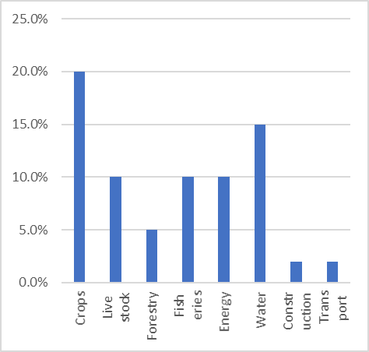 | Sensitivity of Sectors to CC Exposure  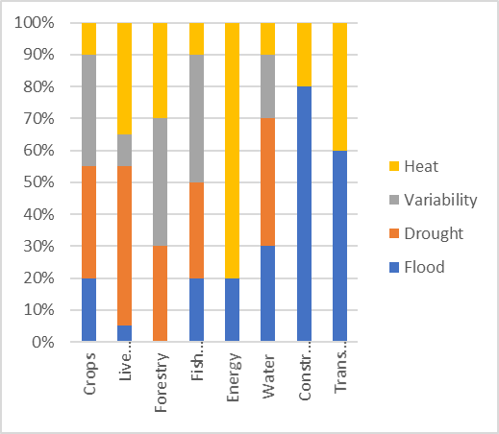
Note: the graph presents the reduction in sectoral GDP from moving instantaneously from current climate to projected climate in 2050, without taking into account growth effects.

Assets. In addition to the impact of productivity on GDP sectors/sub-sectors, CC will also have a direct impact on assets through the impact of sea level rise and increased extreme weather on urban and road infrastructure. This is addressed in section 2.3 on maximum potential impact.

Overall Impact by Country
Instantaneous Change to 2050 Climate. The net effect of the impact on GDP and on assets, sea level effects and health is presented in the figure below, expressed as the expected change from an instantaneous switch to a 2050 climate scenario. Key conclusion from the analysis are as follows.

- The impact for Africa as a whole is for GDP to be 3.2% lower.
- Most countries are expected to incur losses of between about 1% and 5% of GDP.
- There are 18 countries for which the impact is expected to be greater than 4%. These are mostly found in West and East Africa, although Mozambique is also high.
- The countries with the lowest impact are mostly countries that are relatively well developed and have diverse economies with limited reliance on natural resources sectors that are most vulnerable to CC.
- The islands are special cases and the APEA analysis should be treated with especial caution. However, the analysis suggests that their vulnerability is higher than the average for Africa as a whole.

Figure 13 Potential Impact by Country

Growth Effects. Figure 13 presents the GDP loss from a theoretical instantaneous change to 2050 climate. Adaptation benefits are normally estimated as the Net Present Value (NPV) of future benefit flows. To convert the estimates of instantaneous change to the NPV of losses requires a conversion factor. Neoclassical growth models that incorporate a CC damage function suggest that this factor is typically between 2 and 4, depending on the proportion of reduced GDP that affects capital and labour productivity, rather than being absorbed by a temporary fall in consumption. Thus, for example, Nigeria, with a theoretical instantaneous loss of 4% of GDP would see the NPV of GDP to 2050 fall by 8% to 16%, depending on the extent to which capital and labour productivity were affected.

Adaptation Expenditure
The last chapter provided estimates of the impact of CC. This chapter considers the extent to which this impact is likely to be avoided as a result of adaptation expenditure. The chapter focuses on the most recent evidence of public expenditure and does not take private expenditure into account. It considers both the total expenditure and the nature of this expenditure and its effectiveness in reducing the impact of CC.

Definitions and Sources
Scope. The APEA study has been able to find data on adaptation expenditure for 42 of the 54 African countries. More details are provided in Annex2. The scope of the data is as follows.

- For most countries, the data is for budgets rather than actual expenditure. Where actual expenditure is available, this has been used.
- For the 32 countries that are not covered by the BOOST initiative, the data is limited to the most recent year for which data is available. The most recent year was 2017 for 9 countries, 2016 for 10 countries, 2015 for 7 countries, 2014 for 4 countries and 2012 for 1 country. For BOOST countries, all years for which data is available since 2010 have been included.
- The analysis was limited to the data included in the budget or in the government accounts. This would normally include all loan projects. The coverage of donor funded grant projects is more patchy and depends on the success of governments in encouraging donors to register their projects in the budget. A more comprehensive coverage of donor grant projects is one of the key areas of focus for more detailed country work.
- Most of the countries included expenditure only at the central government level. However, data was available for sub-national levels for South Africa and for Kenya. Although sub-national authorities are often important for key adaptation sectors (eg agriculture, water and sanitation and disaster management), the levels of expenditure are relatively modest in most African countries, with the exception of the larger countries with federal structures.
- The analysis aims to cover subsidies, where these are included in the budget, but does not aim to cover tax expenditures (eg reducing taxes to provide incentives), expenditure on maladaptation or private expenditure that is ‘leveraged’ by regulations and incentives.
- The data includes transfers to agencies and State Owned Enterprises (SOE) where these are included clearly in the budget, although this is not common. If the budget includes only a single transfer to an agency or SOE (eg as an operating subsidy or as part of an investment or loan), this is included, but without considering the total costs of the agencies or SOE, for which we will have no data and which might, anyway, be considered as private expenditure.

Ministries, Departments and Projects. The analysis defines 4 levels: national, ministry, department and project. Different countries use different terms, but our proposed definition is based on the following principles.

- National level, including all ministries/agencies
- Ministry is the highest level of government organisation. It may also include agencies if these are managed largely independently for distinctive functions, even if these agencies have clear parent ministries.
- Departments are the main level of organisational responsibility within ministries or agencies. They may sometimes be called Sections. In countries that have switched to programme budgeting, this level is structured as budget programmes within a ministry or agency, e.g. South Africa and Rwanda. In some countries (e.g. Burkina Faso, Kenya and Rwanda) the programme budget is published as an alternative view on the budget at level three. The use of programme budgets – albeit solely or in parallel in budget documents -- will be useful for analysing expenditure because they are associated with clear objectives and benefits, which should facilitate an assessment of the extent to which the benefits are affected by CC.
- Projects are the fourth level of activity. These are distinctive time-bound initiatives. In theory, they should have clear objectives and it should be possible to define the expected benefits and how CC affects these benefits.

In addition to these 4 levels, many countries use policy programmes to help plan and manage public expenditure. These programmes are interventions aligned to a time-bound policy priority and may just be a collection of projects across or within ministries. and be managed as a division of a department. Clear setting out of how CC or CC-related policy programmes – e.g. drought relief programmes -- are funded in budgets, could be useful for identifying expenditure because they are associated with clear objectives and benefits, which should facilitate an assessment of the extent to which the benefits are affected by CC.

Sources. Key source of evidence on public expenditure include the following.

- Ministry of Finance. For most African countries, the only public source of information about government expenditure is on the websites of the Ministry of Finance. The detail provided is variable and is summarised in Figure 14 below. The CABRI budget database provides a central portal of budget information for African countries, supplementing the sometimes incomplete data on Ministries’ websites.
- BOOST Database. The World Bank Open Budget Portal has maintained the BOOST database since 2010. BOOST contains data for 23 countries, of which 10 are in Africa: Burkina Faso, Burundi, Kenya, Mali, Mauritania, Niger, Seychelles, Togo, Tunisia and Uganda. The coverage of data varies from 2 to 7 years. Most countries have organisational expenditure down to the department level and some (Burkina Faso, Burundi, Togo and Kenya) have a separate functional or sector category. Uganda and Tunisia also include a parallel programme classification at the third level. Data are for budget, disbursed and actual (paid) expenditure for all countries. It is freely downloadable in spreadsheet format, and takes several hours to integrate into the APEA database and another several hours to classify, which is much quicker than the manual entry of data from the pdf files typically available on MoF websites.
- OECD/DAC. DAC provide a database of the assistance provided by all member countries. This includes actual disbursements by calendar year, entered by the donor, including an assessment of the sector. For a substantial African country there are typically over 1000 projects for one year. These will include many that are not included in the budget and many that are included in the budget, but with only partial inclusion in the government accounts.
- IMF Article IV. The IMF prepares Article IV Staff Reports for all member countries every two years and these are made available on the IMF website. They include a standard set of tables which include government accounts and balance of payment. The government accounts include total domestic revenue, foreign grants, foreign loans. The balance of payments also includes estimates of foreign official capital flows, which can pick up foreign assistance that is outside the budget. Often Article IV reports also provide a sector / ministry breakdown of budgeted and actual expenditure, as well as projected expenditure.

Figure 14 presents the level of detail at which expenditure was obtained. Data was found at ministry level or below for 42 of the 54 African countries. These countries account for 76% of total GDP. It was not possible to find data even at ministry level for Egypt, which accounts for 15% of African GDP.

Figure 14 Level of Detail at Which Public Expenditure Used by Country
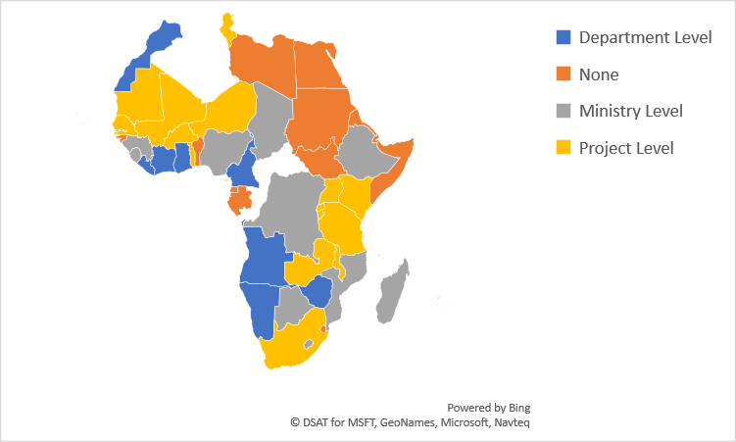

Screening for CC Expenditure
The first step in estimating adaptation expenditure is to screen all expenditure items for a potential contribution to adaptation. This results in an estimate of the total expenditure that has some relevance for adaptation, regardless of the degree of relevance, as presented in the figure below.

Figure 15 Total Unweighted Expenditure Making a Contribution to Adaptation
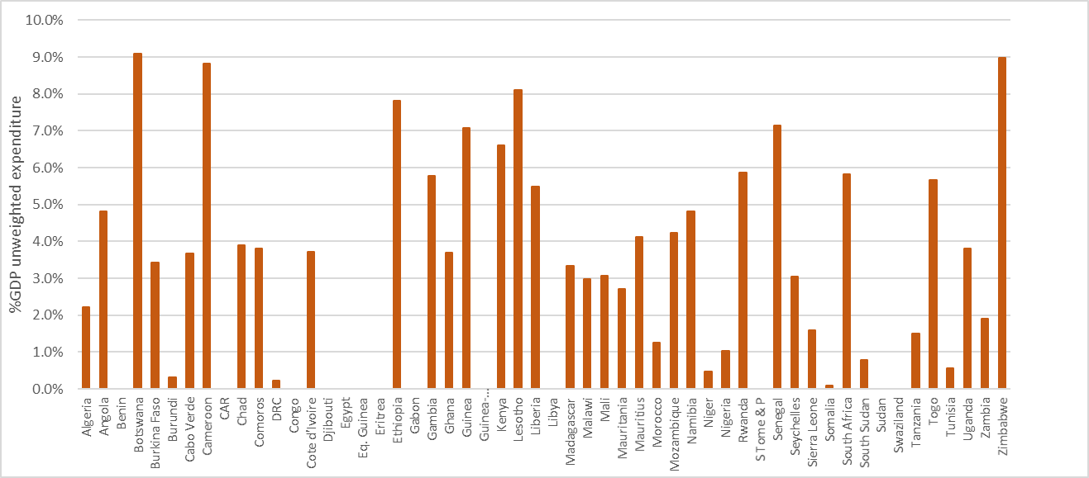

Key challenges with screening include the following:

- In theory, general livelihood programmes do provide opportunities to diversify away from the most vulnerable livelihoods and so could be included. However, this is normally limited to programmes operating in rural areas, where the most vulnerable livelihoods are found. More general support to economic development, such as support to small and medium enterprises, would normally be excluded. Tourism is often included, both because it often benefits households with livelihoods depending on natural resources and because it may include investments in ‘sustainable tourism’ which made direct contributions to adaptation.
- Road construction, rehabilitation and maintenance are normally included, in the hope that the design incorporates some proofing for increased frequency of extreme events.
- Education is normally excluded, even though CC may feature as a small item in the curriculum at all levels of education.
- Health expenditure that relates explicitly to climate sensitive diseases should clearly be included. This usually refers to malaria. But a small but significant part of primary health care deals with water borne diseases that are also climate sensitive, so this may be included if it is classified separately from general health expenditure. Hospitals are normally excluded.

Different CC expenditure programmes make different contributions to adaptation, both qualitatively and quantitatively. This usually results in estimates that are dominated by a few items of expenditure that may be large in total, but only make a small contribution to CC, such as roads and general primary health care. This is illustrated by the figure below, which shows that roads dominate total expenditure, even though there is only a small part of the roads budget that contributes to adaptation. The following sections consider how to classify expenditure to produce more informative analysis of the effort actually devoted to adaptation.

Figure 16 The Sectoral Composition of Unweighted CC Expenditure (% GDP)
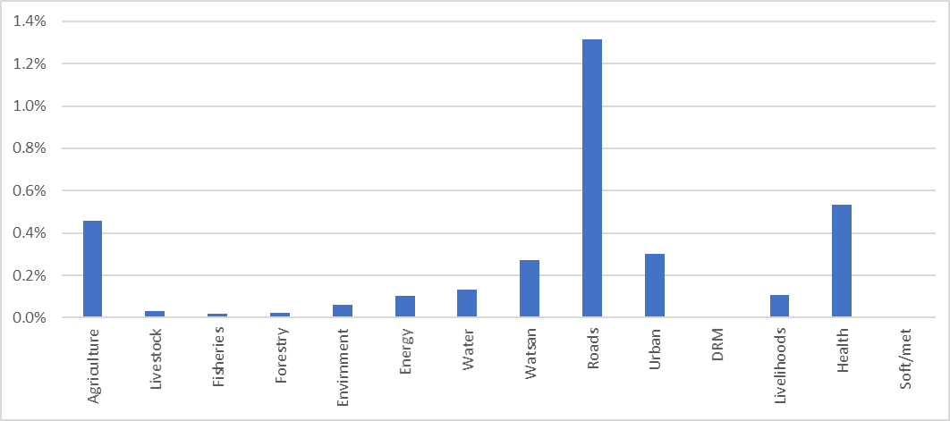

Classification and Effectiveness in Reducing FL&D
The classification of CC expenditure is usually captured by an assessment of both the degree of CC relevance (usually expressed in a % score) and by the type of expenditure (eg investment, services, incentives, capacity building …). The classification addresses two of the key challenges involved in working on the adaptation gap:

- The first challenge is that most expenditure that contributes to adaptation is primarily delivering routine development benefits that simply become gradually more important. In most cases, the adaptation benefit is not different in nature to the development benefit and just involves the extra value of the development benefit. For example, a flood protection project provides development benefits even without CC, but these same benefits will become more valuable as floods become more frequent. Defining such expenditure as 100% CC expenditure undermines the value of the contribution to development, which is usually greater than the contribution to adaptation.
- Understanding the contribution of CC expenditure to adaptation (ie reducing FL&D) requires an assessment of the effectiveness of the expenditure. In IAMs (eg as used in the Stern Review and referred to in the UNEP work on adaptation gaps) this happens through the way in which the production function is adjusted to take account of CC expenditure. In CCFF work, it happens by subjecting typical CC expenditure types to the practice of policy impact appraisal that is normally used in a country, which may be quantitative or may be more qualitative.

Relevance Weights. There are two main approaches to classifying CC expenditure. The first relies on the declared objectives and is used by the OECD/DAC classification and by most of the CPEIR work. The second relies on an assessment of the extent to which the net benefits of the expenditure change as a result of CC. There is also a grey area in between these two approaches, where estimates of the impact on benefits are informed by evidence about the objectives. For convenience, a weight that is based on objectives is referred to in this study as the CC% and a weight that is based on the share of benefits is referred to as the Adaptation Benefit Share (or ABS%).

Whilst most CPEIR and CCFF work applies a CC% to give estimates of the degree of CC relevance, the UNEP Adaptation Gap approach uses the total value of finance that makes some contribution to CC, based on evidence from OECD and from the work by the Climate Policy Initiative (CPI). It does not consider variations in the degree of CC relevance of adaptation expenditure. The I&FF work classifies expenditure in terms of its contribution to investment, financial flows and recurrent costs, without assessing the degree of CC relevance.

The analysis has mainly adopted standardised values for ABS% that have been applied across all countries, without taking into account the nature and severity of the CC risks in each country. The default standard values are presented in the table below. For some countries, the standard default ABS% has been over-ridden with a more specific estimate to take account of any evidence about the particular nature of the expenditure.

Table 12 Standard Default ABS% and CC% Scores
Type of Expenditure | Default CC%
 | ABS% | CC%
Studies and capacity building dedicated exclusively to CC | 100% | 100%
Meteorology and climate science | 33% | 100%
Disaster reduction and management | 33% | 100%
Irrigation and drainage | 33% | 75%
Rural livelihoods targeted at vulnerable households | 25% | 75%
Integrated Water Resources Management | 25% | 75%
Green, low carbon, resilient growth | 25% | 75%
Water resources management | 20% | 75%
Water supply and sanitation | 15% | 75%
Agriculture - crops research and extension | 10% | 75%
Forestry (unless with specific CC focus) | 10% | 75%
Renewable energy and energy efficiency | 10% | 75%
Energy access | 5% | 50%
Agriculture - general sector management | 5% | 50%
Livestock research and extension | 5% | 50%
Fisheries | 5% | 50%
General environment and wildlife | 5% | 50%
Sustainable economic development, incl. tourism | 5% | 25%
General livelihoods & welfare without vulnerability focus | 5% | 25%
Urban development, housing, local development | 5% | 25%
Road infrastructure and transport services | 1% | 10%
Health related to malaria | 10% | 10%
Rural primary health | 1% | 10%

ABS% and FL&D. Both the CCFF and UNEP Adaptation Gap work recognise that expenditure on adaptation reduces FL&D. In the UNEP approach, this occurs through the use of production functions in economic models. The CCFF approach aims to estimate the Benefit Cost Ratio (BCR) of adaptation expenditure by reference to the sort of policy impact assessment that is typically undertaken as a routine part of government planning and budgeting and hence to encourage the integration of CC into planning and budgeting. In most countries, quantitative Cost Benefit Analysis (CBA) is limited to a very few large projects, but there may be other more qualitative practices, such as the use of logframes and some form of beneficiary consultation, which can be used to contribute to a standard approach to assessing how CC affects benefits that is comparable across countries.

CC Impact Assessment. Part of the interest in using the benefits based approach to classification is that it establishes a framework the creates demand within the government system for incorporating CC into whatever practices exist for impact appraisal or assessment. The practices may range from qualitative, but structured, methods of beneficiary assessment to logframe approaches to Cost Benefit Analysis (CBA), although CBA is usually to larger investments. The box below provides further details on CCIA.

Box 3 Climate Change Impact Assessment
CCIA draws on the standard approaches to Policy Impact Appraisal (PIA). The analysis must be clear about the situation with and without the action (ie policy, programme or project). It should consider a number of options and/or scales to explore the sensitivity of the results. It should be conservative add avoid exaggerating benefits. In addition to these standard PIA principles, CCIA must explain the implications of CC for effectiveness. It does this by estimating the net benefits without CC (say A) and then when CC is taken into account (say B). CCIA then defines the CC% as a standard measure of CC sensitivity (or CC relevance), defined as CC% = (B-A)/B.

Practical CCIA work can be done with varying levels of detail.

- Screening, to determine what level of CCIA is warranted, if any (1 minute/action)
- Classification, for broad reviews, such as CPEIRs and CCFFs (2-5 mins/action)
- Qualitative CCIA, giving a structured assessment mainly by experts (1 hour/action)
- Hybrid CCIA, using a mix of qualitative and Cost Benefit Analysis (CBA) (1 day/action)
- Full CCIA adapts extended CBA, normally for large programmes (1 week/action)

More details are available in the CLIMATE SCRUTINY Guide to CCIA.

The Contribution of Expenditure to Adaptation
Weighted CC Expenditure. Figure 17 shows the level of CC related expenditure, after applying weights that show the proportion of total benefits that relate to adaptation, rather than routine development. All figures will need to be checked and refined during the main phase of the work, with particular attention to countries that have unusually high or low values.

Figure 17 Adaptation Expenditure (%GDP, Unweighted and Weighted by ABS%)
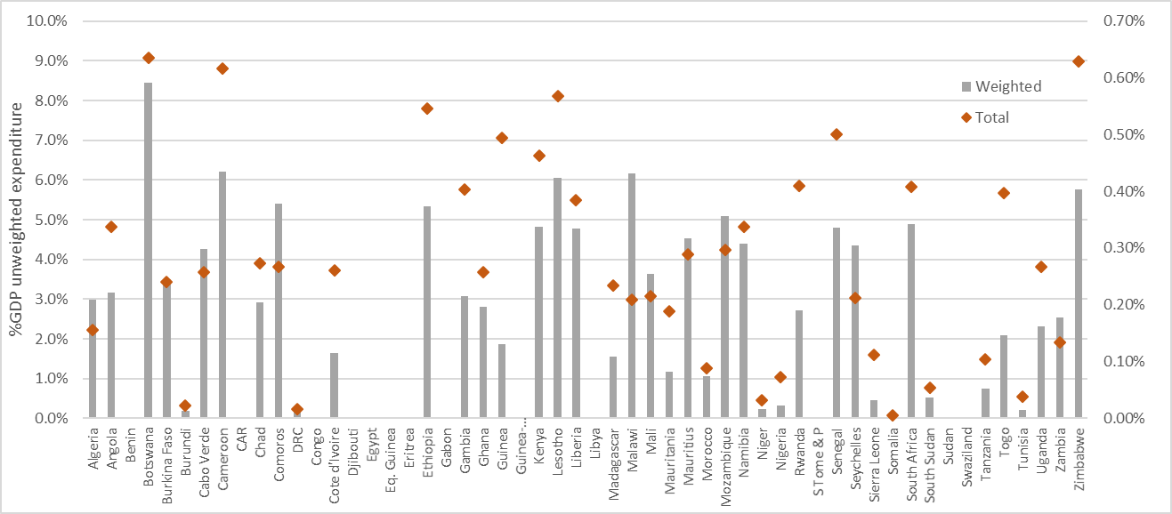
Note: the diamonds repeat the bars in Figure 15 and are included for easy reference.

The figure above shows that total weighted adaptation expenditure amounts to between 0.1% and 0.5% of GDP for 29 of the 42 countries for which expenditure data was found. The weighted average for all 42 countries is for the unweighted total adaptation expenditure to be 3.4% of GDP and the weighted expenditure to be 0.18% of GDP. For the 34 African LDC countries, the unweighted total is higher, at 3.9%, but the weighted average is only slightly higher, at 0.19% of GDP, as shown in the table below.

Table 13 Indicative Overview of Public Expenditure on Climate Change
 | Africa Total |  |  |  | African LDCs
 | Domestic | ODA | Total | Domestic |  | ODA | Total
Public Expenditure (%GDP)
Total Public Expenditure | 27.97% | 2.53% | 30.50% | 22.00% |  | 5.15% | 27.15%
CC Expenditure | 3.40% | 0.94% | 4.34% | 3.90% |  | 1.92%
CC weighted Expenditure | 0.18% | 0.11% | 0.29% | 0.19% |  | 0.23%
Memorandum items
GDP (2016 USD bn) | 1,888 |  |  | 534
Sources: Total public expenditure from ADB AEO 2015; ODA from OECD DAC database; CC expenditure for ODA based on sectoral composition and default CC%s; CC expenditure for domestically funded expenditure from the APEA analysis of 42 countries.

The Overseas Development Institute (ODI) have undertaken CPEIRs in 4 African countries: Ethiopia, Ghana, Tanzania and Uganda. The CPEIRs have used a methodology that defines a CC% that is based on the significance of CC in the objectives of the expenditure (Climate Scrutiny 2017). This typically produces results that are roughly 3 times higher than the ABS%, based on benefits, although the difference depends on the type of expenditure. Key results are presented in the table below. There are some suggestions in the work that different countries applied the objectives-based CC classification system in different ways, which illustrates the challenges associated with subjectivity in the system. The CPEIR figures are significantly higher than the APEA figures in Ethiopia, Kenya and Tanzania, after taking into account the differences in classification methodology. This is likely to be explained partly because of the difference between the CC% and ABS% in specific sectors and partly because the CPEIR analysis was undertaken in more detail and may have picked up some large and important ODA projects that were not included in the budget.

Table 14 Results from CPEIRs in Africa (in % GDP)
 | CPEIR Results |  |  |  | APEA
 | Lead partner | Total public expenditure | Unweighted CC expenditure | Expenditure weighted by CC% | Expenditure weighted by ABS%
Ethiopia | ODI | 18.3% | 6.27% | 1.83% | 0.37%
Ghana | ODI | 27.7% | 4.77% | 0.67% | 0.20%
Kenya | UNDP | 27.2% | 5.85% | 2.86% | 0.34%
Tanzania | ODI | 29.0% | 7.06% | 1.43% | 0.05%
Uganda | ODI | 16.2% | 3.3% | 0.15% | 0.16%
Source: (GoK 2016, ODI 2016)

The use of weighted expenditure allows for a more meaningful comparison of differences in the sectoral composition of countries’ adaptation budgets. Many of the differences are explained by the different natural resource situation and balance of economic activity (eg the importance of water in Botswana and Mozambique, the importance of agriculture in Ethiopia, the Gambia, Kenya, Lesotho, Malawi and Mali and the importance of CC and disaster planning in Comoros and the Seychelles).

Figure 18 Weighted Expenditure Related to CC by Sector (% of GDP, most recent year)
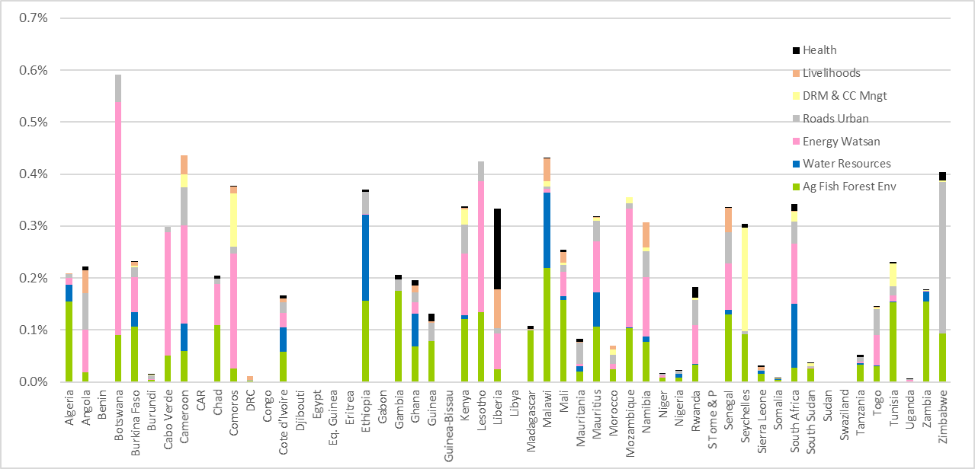

Trends in CC Expenditure. The BOOST dataset makes it possible to analyse the trends in CC expenditure with a reasonable level of details on expenditure programmes. For example, the figure below shows Togo BOOST data from 2009 to 2016, which includes 859 programmes of expenditure that may make some contribution to adaptation. This includes a large number of infrastructure programmes that are assumed to be designed to adapt to CC, with design changes that accept more intense rainfall (for roads) and incorporate energy savings (for buildings). The broad APEA review does not have the resources to assess the extent to which all these programmes in all African countries are actually taking CC into account and has adopted the convention of assuming that 1% of the expenditure is contributing to improved design that reduces CC L&D in future.

Figure 19 Weighted CC Expenditure Trends 2010-16 for BOOST Countries (%GDP)
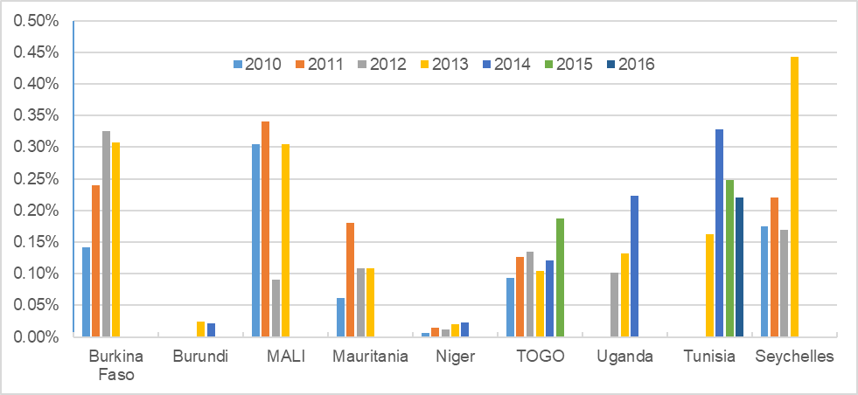Source: BOOST public expenditure data, classified according to default CC%s

Figure 19 above is typical of similar work in other countries, with the pattern of CC expenditure over time showing large shifts, usually associated with several large programmes. The figures above suggest this is likely to be dominated by changes in water and sanitation programmes and an investigation of the data shows that there are a handful of large watsan programmes that finish in 2011 and another group that start in 2013, but with little activity in 2012. Investigating the reasons for this requires more resources than are available for any one country in the APEA work. However, the rapid exercise for the Togo data above shows that it should be possible to use the BOOST data to obtain a valuable insight into trends in CC expenditure which should show interesting patterns when all 10 BOOST countries are included.

Adaptation Gap
This chapter shows how the evidence discussed in the two previous chapters can be brought together to provide an estimate of the adaptation gap. The gap is defined as the part of the potential impact of CC that is not avoided from planned levels of adaptation spending. The potential impact of CC is taken from chapter 2 and the adaptation expenditure from chapter 3. The analysis first assumes that current levels of expenditure are maintained, expressed as a % of GDP, and then reviews options for reducing the gap.

The Adaptation Gap
The estimation of the adaptation gap is defined in Figure 5 and the mathematical calculation used in the review is described in Annex 3. It should be stressed that the analysis provides a rapid overview from the available pan-Africa sources of evidence. Much of the effort in the APEA analysis has been devoted to obtaining the expenditure data for countries, but there are many countries for which this has been only at an aggregate level of department or, in some cases, ministry. This means that the analysis of expenditure is rudimentary and needs to be improved when country specific analysis is undertaken. The figures in this report should therefore be treated as illustrative and are presented more as an example of what might be achievable with a systematic range of country-based studies than as definitive estimates of the adaptation gap.

Chapter 3 focused classifying adaptation expenditure according to ABS%. It did not consider the overall benefits of the expenditure since this would have gone well beyond the capability of the study. Ideally, this would be done using formal impact appraisal methods that provide an assessment of the relative value of benefits compared to costs. However, in practice, this is done in Africa only for large investment projects and the approval of projects is based on a more qualitative process that reflects a range of different factors. These practices are mixed and produce variable results. However, in order to estimate an adaptation gap, it is impossible to avoid making an assumption about the BCR of adaptation expenditure, which can then be combined with the ABS% to produce an estimate of adaptation benefits and of reduced CC impact. The APEA review assumed that the mixed practices of expenditure approval operate to require all expenditure to have a BCR of 2.0, at the point when expenditure is approved. This is close to the actual threshold often used when formal CBA is undertaken. The analysis also assumed that, in practice, the actual performance of adaptation expenditure, in common with other expenditure, does not achieve the expected level. Large ex-post evaluations done by MDBs typically find that actual BCRs are only between two thirds and three quarters of the expected BCRs. The APEA analysis assumed that actual BCRs will be 1.5. The estimate of the adaptation gap is directly proportional to the assumed BCR so, if this is considered to be too conservative, the adaptation gap will be smaller.

Results. The adaptation gap has been estimated for all 42 countries for which public expenditure data could be obtained. The table below summarises the result for Africa as a whole.

Table 15 Adaptation Gap for Africa as a Whole
 | Africa
GDP (USD bn) | 1,901
GDP loss (instantaneous change to 2050) | 3.2%
GDP loss (NPV of GDP loss to 2050, including growth affects) | 12.7%
Total public expenditure (%GDP) | 30.5%
of which international aid | 2.52%
Adaptation finance (%GDP) | 3.4%
of which international aid | 1.0%
BCR of adaptation finance without CC | 2.0
BCR of adaptation finance with CC | 2.1
FL&D reduced by adaptation finance (% NPV of GDP to 2050) | 2.0%
Adaptation gap | 80%
Sources: APEA inception analysis

Figure 20 presents the results for each country. Key conclusions from the analysis are as follows.

- Firstly, it should be borne in mind that the gap reflects what would happen if adaptation expenditure actually performed as planned. Given the tendency for actual performance to lag behind expected performance, the results probably underestimate the gap significantly.
- For Africa as a whole, the estimated adaptation gap is about 80%. So the current level of adaptation expenditure will reduce the potential economic impact of CC by about 20%. African countries are, therefore, already making a major contribution to adaptation.
- The adaptation gap is greater than 90% in nine countries. Most of these countries face major exposure and sensitivity to CC risks as well as fiscal challenges.
- Countries that have reduced the potential impact of CC by more than 20% include those: exposed to low CC risks (eg Liberia, Namibia, Zimbabwe); with high expenditure (eg Ethiopia, Gambia, Zambia); and with lower risk and good expenditure (eg Rwanda, Senegal, Uganda).

Figure 20 Adaptation Gap
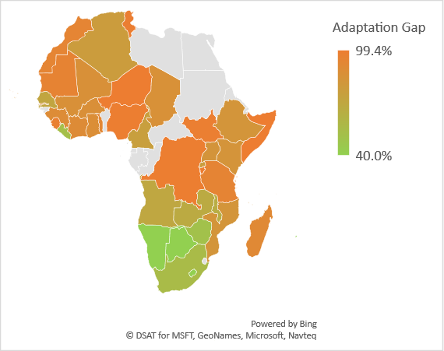

The Adaptation Gap by Sector. In theory, it should be possible to assess the adaptation gap by sector to give some indication of whether sectoral expenditure on adaptation matches the level of potential loss and damage. Figure 21 presents the results of simply dividing the expected adaptation benefits arising from expenditure in each sector by the expected impact of CC in each sector, calculated on a pan-Africa scale. There are, however, some practical limitations to what can be done, given the relatively aggregate level of the public finance data.

- The estimates for agriculture, livestock and fisheries may have some validity.
- Forestry is problematic because much of the expenditure relates to protection of forest biodiversity, As no estimate has been made of the potential value of the impact of CC on forest biodiversity, the assessment of PL&D in the forestry sector is limited to the possible reduction in forest productivity.
- Energy is problematic because it has been difficult to distinguish between adaptation and mitigation ins some expenditure programmes. For example, improved access to renewable energy provides both adaptation and mitigation.
- Water is the most problematic sector because the data available for some countries does not distinguish between water supply and sanitation, irrigation, drainage and flood protection and integrated water resource management. It is therefore not valid to compare all of this expenditure with the potential impact of CC on water and sanitation services. The figure is included to illustrate the problem of working at such high levels of aggregation and has no policy relevance.
- Roads are problematic because of difficulties, in some countries, to isolate expenditure on road construction, rehabilitation and maintenance from other public infrastructure. It is also unknown whether the expenditure on roads has really begun to take CC adaptation into account and to use new standards that reflect the increased frequency of severe weather events.
- The relatively high estimate of urban flood benefits is also affected by the difficulty in isolating expenditure on resilience, amongst total urban expenditure. This is partly addressed by the default ABS% score, but this will vary greatly depending on the nature of the expenditure on urban development and the design of individual programmes.
- In theory, the livelihoods expenditure captures many different types of expenditure, including rural development and economic growth in various sectors like tourism and small and medium enterprises. However, this expenditure is compared with the overall loss of incomes from the impact of CC, as reflected in the loss of GDP, after taking into account that a large part of this overall impact (assumed to be 75%) will affect saving and investment rather than household incomes.
- For health, much of the CC impact relates to reduced labour productivity, which affects many sectors and for which there is no specific adaptation expenditure. In theory, it would be possible to calculate a gap specifically for climate sensitive diseases, but a separate analysis of this has not been done. Health is therefore not included in the figure.

Figure 21 Sectoral Adaptation Gap at the pan-African Scale
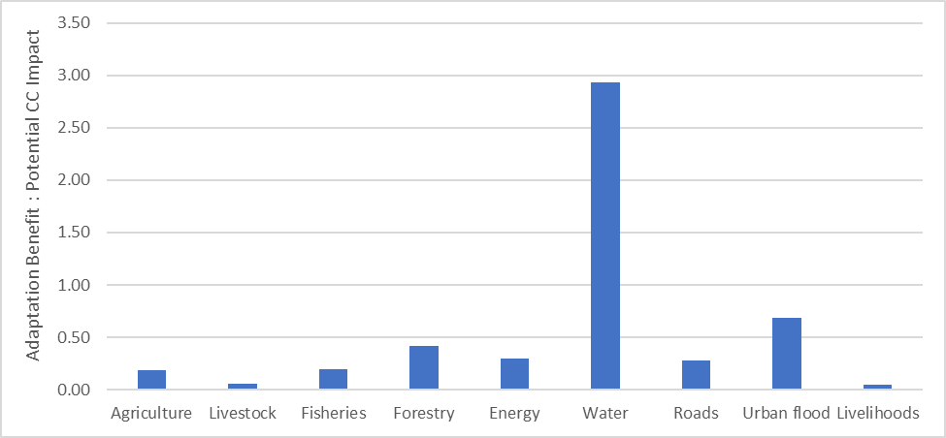

Reducing the Adaptation Gap
Residual Gap. Most assessments suggest that there is a residual gap of FL&D that cannot be reduced by cost effective policies. Some studies have suggested that this is typically about one third of total FL&D (Stern 2006). For example, this would include some of the effects of heat stress on labour productivity in outdoor activities, although there are some policies that can reduce this, for example by providing cooling centres and improved sleep conditions. This may be because there are no technical or institutional options for addressing some types of FL&D or because some programmes are effective in small areas, or on a small scale, but are impossible to scale up to address all the FL&D. This requires further analysis in Africa.

Increased Public Adaptation Expenditure. The most obvious strategic response to closing the adaptation gap is often assumed to be to increase expenditure by ensuring that a higher share of total public expenditure is assigned to ministries and departments that are making the biggest impact on adaptation to CC. There will be scope in most countries to increase adaptation spending in several ways.

- Grow total public expenditure as a % of GDP. In recent years, total public expenditure in Africa has remained fairly stable between 29.5% and 30.5% of GDP (ie about USD 600bn). There may be some tendency for countries with relatively low revenue to increase (eg Uganda has increased revenue collection from 17.1% to 19.2% of GDP in recent years), but this is likely to happen slowly in most countries and overall public expenditure will be determined largely by economic growth, which has averaged 4.7% for Africa as a whole over the last 7 years. This is unlikely to contribute more than about a 10% rise in adaptation expenditure.
- Improve overall spending efficiency with reforms (eg in disbursement rates and coordination and predictability of spending). Most African countries are conducting programmes of continuous improvement in public finance and it should be possible for this to contribute to an increase in effective expenditure of at least 10%. If this is focused on key adaptation sectors, the impact could be larger.
- Allocate a higher share of spending to adaptation. Whether adaptation sectors will receive a marginal increase in the share of expenditure will depend on the relative importance of CC priorities, compared to the wide range of other priorities covered by national development strategies and Sustainable Development Goals (SDGs). It seems unlikely that the share of total spending devoted to adaptation will increase by more than about 20%.

If all the three above changes take place, it is possible that effective adaptation could increase by about 40%, when expressed as a % of GDP. This could reduce the adaptation gap by 8%.

Effectiveness of Public Adaptation Expenditure. Although obtaining a higher share of the budget may be the first response of many officials, ensuring that all programmes are designed in a way that takes CC into account will often be the way in which most countries can make the biggest impact on closing the adaptation gap. There is limited experience or empirical analysis of the potential contribution of improved effectiveness of adaptation expenditure. However, more general experience with project design suggests that it is not unreasonable to expect effectiveness to increase by at least 20%, as officials improve project design and appraisal skills. This would lead to a reduction in the adaptation gap of an additional 4%, if total expenditure remains at current levels and would otherwise deliver a 20% reduction in the impact of CC.

Official Development Assistance (ODA). Most large ODA projects are captured in the budget. However, ODA outside the budget also makes an important contribution. Total ODA has been fairly stable for the last 5 years, at between USD 51bn and 57bn, for Africa as a whole. Although this is only 10% of total public expenditure for Africa as a whole, it is much higher in most of the least developed countries (LDCs) and is often between 25% and 50% of development spending and of ‘discretionary’ spending. The CC relevance of this ODA requires further investigation. However, the data on sectoral allocations suggests that CC sensitive sectors receives a higher share of ODA than of public expenditure as a whole. For example, agriculture, forestry and fishing receives 6.7% of ODA and 3.7% of total public expenditure, while water and sanitation receives 3.9% of ODA and 1.7% of total public expenditure.

The OECD produces a Survey on Donors Forward Spending Plans which reports substantial drops in aid in the coming years. In past years, the OECD supplemented this with a review of aid prospects, but this has not been done since 2015 and is now out of date. Based on this evidence, it seems unwise to expect a significant increase in the contribution of routine ODA to adaptation.

International Climate Finance. Projections of CC finance recently made by the World Resources Institute (WRI) and the OECD and suggest that global public climate finance may increase to about USD 65bn by 2020 (WESTPHAL, CANFIN et al. 2015, OECD 2016). The GCF have said that half their funding will be devoted to developing countries and half of this to adaptation. If all climate finance followed the same pattern, then it would leave USD 16bn available for adaptation in LDCs. This suggests that the target of USD 100bn by 2020 may be achievable. Half of this is expected to be devoted to adaptation. Assuming that Africa received the same share of adaptation finance as it receives in ODA (ie 34% in 2015), this would mean Africa can expect an additional USD 15bn in adaptation finance. This would reduce the adaptation gap by 15% and make a major contribution to protecting Africa’s population and ecosystems from CC.

Many development partners are in the in the process of refining the way in which their funding of CC is defined and accounted for, which is changing the incentives for managing CC. For example, DFID is switching from separate funding of CC projects to an integrated approach to managing all projects, in which the CC element is more clearly defined and enumerated.

The Private Sector. The private sector already contributes to adaptation. For Africa as a whole, private investment is about 50% more than public investment, suggesting an important role for private adaptation, especially if government expands appropriate policies (eg subsidies, incentives and regulations). However, effective public policies require public and private capacity, which will take time, and there may be limits to the role of the private sector in some areas (eg in water and transport infrastructure). The potential of the private sector to contribute to adaptation in Africa requires further work.

Table 16 presents a typical strategic scenario for closing the adaptation gap. Country level strategies will vary depending on the CC threat, current adaptation expenditure, the potential of the private sector and prospect for support from international partners. The scenario suggests that the contribution of African governments, international partners and the private sector are of roughly equal importance in closing the adaptation gap.

Table 16 Typical Strategic Scenario for Reducing the Adaptation Gap
Strategic Response to Reducing the Adaptation Gap | % of Needs
Residual CC impact, than cannot be reduced in a cost effective manner | 33%
Existing public adaptation expenditure | 20%
Increased expenditure on adaptation | 8%
Improving the effectiveness of adaptation expenditure | 4%
Routine ODA, with adaptation benefits | 0%
International climate finance | 15%
Private sector | 10%
Remaining gap | 10%

Conclusions
This review of African Public Expenditure on Adaptation has suggested that governments across Africa are already making significant efforts to reduce the potential impact of CC. It seems likely that as much as 20% of the potential impact will be avoided, if current levels of adaptation expenditure are maintained, when expressed as a % of GDP. The previous chapter identified five main ways of closing this gap. This chapter reviews what needs to be done to pursue each of these strategies.

Managing the Reduction of the Adaptation Gap
Total CC Public Expenditure. The most obvious strategic response to closing the adaptation gap is often assumed to be to increase expenditure by improving revenue collection and efficiency and by ensuring that a higher share of total public expenditure is assigned to ministries and departments that are making the biggest impact on adaptation to CC. The potential for increasing the priority given to adaptation may be limited because CC adaptation has to compete with other sectoral and cross sectoral priorities, as defined in government strategies. However, the APEA study helps to lay the groundwork for this in the following ways.

- CC strategies need to incorporate comprehensive financing frameworks that consider the full range of expenditure and go well beyond a list of costed projects. A classification system is required which accommodates both the expenditure that should clearly contribute to adaptation as well as the large expenditure items that make small contributions to adaptation.
- Clearer definitions of the extent to which public expenditure contributes to adaptation will help budget negotiations to understand the impact on adaptation of proposed alternative allocations. A few Asian countries have started using budget tags and scores to assist with this. Ideally this should provide weighted CC expenditure tables as companion tables to full budget tables, in real-time budget negotiations.

Effectiveness of CC Expenditure. Although obtaining a higher share of the budget may be the first response of many officials, ensuring that all programmes are designed in a way that takes CC into account will often be the way in which most countries can make the biggest impact on closing the adaptation gap.

- The APEA study uses the concept of the Adaptation Benefit Share (ABS%) to define the relative importance of adaptation and routine development for each expenditure item. This requires programme managers to understand the way CC will affect their activities and how they can adjust their activities to maximise the extra benefits from protecting people and ecosystems from CC. CC Impact Appraisal (CCIA) provides a systematic basis for doing that, building on existing appraisal methods (Climate Scrutiny 2017). Some countries in Asia have introduced guidelines to help adjust existing appraisal activities to include adaptation benefits and the APEA study aims to help countries in Africa to do the same.
- The use of CCIA helps programme designers to improve the contribution of their programmes to adaptation. It also helps senior officials in a ministry understand which of the various programmes under their responsibility makes the biggest contribution to adaptation and how the effectiveness of expenditure may decline with the scale of the programme.
- The analysis of effectiveness will help understanding of the extent to which some of the impact of CC is impossible to address cost effectively.
Official Development Assistance (ODA). Although ODA is only 10% of total public expenditure across the whole of Africa, it is much higher in most of the developing countries and is often between 25% and 50% of development spending and of ‘discretionary’ spending. Many development partners are in the process of refining the way in which their funding of CC is defined and accounted for, which is changing the incentives for managing CC. As mentioned above, DFID is switching from separate funding of CC projects to an integrated approach to managing all projects, in which the CC element is more clearly defined and enumerated.

- The APEA approach to defining and classifying CC expenditure aims to help African countries engage with development partners, both in terms of the way in which they have classified their assistance in the OECD/DAC (using the objectives based classification) and the way in which they define and enumerate CC expenditure within their own programme management, using a benefits based classification.
- Showing leadership in the debate with development partners will help African governments avoid the proliferation of parallel funding streams and so maximise the effectiveness of the key management skills within government.
- The pan-African view of the size of CC expenditure provided by the APEA study should help African governments to lobby internationally for more rigorous measurement, reporting and verification on the progress towards the international commitments on CC expenditure.
Climate Funds. International climate finance has the potential to provide a modest additional source of funds for adaptation. Early successes have mainly involved ‘soft’ adaptation associated with capacity building, studies and research. Support for investment, services and finance is proving problematic, largely because there is no clear definition of what they should be used for, which has then led to demanding application processes and delays and uncertainty amongst countries.

- The APEA study aims to help African governments apply for climate funds by providing a framework for national prioritisation that can strengthen applications to climate funds.
- In theory, a comprehensive CC finance framework should help African countries to design applications to climate funds in a way that limits dedicated projects to soft activities and requires hard adaptation funds to be integrated with blended funding. This will provide greatly improved efficiency and effectiveness, through consistency, continuity, coordination and efficiency, by using scarce skilled management resources in a coherent way.
Private Sector and New Instruments. Given the constraints on public expenditure and the strong growth in private sector activity in many African countries, there are good opportunities for introducing new policies and instruments that shift public expenditure away from direct expenditure towards incentives and regulations that encourage the private sector to adapt to CC.

- The approaches to understanding how CC will affect the benefits of investments and services have been developed largely in the context of public expenditure. However, they are even more appropriate for private sector appraisal, because private companies are often more focused and experienced in estimating the benefits and revenue from those benefits as part of their own financial planning. The design and appraisal of public sector policies that provide incentives and regulations for the private sector needs to be done with the same rigour, in order to ensure that policies are effective.

Further Analytical Work on Africa’s Adaptation Gap
This APEA study was conducted rapidly with limited resources and access to data. There are four main priorities for further work.

Country Level Analysis. The main priority for further work on the adaptation gap is for countries to make their own estimates of their adaptation gap, to replace the estimates provided in the rapid APEA review. In particular, this will involve classifying expenditure at a greater level of detail than was possible in this review, with more information about the nature of the main programmes and projects in the country.

The standard value for ABS% that have been used in this review will need to be replaced by values that take into account more evidence about the nature of the risks facing each country. In particular, the standard values for ABS% assume that the frequency of all climate events that relate to rainfall variability (ie floods, droughts, storms, intensity and seasonality) will gradually double by 2050. In countries where there is evidence that this change will happen more quickly, the ABS% of programmes and projects that protect the country from this variability will be higher than the standard default ABS%.

Evidence on Effectiveness using CCIA. More work on the effectiveness of adaptation expenditure in reducing the impact of CC is urgently needed. Many Asian governments have started this process by piloting the work with a few key ministries (eg agriculture, irrigation, water resources and energy), building capacity and evidence by selecting a few key programmes. The results of this work should be made available on the internet as much as is feasible, given the constraints of commercial confidentiality.

There is a growing body of experience with rapid and hybrid versions of CCIA that allow a reasonable first estimate of the ABS% to be made without detailed quantitative analysis similar to CBA analysis (Climate Scrutiny 2017). This can be used to build awareness of how CC affects the performance of public expenditure in a structured way that includes an explicit statement of assumptions and thus facilitates transparency and common understanding.
Growth Effects. The implications of CC for economic growth requires more study. In particular, it is important to understand whether CC simply results in more frequent temporary reductions in income or whether it creates a more fundamental impact on the productive potential of countries, by reducing labour productivity and capital, including financial, physical, human and environmental capital.

Monitoring Adaptation. African countries are committed to reporting progress on adaptation under the Paris Agreement. The ideal metric for doing this is to report on progress in reducing the adaptation gap. This will require reporting on each of the key indicators that determine the gap, including:

- the latest evidence on the nature and severity of CC for the country
- evidence on changing sensitivity to CC, including changes in economic structure and in the nature and distribution of key capital assets (physical, financial, human and environmental)
- evidence on the level of public and private expenditure and on the effectiveness of this expenditure in reducing the impact of CC

Bibliography

Adhikari, U., A. P. Nejadhashemi and S. A. Woznicki (2015). "Climate change and eastern Africa: a review of impact on major crops." Food and Energy Security 4(2): 110-132.
Brakenridge, G. (2017). "Global Active Archive of Large Flood Events." Dartmouth Flood Observatory, University of Colorado.
Brown, S., A. S. Kebede and R. J. Nicholls (2011). "Sea-Level Rise and Impacts in Africa, 2000 to 2100 ".
Busby, J., T. G. Smith and N. Kirshnan (2015). "Climate Security Vulnerability in Africa Mapping 3.0: An Update."
Caminade, C., S. Kovats, J. Rocklov, A. M. Tompkins, A. P. Morse, F. J. Colón-Gonzáleze, H. Stenlund, P. Martens and S. J. Lloyd (2014). "Impact of climate change on global malaria distribution."
Climate Scrutiny (2017). "Climate Change Impact Appraisal: Manual."
Climate Scrutiny (2017). "Estimating Full Economic Loss and Damage: Practical Guide."
ClimateCost (undated). "The PAGE09 Integrated Assessment Model Policy Brief."
COMESA, EAC and SADC (2011). "Programme of CC Adaptation and Mitigation in the Eastern and Southern Africa Region."
Dai, A. (2011). "Characteristics and trends in various forms of the Palmer Drought Severity Index during 1900–2008." JOURNAL OF GEOPHYSICAL RESEARCH, VOL. 116, D12115.
Dartmouth Flood Observatory (2008). "World Atlas of Large Flood Events 1985-2002."
Dilley, M., R. S. Chen, U. Deichmann, A. L. Lerner-Lam and M. Arnold (2005). "Natural Disaster Hotspots: a global risk analysis." World Bank.
GoK (2016). "Kenya Climate Public Expenditure and Budget Review."
Guillaumont, P. and C. Simonet (2011). "To What Extent Are African Countries Vulnerable to Climate Change? Lessons from a New Indicator of Physical Vulnerability to Climate Change."
Harmeling, S. and D. Eckstein (2014). Global Climate Risk Index 2014: Who Suffers Most from Extreme Weather Events? Weather-Related Loss Events in 2012 and 1993 to 2012. https://germanwatch.org/en/download/8551.pdf. G. W. B. Paper.
HEIT (2016). "Effects of climate change on health and productivity in the workplace: submission to UNFCCC."
HLAG (Nov 2010). "Report of the Secretary-General’s High-level Advisory Group on Climate Change Financing ".
Intelligence Community (2011). "Global Water Security."
IRENA (2014). "Pan Arab Renewable Energy Strategy."
Jalloh, A., G. C. Nelson, T. S. Thomas, R. Zougmoré and H. Roy-Macauley (2013). "West African Agriculture and Climate Change: a Comprehensive Analysis."
Knox, J., T. Hess, A. Daccache and T. Wheeler (2012). "Climate change impacts on crop productivity in Africa and South Asia." Environmental Research Letters, Volume 7, Number 3.
Kreft, S., D. Eckstein and I. Melchior (2017). "Global Climate Risk Index 2017." GermanWatch Briefing Paper.
Maplecroft (2014). Climate Change and Environmental Risk Atlas 2015. http://maplecroft.com/portfolio/new-analysis/2014/10/29/climate-change-and-lack-food-security-multiply-risks-conflict-and-civil-unrest-32-countries-maplecroft/.
Nicholls, R. J., S. Hanson, C. Herweijer, N. Patmore, S. Hallegatte, J. Corfee-Morlot, J. Chateau and R. Muir-Wood (2007). "Ranking of the World's Cities Most Exposed to Coastal Flooding Today and in the Future."
Nordhaus, W. D. (2007). A Review of the Stern Review on the Economics of Climate Change. Journal of Economic Literature. Vol. XLV (September 2007), pp. 686–702.
ODI (2016). "Public spending on climate change in Africa: Experiences from Ethiopia, Ghana, Tanzania and Uganda."
OECD (2016). "2020 projections of Climate Finance towards the USD 100 billion goal: Technical Note."
Pan African Parliament (2014). "Mainstreaming Sustainable Energy Access in Africa." Workshop Report.
Samson, J., D. Berteaux, B. McGill and M. Humphries (2011). "Geographic disparities and moral hazards in the predicted impacts of climate change on human populations." Global Ecology and Biogeography.
SCF (2016). "Report of the Standing Committee on Finance to the Conference of the Parties."
Sheffield, J. and E. F. Wood (2007). "Projected changes in drought occurrence under future global warming from multi-model, multi-scenario, IPCC AR4 simulations." Springer.
Stefano, L. D., J. Duncan, S. Dinar, K. Stahl, K. Strzepek and A. T. Wolf (2010). "Mapping the Resilience of International River Basins to Future Climate Change-Induced Water Variability."
Stern, N. (2006). "Stern Review on The Economics of Climate Change."
Sultan, B. and M. Gaetani (2016). "Agriculture in West Africa in the Twenty-First Century: Climate Change and Impacts Scenarios, and Potential for Adaptation." Frontiers in Plant Science 7: 1262.
UN HABITAT (2010). "State of the World's Cities 2008/2009."
UNDP Climate Change Investment and Financial Flows in 15 Development Countries.
UNDP (2016). "Climate Change and Labour: Impacts of Heat on the Workplace."
UNDP (2016 (forthcoming)). Climate Change Financing Framework Stock Taking Review.
UNEP (2013). "Africa's Adaptation Gap."
UNEP (2014). The Adaptation Gap Report 2014. N. United Nations Environment Programme (UNEP).
UNEP (2015). "Africa's Adaptation Gap 2."
UNEP (2016). "Adaptation Gap Report."
UNFCCC (2007). "Investment and Financial Flows to Address Climate Change."
WESTPHAL, M. I., P. CANFIN, A. BALLESTEROS and J. MORGAN (2015). GETTING TO $100 BILLION: CLIMATE FINANCE SCENARIOS AND PROJECTIONS TO 2020
WHO (2008). "Global Burdon of Disease Report 2004 Update."
World Bank (2010). "Economics of Adaptation to Climate Change: Synthesis Report."
Zinyengere, N., O. Crespo and S. Hachigonta (2013). "Crop response to climate change in southern Africa: A comprehensive review." Global and Planetary Change 111: 118-126.

Annex 1 Status of National CC Related Strategy Documents
 | NAPA | INDC | NDC | FNC | SNC | TNC | CCS/P/AP | X-sector | Sector | CC Econ
Algeria |  |  |  | 2001 | 2010
Angola | 2011 |  |  | 2012
Benin | 2008 |  |  | 2002 | 2011
Botswana |  |  |  | 2001 | 2013 |  | CCP ongoing
Burkina Faso | 2007 |  |  | 2002 | 2015 |  | NAP 2015
Burundi | 2007 |  |  | 2001 | 2010
Cabo Verde | 2007 |  |  | 2000 | 2011 |  | NCCS 2000
Cameroon |  |  |  | 2005 | 2016 |  | NAP 2015
Central African Rep. | 2008 |  |  | 2003 | 2015
Chad | 2010 |  |  | 2001 | 2013 |  | NAP ongoing
Comoros | 2006 |  |  | 2003 | 2013
Congo | 2006 |  |  | 2001 | 2009
Cote d'Ivoire |  |  |  | 2001 | 2010 |  | CAS 2012
Djibouti | 2006 |  |  | 2002 | 2014 |  |  |  |  | GFDRR
Egypt |  |  |  | 1999 | 2010 | 2016 | NSACC 2011
Equatorial Guinea | 2013 |  |  |  |  |  | NCCP 2014
Eritrea | 2007 |  |  | 2002 | 2012
Ethiopia | 2008 |  |  | 2001 | 2016 |  |  | CRGES 2011 |  | EACC CPEIR
Gabon |  |  |  | 2004 | 2011 |  | SNAGL date?
Gambia | 2008 |  |  | 2003 | 2013 |  |  |  |  | I&FF
Ghana |  |  |  | 2001 | 2011 | 2015 | NCCP 2012  NCCAS date? | DMP 2010 | En ‘06  Fo ‘16 | EACC  CPEIR
Guinea | 2007 |  |  | 2002
Guinea-Bissau | 2006 |  |  | 2005 | 2011
Kenya |  |  |  | 2002 | 2015 |  | NCCAP 2013  NAP 2016 | NWSS 2007  DMP 2009 | Ag ‘15  Ev ‘13 | GFDRR CPEIR
Lesotho | 2007 |  |  | 2000 | 2013
Liberia | 2008 |  |  | 2013 |  |  |  | NDMP 2012 |  | I&FF
Libya
Madagascar | 2006 |  |  | 2004 | 2010
Malawi | 2006 |  |  | 2003 | 2012 |  | NCCP 2012  NCCMP 2016 | DRMP 2015 | En ‘03  Ag ‘11
Mali | 2007 |  |  | 2000 | 2012
Mauritania | 2004 |  |  | 2002 | 2008 | 2014
Mauritius |  |  |  | 1999 | 2011 | 2017 | NCCAPF 2012 | MWP 2014 | En ‘09  Ev ‘07
Morocco |  |  |  | 2001 | 2010 | 2016
Mozambique | 2007 |  |  | 2006 |  |  | NCCS 2012 |  | Ag ‘10 | EACC, CPEIR
Namibia |  |  |  | 2002 | 2011 | 2015 | NPCC 2011  NCCSAP 2015 | IWRMP 2010 | Ag ‘15 | I&FF
Niger | 2006 |  |  | 2000 | 2009 | 2017 |  |  |  | I&FF
Nigeria |  |  |  | 2003 | 2014 |  | NASP 2011 |  | Ag ‘16  Eg ‘15  Ev ‘16 | GFDRR
Rwanda | 2006 |  |  | 2005 | 2012 |  |  | GGS 2011  IWRMP 2011  DMP 2012 | Eg ‘15
Sao Tome & Principe | 2006 |  |  | 2005 | 2012
Senegal | 2006 |  |  | 1997 | 2010 | 2016
Seychelles |  |  |  | 2000 | 2013 |  | NCCS 2009 |  | Ag ‘15
Sierra Leone | 2007 |  |  | 2007 | 2012 |  |  | DMP 2006 | Ag ‘09
Somalia | 2013
South Africa |  |  |  | 2003 | 2011 |  | NAS 2016 |  | Ag ‘14
South Sudan | 2017
Sudan | 2007 |  |  | 2003 | 2013
Swaziland |  |  |  | 2002 | 2012 | 2016
Tanzania | 2007 |  |  | 2003 | 2015 |  | CCS 2012 |  | Ag ‘13 | GCAP ZZ  CPEIR
Togo | 2009 |  |  | 2001 | 2011 | 2015 |  |  |  | I&FF
Tunisia |  |  |  | 2001 | 2014
Uganda | 2007 |  |  | 2002 | 2014 |  | NCCP 2012 | PDPM 2010 | Ag ‘15  RE ‘07 | GFDRR, CPEIR
Zambia | 2007 |  |  | 2004 | 2014 |  |  |  | Ag ‘11  En ‘07
Zimbabwe |  |  |  | 1998 | 2013 | 2017 | CCRS date? | NWP 2012 | Ag ‘12
In the strategy/policy column, N = national, S = strategy, P = policy, CC = climate change, D = disaster, WR = water resources, A adaptation, AP = action plan, GG = green growth.
In the sector column: ag = agriculture, En = energy, Ev = environment, RE = renewable energy
NAPA: http://unfccc.int/adaptation/workstreams/national_adaptation_programmes_of_action/items/4585.php?black=j
National Communications: http://unfccc.int/national_reports/non-annex_i_natcom/items/10124.php

Annex 2 Global Maps of Exposure to CC

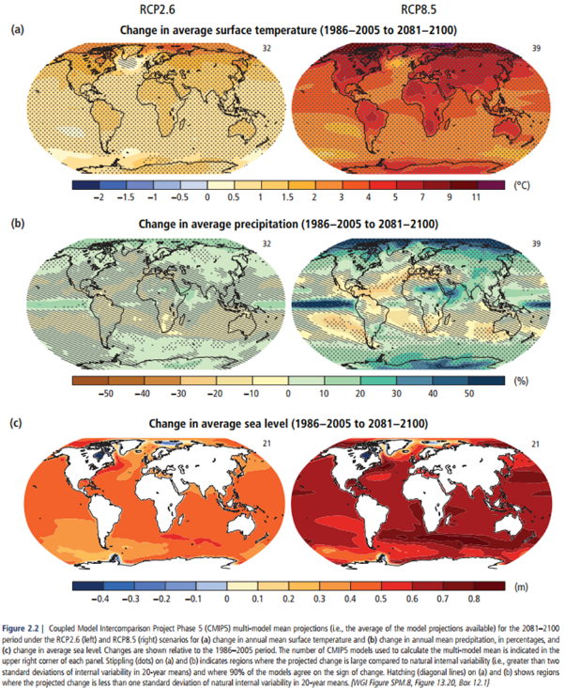
Source: IPCC 2014 AR5 Synthesis Report

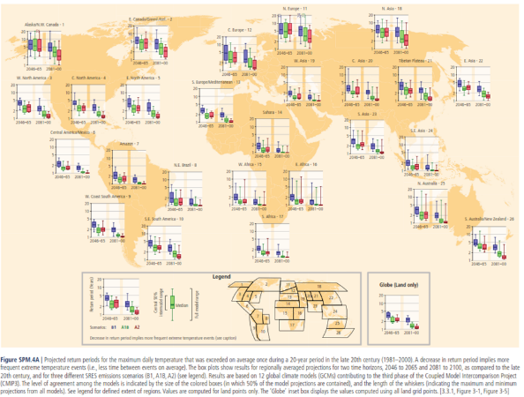
Source: IPCC 2012 SREX
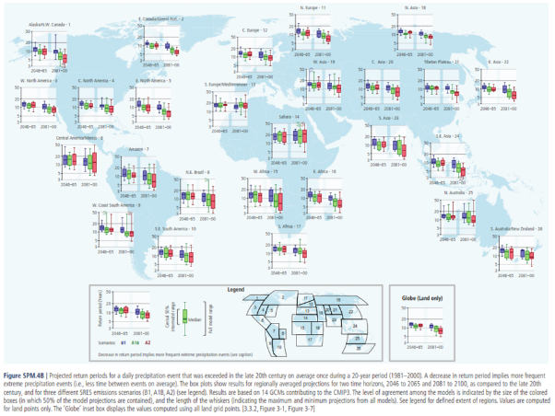
Source: IPCC 2012 SREX

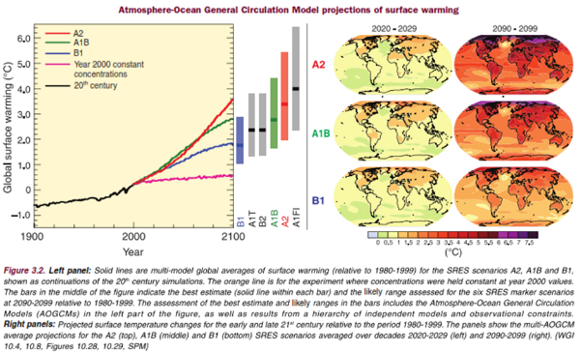
Source: IPCC 2007 AR4
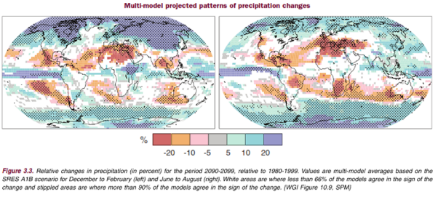
Source: IPCC 2007 AR4

Annex 3 Equations for Calculation the Adaptation Gap

The calculation of the adaptation gap used in this review was based on the following equations.

AGAP = (PL&D – ABEN) / PL&D

PL&D = BASE x MPL&D x ECC x M x CA

AB = EXP x BCR x ABS% x CB

Where

AGAP = the adaptation gap
PL&D = the potential L&D or economic impact, without adaptation, expressed as the reduction in the NPV of GDP growth path up to 2050
ABEN = adaptation benefits from expenditure, also expressed as the NPV of the benefits to 2050
BASE = a vector giving the base level for the pathway for the country (ie the GDP share of the sector affected or the level of assets affected)
MPL&D = a vector of the maximum PL&D for the pathway, as experienced by a country with the worst exposure to CC dimensions
ECC = a vector of the exposure index for the main CC dimensions for the country
M = a matrix of how each CC exposure index determines MPL&D
CA = a conversion factor that converts from impact of instantaneous change to 2050, which is how most empirical evidence is assessed, to impact on the NPV of GDP paths (typically between 2 and 4.5 depending on growth effects)
EXP = a vector of expenditure items (ie the disaggregated budget or actual accounts)
BCR = the expected level of average BCR, which could be the same for all expenditure items (as in this review) or differentiated by expenditure item, if evidence for this exists (eg from project appraisal reports
ABS% = a vector of the adaptation benefit share for each item of expenditure, which may be guided by a standard ABS% for different types of expenditure, as in this review, over-ridden where there is reason to suggest deviation of particular items from the standard
CB = a conversion factor that converts from the NPV of adaptation benefits for one dollar of expenditure in Y0 (as reported by BCR x ABS%) to the NPV of adaptation benefits to 2050, assuming the Y0 level of expenditure is maintained (typically about 10, assuming an equal annual benefit stream)

Countries that use programmes as a component of their budget structures often use the word in two different ways. A budget programme refers to a permanent classification level in the national budget, to which money is allocated. When used, the full expenditure of a ministry, department or agency is usually broken down into programmes. This classification often replaces the administrative department level in budget documents, or is parallel to it in multidimensional budget classification schemes. In the second use, a policy programme refers to a time-bound intervention within or across ministries linked to a specific policy priority for a government, e.g. industrial development programme. The financing for such a programme could come from different budget programmes, and it may consist of several projects.

