CLIMATE SCRUTINY

Estimating the Full Economic Impact of Climate Change

Practical Guide

Second Edition: May 2018

Contents
1 Introduction 1
2 Sources of Evidence 1
2.1 Agriculture 2
2.2 Forestry 3
2.3 Energy Sector 3
2.4 Infrastructure 4
2.5 Sea Level Rise 4
2.6 Labour Productivity and Health 4
2.7 Summary 5
3 Growth Between Now and 2050 5
3.1 Models of Instantaneous Change 6
3.2 The ‘Climate Brake’ Approach 6
3.3 CC Impact on Economic Growth 7
3.4 Climate Economic Growth Impact Model (CEGIM) 9
3.5 Comparing Approaches 11
4 Reducing FL&D 12
4.1 CC Strategies, Action Plans and Financing Frameworks 12
4.2 Climate Change Impact Appraisal 14
Bibliography 16

Acronyms

ABS Adaptation Benefit Share
BAU Business as Usual
BCR Benefit Cost Ratio
CC Climate Change
CCFF CC Financing Framework
CCIA CC Impact Assessment
CEGIM CC Economic Growth Impact Model
CPEIR Climate Public Expenditure and Institutional Review
DALY Disability Adjusted Life Year
FL&D Full L&D
GDP Gross Domestic Product
GHG Green House Gas
IMF International Monetary Fund
INDC Indicative NDC
IPCC Intergovernmental Panel on CC
L&D Loss and Damage
NDC National Determined Contribution (to the Paris Agreement)
NPV Net Present Value
RCP Representative Concentration Pathways
RMSM Revised Minimum Standard Model
SRES IPCC Special Report on Emissions Scenarios
SREX IPCC Special Report on Extreme Events
UNFCCC UN Framework Convention on CC
WDI World Development Indicators
WESS World Economic and Social Surve

Introduction
This guide aims to help policy makers and analysts to consider the likely full economic impact, or Full Loss and Damage (FL&D), of climate change (CC) in a location (ie a country, state, district or village). It aims to be useful at various levels, including the following circumstances.

- Finance and planning bodies are reviewing the full range actions in a location to determine the priorities that maximise the protection of the population from CC, and hence help guide the timing and allocation of resources to the actions. This will often happen in the context of a CC Financing Framework (CCFF).
- Line ministries or other sectoral agencies are reviewing priorities in their sectors. This will often happen in the context of a National Adaptation Plan (NAP).
- Designers and managers of actions are seeking to ensure that their actions are fully adjusted to the challenges and opportunities created by CC, in order to maximise the effectiveness of their actions and secure new or increased finance. This will involve CC Impact Appraisal (CCIA – see Box 4) of some sort and may happen in the context of the budget process and when preparing proposals for new project finance. It will also provide key management targets and for subsequent monitoring and evaluation.

CC policy and programmes aim to reduce full loss and damage (FL&D), either directly, by adapting to expected CC, or indirectly, by reducing greenhouse gas (GHG) emissions and, hence, contributing to the pooled global effort to reduce CC itself. CLIMATE SCRUTINY aims to be as rigorous as possible in estimating the reduction in FL&D. Because the first hurdle for many policy and programme managers is to obtain approval for new or increased funding, and because ministries of finance and funding agencies are often focused on economic growth, this guide focuses on the full economic loss and damage (FL&D). It is conceptually straightforward to expand this to include social development and environment, although there are tough practical challenges in doing so with the same rigour and credibility as for economic development.

Box 1 L&D, Economic L&D and Full L&D
The term loss and damage (L&D) is often used to refer to the direct costs of extreme climate events, like floods, droughts and storms. This is an important element of the full impact of climate change, but there are also wider impacts on sustainable development. The term economic loss and damage (FL&D) is used to refer to the full economic impact, including any implications for growth, and the term full loss and damage (FL&D) is used to refer to all the wider impacts of all dimensions of sustainable development, including economy, society and environment.

Sources of Evidence
Most CC projections provide information about conditions at mid Century (eg 2050) and in the long term (eg 2080 or 2100). As a result, the starting point of most analysis of impact is to consider the implications of moving instantaneously from current climate conditions to those in the future scenarios. This chapter reviews the evidence available, for each sector and sub-sector. The ‘typical L&D’ figures presented below refer to what would happen if there was an instantaneous move from current conditions to those projected for 2050. These are used to calibrate the modelling work referred to in section 3.

The results are presented in terms of the %GDP, rather than in absolute monetary terms, to assist with comparison between sectors and countries. Using %GDP also has the advantage of avoiding confusion about whether values are presented in in nominal terms (ie allowing for inflation, as is done in most fiscal analysis) or in real terms (ie excluding inflation, as is done in most economic analysis). Although a figure of 0.01% of GDP may seem small, the absolute values are large (eg $100m for larger middle income countries and $10m for least developed countries).

Agriculture
The economic impact on the agriculture sector is complex and often requires triangulation from several sources of evidence. Key sources of FFL&D include the following.

Flood and Drought in Agriculture. The narrow L&D from occasional floods and droughts can usually be estimated from evidence relating to area and the level of losses. However, government statistics are often collected by officials, who may not have the resources to investigate the full impact objectively and may also be constrained by pressures to avoid alarming the population with high estimates of L&D. Sometimes, evidence may also be available from insurance companies and/or government compensation schemes, but these tend to underestimate the full L&D because insurance coverage is usually limited and government schemes usually focus on the worst levels of L&D. Direct consultation with farmers can often provide valuable ground-truthing to statistical sources, although this can result in exaggeration of the claims of L&D. Triangulation of these sources is therefore required.

Typical CC-related L&D: 2-10% of agricultural GDP, depending on severity of flood/drought. This is the current level of L&D. The SREX findings can be used to show how this will be affected by CC (eg roughly doubling in S and SE Asia).

Average Temperature and Rainfall. In addition, loss in productivity can arise from changes in average temperature and rainfall. The impact of average temperatures and rainfall is often estimated using crop response models. There are many options for models, some of which require substantial time and finance to run and some of which are rapid and approximate. In general, the results are fairly consistent and the more sophisticated models are only justified when governments are wishing to refine the detailed design of programmes and the specific advice to be given to farmers. Other sources of evidence may include reports from research projects on crop response and research into regional differences (ie ‘Ricardian’ research). Consultation from farmers and experienced extensionists may also provide useful ground truthing of results.

Typical CC-related L&D: 5-10% of crop GDP, depending mainly on whether temperature is close to the maximum and/or the average rainfall is close to the minimum level for key crops.

Seasonality of Rainfall. This is often more important that average rainfall and than major flood and drought. It is also more difficult to obtain evidence. Consultation with farmers and experienced extensionists may also be valuable.

Typical CC-related L&D: 5-10% of crop GDP, depending on current variability.

Pest and Diseases. Losses from pest and disease attack are usually sensitive to CC and agricultural scientists will usually have information about the methods by which CC increases the risks of attack. The scale of the losses may be more difficult to assess, but there are some useful case study research papers that give some order of magnitude.

Typical CC-related L&D: 1% of crop GDP, depending on current vulnerability to pests and diseases.

Overall. One of the most powerful sources of evidence on FFL&D in the agriculture sector is the time series data on yields over recent decades. These typically show a general upward trend, but with substantial annual variations. A line drawn between the years with highest yields normally reveals an underlying upward trend of ‘potential yield’, reflecting technological programmes. For years with lower than the potential, the main cause of reduced yield is climate, including the four causes described above. The estimate may slightly underestimate the total losses because, even in the good years, some L&D is likely to be felt in certain regions.

Typical CC-related L&D: 10-15% of crop GDP. This estimate combines all the factors above and should be used as a validation estimate, triangulated with the other factors to check that overall estimates are roughly consistent with past experience.

Livestock. There is clear evidence that CC has a significant impact of livestock productivity, including on growth, fertility and disease threats. However, there is limited evidence on the scale of this impact.

Typical CC-related L&D: 5% of livestock GDP, indicative.

Fisheries. There is strong evidence that CC has a major impact of aquatic ecosystems, including both freshwater and marine fisheries. However, the nature of this impact, and the way in which ecosystems may adjust to produce different fisheries opportunities is very unclear. Whilst CC is happening, the productivity of fisheries is likely to be significantly affected.

Typical CC-related L&D: 10% of fisheries GDP, indicative.

Forestry
The impact of CC on forestry is similar to that for agriculture. If water is not a constraint, then a rise in temperature will usually cause an increase in physical productivity of the forest and some changes in species and ecosystems. The main L&D may well be associated with threats to biodiversity, not just of tree species, but also of all related fauna and flora. There are some methods for valuing loss of biodiversity which can allow this to be accommodated into FFL&D calculations, but these can be difficult to justify to ministries of finance and planning or to private investors (Pearce 2001).

Although the impact on forestry is difficult to quantify, forestry policies and projects do provide a very wide variety of benefits from reduced L&D in other sectors, notably by reducing risks from flood, soil erosion and siltation. But these forms of L&D are captured in other sectors.

Energy Sector
Higher temperatures involve increased losses from transmission and increased costs for cooling. Electricity generation and distribution is usually worth 1-3% of GDP. Losses during transmission are typically 20-25% and cooling costs typically amount to 1-5% of generation costs, depending on how water is valued. Surprisingly, there is little international evidence of the sensitivity of these losses to temperature. However, it seems likely that they could increase by as much as 10%. Assuming that these costs increase by 10% with CC the overall L&D is 0.012% (ie 1%x(22%+2%)x5%).

Typical CC-related L&D: 0.01% of GDP, indicative.

Hydropower. The impact of CC on hydropower is complex and depends on the nature of the precipitation regime. For hydropower plants that have limited storage capacity and rely on constant refilling of the reservoir, CC will reduce the output because more of the water coming into the reservoir is likely to be wasted when the reservoir is already full. For schemes that are already designed to accommodate highly seasonal rainfall, CC may make little difference, other than to increase the evaporation from the reservoir, which could reduce output by as much as 10%.

Typical CC-related L&D: 10% of hydropower value added, indicative.

Infrastructure
Roads. In countries that are highly vulnerable to flooding, road rehabilitation is much more expensive than average. The total value of the road infrastructure in most developing countries amounts to between 20 and 30% of GDP and average maintenance costs are between 1 and 2% of the asset value, depending largely on the frequency and severity of floods.

Typical CC-related L&D: 0.30% of GDP, indicative.

Industry and Urban Infrastructure. This varies greatly depending on the level of urbanisation and whether towns and cities are located in floodplains and/or low lying coastal areas that are vulnerable to storm surges and sea-level rise. The WB 2010 EACC international study suggested that the potential increase in L&D to infrastructure as a whole (including roads) could reach 1% of GDP in the most vulnerable countries, like Bangladesh.

Typical CC-related L&D: 0.00 - 0.30% of GDP, indicative.

The World Bank 2010 Economics of Adaptation to CC (EACC) reviewed evidence on the costs of CC using a narrow interpretation that focused on infrastructure costs. The study estimated average annual losses of up to 0.2% of GDP between 2010 and 2050 (World Bank 2010).

Sea Level Rise
The impact of sea level rise on storm surges and flooding is covered above. In addition, some countries can expect to have a significant economic impact arising from salinity associated with sea level rise. This will be on top of salinity effects from unsustainable use of groundwater, which are not directly related to CC, though they may be aggravated by CC. Estimates of flood/storm damage include the impact of sea level on increased frequency of storm surge. In Bangladesh, which is one of the countries most vulnerable to sea level rise, increased salinity associated with sea level rise is expected to affect 24% of agricultural land and to lead to yield reduction of 16% on this land. This will involve a reduction in GDP of 0.29%. Other countries will normally be much lower.

Typical CC-related L&D: 0.00 - 0.30% of GDP, indicative.

Labour Productivity and Health
Heat Induced Labour Productivity. There is increased evidence of the importance of heat stress for labour productivity and mortality. The IPCC Fifth Assessment Report suggested that labour productivity could decline by more than 20% in the last half of the century, for sectors most affected (IPCC 2014). A recent global review by UNDP suggested that, with the worst case IPCC CC scenario (ie RCP8.5, with a 3.7ºC rise), the more vulnerable tropical developing countries could see an average reduction in productivity across all sectors of more than 6% by 2055 (UNDP 2016), with impacts of 10% in heavy outdoor manual work, 5% in manual work and 1% in office work. The relationship between temperature and labour productivity is roughly linear.

Typical CC-related L&D: labour productivity may fall by 10% for sectors depending on heavy manual labour (eg agriculture and construction), 5% for sectors using light manual labour (eg industry) and 1% for office jobs (eg in services).

Climate Sensitive Diseases. The most important climate sensitive disease in most developing countries is Diarrhoea. Other climate sensitive diseases include malaria, dengue, some skin diseases and malnutrition, but these have a smaller overall impact. The combined DALYs lost from climate sensitive diseases typically amounts to about 10 per thousand people in developing countries. For most countries, the WHO provides statistics of the number of Disability Adjusted Life Years (DALYs) that are lost to the main types of diseases. DALYs are a good indicator of lost economic activity. Some of the lost activity happens in subsequent years, but activity is also reduced as a result of disease and mortality in previous years, so the DALY is a good approximation for the average annual impact. The normal convention is to value DALYs at three times the per capita GDP. There is limited evidence on the level of CC impact on climate sensitive diseases, but some research suggests that they may increase by 10% by 2050.

Typical CC-related L&D: 0.50 – 0.80% of GDP, depending on the existing disease burden.

Summary
Table 1 summarises the typical range of FFL&D, sector by sector, presenting the reduction in GDP that would happen if a country moved immediately from current climate conditions to those projected for 2050.

Table 1 Typical Ranges of Sectoral Loss and Damage
Source of Loss and Damage | Reduced GDP growth 2050
Reduced agricultural yields from average temperature and rainfall | 0.50 – 1.00%
L&D to crops from flood, drought and variable rainfall | 0.30 – 0.80%
Crop losses from pest and disease, sensitive to erratic climate | 0.05 – 0.10%
Reduced livestock productivity, mainly from temperature | 0.10 – 0.30%
Reduced forestry and fisheries productivity | 0.05 – 0.10%
Higher losses in the energy sector | 0.01 – 0.02%
Urban flood damage and higher reconstruction costs in infrastructure | 0.05 – 1.00%
Sea level rise and impact of salinity on crops and water supply | 0.00 – 0.30%
Health impacts | 0.50 – 1.00%
Total impact | 1.60 – 4.60%

Growth Between Now and 2050
Chapter 2 referred to what happens if a location moves instantaneously from current climatic conditions to those projected for the future (eg 2050). This is the easiest way of exploring the size of the potential FL&D and some of the non-economic analysis in the literature refers to instantaneous change (see 3.1). However, this is not the whole story and it is also necessary to consider what happens in-between now and, say, 2050. This is explored in a range of models of economic growth, (see 3.2 and 3.3).

Whatever approach is taken to reporting on FL&D, it is clearly extremely important that the results are reported in a way that explains exactly what the headline figures refer to. Simply stating ‘GDP is x% lower’ is ambiguous and, in fact, useless to policy makers. The reports need to make clear whether the figure refers to absolute GDP in 2050, GDP growth or the sum (or NPV of the sum) of GDP over a period. And they need to provide a description of the basic principles of the analysis, that is intelligible to a non-expert. This is rarely done.

Models of Instantaneous Change
The sectoral evidence presented in chapter 2 reviewed what would happen if the situation moved instantaneously from current conditions to those projected for 2050. There are a range of models, or approaches, that aggregate this sectoral evidence to produce estimates of the impact on the whole economy.

More complex models, especially in the agricultural sector, include the Decision Support System for Agrotechnology Transfer (DSSAT) model (Jones, Hoogenboom et al. 2003) and the International Benchmark Sites Network for Agrotechnology Transfer (IBSNAT) model (Parry 2007), which are based on a detailed crop response simulations. The International Food Policy Research Institute (IFPRI) IMPACT model includes the DSSAT crop model, a hydrological model and an economic model (Nelson, Rosegrant et al. 2010). Another example of a complex simulation model that focuses on understanding the details of instantaneous change is the FAO’s Modelling System for Agricultural Impacts of Climate Change (MOSAICC) which also includes climate, crop, hydrology and economic modelling (FAO undated).

Most of the models focus on the natural resource sectors and then aim to pick up the wider economic implications of change in these sectors. The economic element of these simulation models typically uses equilibrium analysis, which may be a partial equilibrium (in the case of IMPACT) or computable general equilibrium (CGE) approach. Some modelling work reports using dynamic CGE models that allow growth to be estimated within the models (see 3.3).

Another strand of model that deals with instantaneous change is Ricardian techniques that use geographical differences as a proxy for changes over time (Seo and Mendelsohn 2007, Passel, Massette et al. 2012). These have the advantage of having the potential to pick up all the varied factors that may causes changes, including adaptation to different climate conditions. However, they need to be used carefully, because geographical differences are affected by many ‘confounding factors’ other than climate (eg social, political and economic circumstances) and these need to be isolated from the analysis.

The ‘Climate Brake’ Approach
Most work on CC Financing Frameworks (CCFFs) has used a ‘climate brake’ approach. This starts from the evidence from instantaneous change, to say 2050, and assumes that the severity of the impact in the intervening years grows gradually. Thus, it assumes that the increase in temperature that is projected for 2050 (and the associated implications for rainfall) happens in a linear fashion, in equal annual increments. A few CC models do provide time paths for CC, which would, in theory, present discontinuities (eg related to changes in ocean currents and/or glacial melt). But the evidence for such discontinuities is usually limited and the assumption of linear change seems reasonable. There will continue to be annual variations (which are likely to increase in most locations and are impossible to predict) but the trend average can be assumed to be linear.

The analysis assumes that the FL&D reduces GDP and that this reduced GDP is then the base for growth in the following year. The impact of CC is therefore gradually increasing, but is cumulative. The FL&D is therefore seen as a brake on economic growth, not as an occasional hit after extreme events, after which the economy returns to it’s normal target growth path.

The climate brake approach implies that existing climate challenges already act as a break on the potential growth that would be achieved if climate conditions were perfect in every year. In many S and SE Asian countries, recent economic growth has been about 5%, despite average annual FL&D of about 2%, over recent decades. This suggests a potential growth rate of 7%, if climate conditions were ideal in every year. The evidence from comparative static analysis typically suggests that the climate brake will reduce growth by a further 2-5% by 2050 and this is assumed to happen gradually over the period.

Using the climate brake approach produces much higher CC impact and most CCFFs have found that the reduction in growth rate gradually rising to between 3% and 5% by 2050 (as illustrated in chapter 2), resulting in absolute GDP in 2050 that is 30% to 50% lower. The total GDP over the period is 20% to 30% lower and the NPV of GDP over the period is 15% to 20% lower, using a 5% discount rate.

CC Impact on Economic Growth
The IPCC 2001 Third Assessment Report (AR3) reviewed the state of CC economic modelling, which suggested that global GDP would be 1-2% lower for a 2ºC rise in temperature. The IPCC 2007 AR4 confirmed this evidence, drawing on the Stern Review, and extended the conclusion to be 1-5% for temperatures with a temperature change of 4ºC and these estimates are repeated in AR5. These conclusions refer to the results of economic models that are based on neoclassical economic growth theory (see Box 2). They mostly report on the difference in the Net Present Value (NPV) of different growth paths.

Neoclassical growth models calculate how resources are allocated by households and enterprises, by maximise welfare over a period. At the heart of all these models are three key relationships.

The production function: GDP is a function of capital stock, labour and FL&D
Investment: capital stock is the previous year’s stock less depreciation plus investment
The damage function: FL&D is a function of various climate indicators

Each model introduces different forms and features to these relationship and adds further details to reflect important changes in the economy and in the damage function. For example: the production function usually uses a ‘Cobb-Douglas’ function that is considered more realistic than linear relationships (and is also easier to treat in mathematical optimisation theory); the savings rate may be determined by a range of factors, such as per capita income; and the damage function may take account of key bio-physical thresholds and discontinuities.

Box 2 Neoclassical Economic Growth Theory
Most theories of economic growth are based on a neoclassical approach, which assumes that actors pursue rational behaviour in search of optimum utility and that markets adjust to allow producers and consumers to achieve this optimum through adjustments to supply and demand. Theories are based on defining and estimating the relationship between output and the two main factors of production, capital (both financial and human) and labour. The following theories are the key building blocks of neoclassical growth theories and there have been a huge variety of more sophisticated models based on these foundations. The validity of each model is generally tested through statistical analysis.

The Harrod-Domar model was developed in the 1930s, following the pioneering work by Keynes. Growth is a function of capital stock, which is determined by the existing stock plus investment less depreciation. Investment is given by savings, which is given by assumed savings rate, which may be constant or change over time. Many subsequent growth models build on the Harrod-Domar foundation and provide further elaboration on the behaviour of investment, savings and the production function.

The Lewis Dual Sector model was developed in the 1950s and recognised that growth involved changes in economic structure, which the model illustrated by two sectors. The growth theory is similar to the Harrod-Domar model, but the model suggests that the increased productivity of labour and capital in modern sectors would lead to differential sectoral growth.

The Solow-Swan model was developed in the 1950s and extends the Harrod-Domar model by using a more sophisticated relationship between capital and growth that incorporates changes in the productivity of both capital and labour. One of its most useful features was that the production function (ie linking output to capital and labour) could be calibrated by evidence from changes in productivity, which therefore connected macro and micro economic theory.

The Ramsey-Cass-Koopmans model evolved between 1928 and the 1960s and was similar to other neoclassical models in being based on a production function that relates growth to the key factors of production. One of the key advances in this model was that the savings rate (and hence the investment rate) was based on a model of how households make trade-off decisions between current and future consumption.

PAGE. One of the most widely used growth model is the Policy Analysis for the Greenhouse Effect (PAGE) model. There have been various versions, including one in 2002 and a significant update in 2009 (Hope 2011). The model is run on a spreadsheet that defines 8 world regions and includes weights to allow some regions to be more vulnerable. It uses 10 time periods, up to the year 2200. It models the projections for 6 greenhouse gases (GHG) and how these affect temperature. The damage function recognises that damage starts only above a certain tolerable plateau and also takes sea level rise into account. The model includes mitigation policies, which reduce GHG by assuming a Marginal Abatement Cost Curve. It also includes adaptation policies which are modelled by assuming their impact on the standard temperature level. The calibration of the damage function and of policy effectiveness is clearly critical and this is often not reported in a transparent manner, making it difficult to adapt the model to be used in particular locations, without specialist expertise.

PAGE was used by in the Stern Review and was calibrated using insurance data and other sources (Stern 2006). The Stern Review concluded that the NPV of global GDP would be about 5% lower than without CC, which was considerably higher than previous modelling had suggested. In an influential critique of the Stern Review, Nordhaus argued that these results were determined largely by the fact that Stern argued for a very low discount rate (Nordhaus 2007).

PAGE was also used in the ADBs 2009 SE Asia Review and 2014 S Asia Review (ADB 2009, Ahmed and Suphachalasai 2014), which concluded that, in SE Asia, GDP would be up to 6.7% lower and, in S Asia, it would be at least 1.8% lower. The ADB papers are not explicit about how they calibrated PAGE, though they refer to the expected FL&D arising from instantaneous change in key sectors.

In both the Stern Review and the ADB analysis, the results are reported in a very ambiguous way without making it clear that they refer to the NPV of different growth paths. The language simply reports the headline figure and assumes that readers know that this refers to the NPV of growth paths. In the case of Stern, the situation is further confused by reporting the FL&D as applying ‘each year, now and forever’.

DICE and RICE. The Dynamic Integrated Climate and Economy (DICE) model and the Regional Integrated Climate and Economy (RICE) model are based on a neoclassical growth model in which growth is determined by capital (financial and natural), labour and energy (both carbon and non-carbon) (Nordhaus and Boyer 2000). The impact of CC is determined by a damage function that links GDP loss to temperature for 5 types of damage: agriculture, sea-level rise, health, non-market damage and catastrophic damage. The models have been used mainly to assess the optimal rate of spending on mitigation and mainly in developed countries. Results are reported in terms of the impact of GDP in the year at which a specified temperature is achieved. Results for the global analysis suggest damage of only 1.5% of GDP in the year when a 2.5ºC rise occurs. The highest FL&D estimates are for India (4.9%) and Africa (3.9%), but these are still very low figures, compared to the potential change in GDP arising from economic growth, which is likely to involve an increase in GDP of at least 300%.

FUND. The Climate Framework for Uncertainty, Negotiation and Distribution (FUND) model was used in early analysis of CC impact and had the benefits of including per capita income in the damage function. The calibration of the damage function was referred to by the author as relying largely on ‘informed guesses’, but there has subsequently been a growing body of evidence on the impact of CC on key sectors (Tol 2002). The FUND model does have the capacity to consider change over time, but this is achieved not by considering the impact on economic growth but simply by considering how temperature increases may initially increase production (especially in agriculture in cooler countries) and then then lead to declines after thresholds are reached.

Climate Economic Growth Impact Model (CEGIM)
Growth theory models have a long pedigree and have been subjected to extensive testing and debate. Dietz and Stern provide a useful review the way growth is treated in analysing the economic impact of CC (Dietz and Stern 2015). Although both PAGE and DICE have both been designed to be relatively simple and accessible, they still require some specialist expertise and have not been used by non-modellers in rapid applied policy work. In particular, it is difficult to adjust the damage function to reflect the latest evidence in each location.

CEGIM. A simpler version is required for applied policy work and this section describes a Climate Economic Growth Impact Model (CEGIM) that aims to reflect the essence of growth models in a framework that simple enough to relate directly to the applied local evidence of sectoral FL&D and to be managed in a very simple spreadsheet that can be set up and adapted transparently without any modelling expertise.

The CEGIM distils the various CC growth models to their key relationships as follows.

A Production GDP = f(aK, bL, D_{Y}) a = capital productivity
K = capital assets
b = labour productivity
L = labour supply, linked to employment and popution
D_{Y} = income loss (expressed as % of GDP)
B Capital K_{t} = K_{t-1} (1 - d + i) – D_{K} d = depreciation
i = investment, linked to savings and capital markets
D_{K} = damage to assets (expressed in value, eg USD)
C Labour b_{t} = b₀ (1 – D_{L}) D_{L} = effect of heat stress on b (expressed as % drop)

Figure 1 Diagrammatic Summary of Typical CEGIM
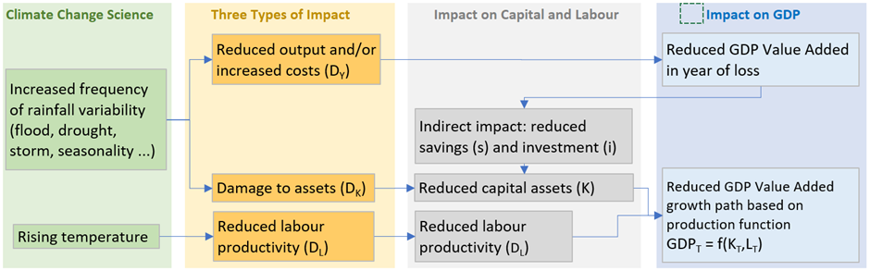Source: Cambodia CEGIM Report (2018)

Full Loss and Damage. The evidence for the three types of FL&D comes from the sources described in chapter 2. Loss of income (D_{Y}) reduces GDP in one year, but does not affect future years, except through the indirect effects of reduced investment in the year. Loss of labour productivity (D_{L}) results in declining labour productivity which has a gradually increasing impact on output. Damage to capital assets (D_{K}) reduces the stock of assets permanently and hence shifts the growth path downward. In addition to these three direct types of FL&D, any reduction in GDP in one year results in a reduction in savings and investment which gives a permanent reduction in the growth path. The severity of the three types of FL&D can be related to the CC scenario to allow for the sensitivity of results to CC scenarios to be explored.

Calibration. CEGIM often uses a ‘Cobb-Douglas’ production function (ie GDP = aK bL (1-D_{Y})) but it may also use a linear relationship (ie GDP = (aK + bL)(1-D_{Y})), which can be more stable for the outer years of long term projections. The analysis is normally done with some sectoral disaggregation of GDP to capture the implications of changing sectoral balance in the economy. Often this works best at a relatively high level (eg agriculture, industry and services) which keeps the analysis simple and makes the calibration more reliable, especially if data is limited. An estimate of past capital assets is required and this can be done using a ‘perpetual inventory’ method, which applies equation B above historically. This requires data on sectoral investment, which can be problematic in some countries, although some evidence can often be obtained from formal financial sector investment. National evidence on typical depreciation rates per sector is rare, but this can be based on international sources. The data for past labour supply can come from employment statistics, if these are available, or from population data, including age structure, with assumptions for employment rates.

Figure 2 describes a simple version of the CEGIM, using a 7 line spreadsheet and no sectoral disaggreation. The example is for a country that is expected to grow at 5% without CC. FL&D is expected to grow to 3.5% of GDP over the next 35 years. Half the FL&D will reduce incomes and half will reduce capital, either through reduced investment (ie squeezed savings) or increased depreciation (ie direct damage). The net effect is to reduce growth to 3.7% by Y35. Depending on the assumption for c, the Y35 growth rate varies from 2.7% to 4.6%.

Figure 2 A Simplified CEGIM Spreadsheet
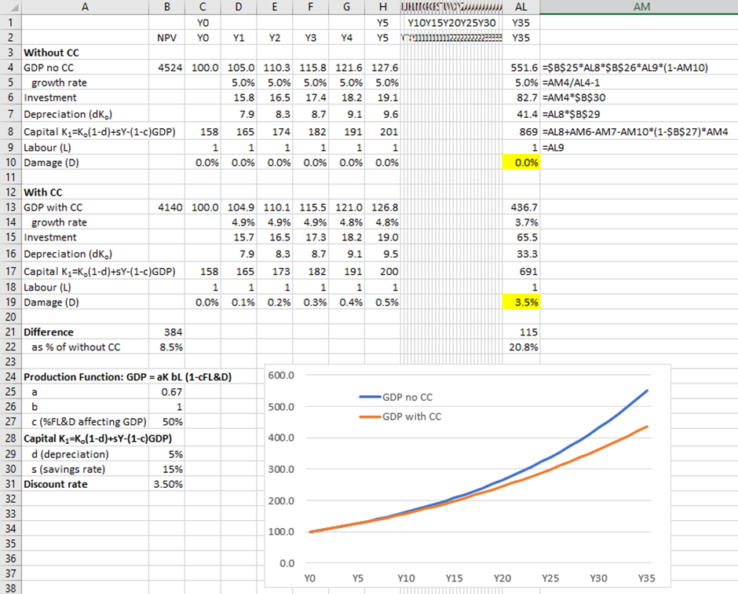

The CEGIM approach is similar in style to the Revised Minimum Standard Model (RMSM) used by the WB in the 1980s and 90s, although without any consideration of CC. RMSM formed the basis of the routine economic assessments for member countries. Growth was proportional to investment in the previous year (typically in a linear relationship, calibrated by reference to Incremental Capital Output Ratios or ICORs) and the model was used to check that target growth rates were viable, given the likely availability of investment (including from the World Bank) and the wider economic situation (eg in balance of payments and monetary accounts). Although RMSM is no longer used as a matter of routine, the IMF financial programming approach retains the same elements of the approach and is used to check that growth and investment are consistent. This suggests that, whilst CEGIM is no replacement for the more sophisticated models, especially in the long term, when linear relationships will not hold, it should provide a useful tool for applied CC policy analysis.

Comparing Approaches
Figure 3 describes five results produced using different approaches and illustrates how different the results are. From higher to lower growth, the lines describe the following approaches.

- The black line shows a baseline with 5% growth a year through the period.
- The solid orange line is the situation if it is assumed that absolute GDP in Y35 is 5% lower than without CC, which is typical of results from analysis of instantaneous change.
- The third (dash/dot) line shows the GDP growth path if the NPV of GDP over the period is 5% lower. This is similar to the conclusions reach by the Stern Report.
- The fourth and fifth lines show the conclusion from the CEGIM analysis (also called Distilled Growth Analysis), with 50% and 100% of FL&D affecting capital/assets, rather than incomes.
- Finally, the dotted line describes the situation of FL&D is assumed to act as a climate brake and is similar to the results reported in CCFF work.

Figure 3 Results Typically Reported Using Different Methods
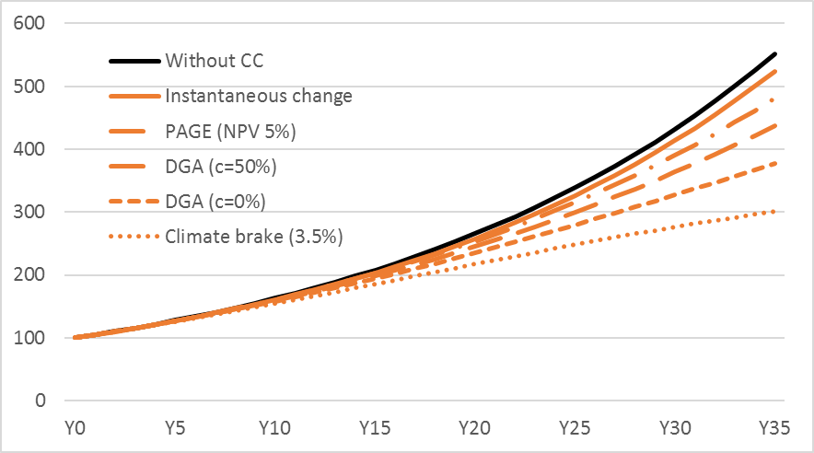

Reducing FL&D
This chapter reviews the way in which an understanding of the extent and nature of L&D provides the foundation for CC Financing Frameworks and for the use of CC Impact Appraisal, as tools for providing a balanced response to CC that makes the most effective use of limited resources.

CC Strategies, Action Plans and Financing Frameworks
Most countries now have CC strategies that cover both mitigation and adaptation and most of these strategies are supporting by action plans. These have often included National Adaptation Programmes of Action (NAPAs) and Nationally Appropriate Mitigation Actions (NAMAs), which have now been supplemented (or superseded) by National Determined Contribution (NDCs) under the 2015 Paris Agreement. These strategies and action plans reveal that most CC related expenditure is predominantly development expenditure that becomes more important when CC is taken into account. To understand better the relationship between development and CC expenditure, many countries have prepared Climate Public Expenditure and Institutional Reviews (CPEIRs), to assess the existing CC effort, and are working on National Adaptation Plans (NAPs), which integrate CC into the planning process.

In addition to the above initiatives, several countries and states in S and SE Asia have been working on CC Financing Frameworks (CCFFs). Some related work has also been happening in Africa. The UNDP recently produced a review of this work (UNDP 2016) which shows the common elements and the diversity of focus and approach. A comprehensive CCFF contains the following components:

- estimates of the potential FL&D
- recent climate expenditure trends (ie CPEIR)
- scenarios of future climate expenditure
- analysis of the effectiveness of climate expenditure (CCIA – see below)
- estimates of the extent to which expenditure scenarios will reduce the potential FL&D and, hence, of the Adaptation Gap

The starting point for this CCFF work is to estimate the potential FL&D that is likely to occur if there is no adaptation. Figure 4 presents the first estimates of potential FL&D in four countries, using the climate brake method (see 3.2 above).

Figure 4 Estimates of FL&D in CC Financing Frameworks
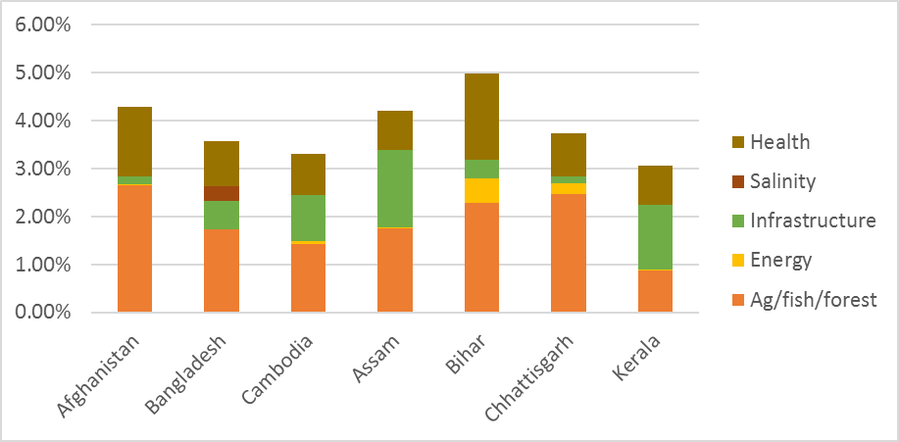
Sources: CCFF reports produced either by governments or by Action on Climate Today

Although CCFF work typically focuses on selected components, most concludes with a headline estimate of the adaptation gap, using a figures similar to those in Figure 5. The adaptation gap is defined as the extent to which potential FL&D is not addressed by expenditure scenarios. This is slightly different to the approach taken in the UNEP Adaptation Gap reports (see Box 3). Understanding the extent and nature of FL&D is therefore the foundation of CCFF work.

Figure 5 Growth Paths with and without Climate Change
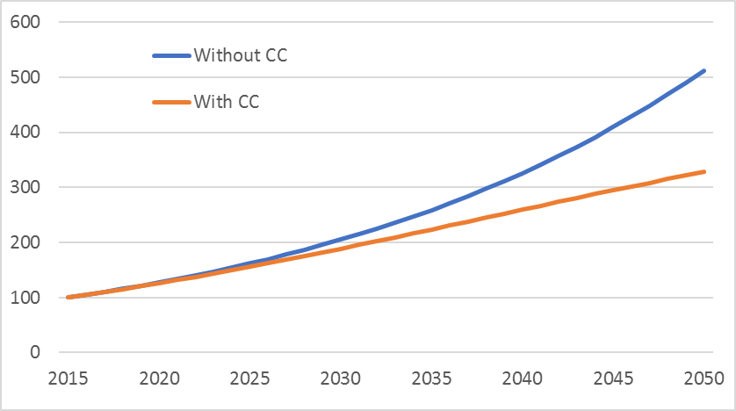

Most CCFF work identifies strategies for reducing FL&D, and so closing the adaptation gap, which typically cover a combination of the options described in Table 2. Having a clear and consistent methodology for estimating FL&D, with about without alternative policies, is at the heart of defining and managing a coherent strategy for closing the adaptation gap.

Table 2 Typical Features of a Strategy to Reduce FL&D
Strategy | Fiscal Cost
Ensure all existing expenditure optimised for reducing FL&D | None
Shift resources to actions that provide best reduction in FL&D | None
Some increase in total spending on actions that reduce FL&D | Mid
Use of national climate change funds and schemes | Low
Access international support for CC | Low
Switch to incentives/regulations to engage private sector in reducing FL&D | Low
Awareness raising for wider public involvement | Low

Box 3 Definitions of the Adaptation Gap
UNEP have produced Adaptation Gap Reports for 2014 and 2016. UNEP estimate the gap by comparing the current level of funding with a level of funding that will deliver a nationally determined target level of adaptation that takes into account the impact of CC and the ability of a country to fund adaptation. Key differences and similarities between the UNEP and CCFF definitions of the adaptation gap are as follows.

- Both approaches rely on estimates of L&D and refer to international sources, such as the UNDP Investment and Financial Flows approach, the World Bank Economics of Adaptation to CC work and the various modelling work, such as that done for the Stern Review and in two influential ADB studies on the economic impact of CC in S and SE Asia. In the UNEP approach, the distinction between L&D avoided and the adaptation expenditure is not always clear.
- The CCFF gap is based on reduction in L&D whilst the UNEP gap is based on expenditure. The two approaches are closely related, since expenditure should lead directly to reduced L&D. The CCFF approach requires explicit estimates of the effectiveness of adaptation expenditure in reducing L&D, which then guide the integrated of CC into planning and budgeting.
- Both approaches accept that full avoidance of all potential L&D is not achievable. The UNEP approach requires an explicit definition of what is achievable and then focuses on achieving that, whilst the CCFF approach allows the boundaries of what is achievable to be explored as part of the CCFF work.
- The UNEP approach uses only the total value of adaptation finance, based on OECD and CPI work. It does not consider variations in the degree of CC relevance of adaptation expenditure. In contrast, the CCFF work focuses on the degree of CC relevance and the way in which this is linked to effectiveness in reducing L&D.

Climate Change Impact Appraisal
The primary purpose for understanding FL&D is to inform policies, programmes and projects that respond to reduce the FL&D, either directly through adaptation, or indirectly through mitigation and, hence, by contributing to the globally pooled reduction in CC itself. This work is often referred to as CC Impact Appraisal (CCIA). CCFF work aims to generate the demand for CCIA from ministries of finance and planning as well as the supply of CCIA from line ministries. The NAP process also focuses on improving CCIA in line ministries.

In theory, CCIA tries to ensure that the resources allocated to policies, programmes and projects are roughly proportional to the reduction in FL&D that they are expected to generate. For large expenditure that is sensitive to CC, this would normally involve adding climate sensitive dimensions to an existing extended Cost Benefit Analysis (eCBA). For smaller and/or less sensitive initiatives, there are options for undertaking more rapid and qualitative CCIA. ACT and UNDP have recently produced CCIA Guidelines.

CEGIM has not yet been used in CCIA work. However, the insights provided by CEGIM should help to focus CCIA work on the nature of the FL&D that is being reduced and, specifically, on whether it is likely to lead just to reduced incomes, or to reduced capital (through lower investment or higher depreciation), which has more serious longer term economic consequences.

Box 4 Climate Change Impact Appraisal
CCIA draws on the standard approaches to Policy Impact Appraisal (PIA). The analysis must be clear about the situation with and without the action (ie policy, programme or project). It should consider a number of options and/or scales to explore the sensitivity of the results. It should be conservative add avoid exaggerating benefits. In addition to these standard PIA principles, CCIA must explain the implications of CC for effectiveness. It does this by estimating the net benefits without CC (say A) and then when CC is taken into account (say B). CCIA then defines the CC% as a standard measure of CC sensitivity (or CC relevance), defined as CC% = (B-A)/B.

Practical CCIA work can be done with varying levels of detail.

- Screening, to determine what level of CCIA is warranted, if any (1 minute/action)
- Classification, for broad reviews, such as CPEIRs and CCFFs (2-5 mins/action)
- Qualitative CCIA, giving a structured assessment mainly by experts (1 hour/action)
- Hybrid CCIA, using a mix of qualitative and Cost Benefit Analysis (CBA) (1 day/action)
- Full CCIA adapts extended CBA, normally for large programmes (1 week/action)

More details are available in the CLIMATE SCRUTINY Guide to CCIA.

Bibliography

ADB (2009). "The Economics of Climate Change in Southeast Asia: A Regional Review."
Ahmed, M. and S. Suphachalasai (2014). "Assessing the Costs of Climate Change and Adaptation in South Asia."
Dietz, S. and N. Stern (2015). "Endogenous Growth, Covexity of Damage and Climate Risk: how Nordaus' Framework Supports Deep Cuts in Carbon Emissions."
FAO (undated). "The Modelling System for Agricultural Impacts of Climate Change."
Hope, C. (2011). "The PAGE09 Integrated Assessment Model: a Technical Description."
IPCC (2014). "Fifth Assessment Report: Summary for Policy Makers."
Jones, J. W., G. Hoogenboom, C. H. Porter, K. J. Boote, W. D. Batchelor, L. A. Hunt, P. W. Wilkens, U. Singh, A. J. Gijsman and J. T. Ritchie (2003). "The DSSAT cropping system model." European Journal of Agronomy 18(3-4): 235-265.
Nelson, G. C., M. W. Rosegrant, A. Palazzo, I. Gray, C. Ingersoll, R. Robertson, S. Tokgoz, T. Zhu, T. B. Sulser, C. Ringler, S. Msangi and L. You (2010). "Food Security, Farming and Climate Change to 2050: scanarios, results, policy options."
Nordhaus, W. and J. Boyer (2000). "Warming the World: Economic Models of Global Warming."
Nordhaus, W. D. (2007). A Review of the Stern Review on the Economics of Climate Change. Journal of Economic Literature. Vol. XLV (September 2007), pp. 686–702.
Parry, M. (2007). "The Implications of Climate Change for Crop Yields, Global Food Supply and Risk of Hunger." INCRISAT Open Access Journal.
Passel, S. V., E. Massette and R. Mendelsohn (2012). "A Ricardian Analysis of the Impact of Climate Change on European Agriculture." Fondazione Eni Enrico Mattei: Nota de Lavoro.
Pearce, D. W. (2001). The Economic Value of Forest Ecosystems.
Seo, N. and R. Mendelsohn (2007). "A Ricardian Analysis of the Impact of Climate Change on Latin American Farms." World Bank Policy Research Working Paper 4163, March 2007.
Stern, N. (2006). Stern Review on The Economics of Climate Change.
Tol, R. (2002). "Estimates of the Damage Costs of Climate Change."
UNDP (2016). "Climate Change and Labour: Impacts of Heat on the Workplace."
World Bank (2010). "Economics of Adjustment to Climate Change."

The IPCC’s Fifth Assessment Report uses four main CC scenarios: RPC8.5, RCP6.0, RCP4.5 and RCP2.6. RCP8.5 is considered the worst case scenario, with little mitigation, and has an increase in global mean temperature of 2.0ºC +/-30% by 2050. The RCP2.6 scenario reflects the best case target of the Paris Agreement and has a rise in temperature of 1.0 +/-60% by 2050. The other two scenarios are intermediate, with the change and range roughly proportional to the pathway concentration numbers. Projects from 2050 to 2100 are roughly linear.

