CLIMATE CHANGE IMPACT APPRAISAL

MANUAL

Introduction
There is growing evidence that climate change (CC) will reduce economic growth by at least 1% by 2050 in most countries and by as much as 5% in the more vulnerable countries, most of which are found in the tropics, where natural resources and people are existing near the upper thresholds of temperature tolerance and where rainfall patterns are likely to become much more variable, with more frequent and severe floods and droughts and less predictable seasons. This reduce economic growth leads to broad losses and damage (L&D) that accumulates through the period as described in the Climate Scrutiny Guide to Estimating Full Loss and Damage (FL&D).

Adaptation actions (including policies, programmes and projects) aim to reduce the FL&D directly by protecting people and ecosystems from CC risks. Mitigation actions also reduce FL&D, but only directly after contributing to the pooled global slowing of CC itself. This guide describes how to use CC Impact Appraisal (CCIA) to estimate the extent to which adaptation and mitigation actions reduce FL&D. The various techniques share a number of common principles that distinguish CCIA from other forms of impact appraisal that do not focus on CC.

The guide aims to be useful for the following purposes.

- Helping private enterprises to assess how CC will affect their suppliers, their customer and their operations and, hence, their profitability
- Helping government departments design and evaluation their actions and so improving their chances of obtaining funding, in the budget or from other funds
- Helping ministries in charge of planning and finance, and fund managers, to select the highest priority actions to fund
- Providing one of the key building blocks to enable national and local governments to assess what proportion of the CC challenge they are likely to address

CCIA is one of a range of impact assessment tools and needs to be used in conjunction with the other tools to provide enterprises and governments with the full evidence needed to allocate resources efficiently.

Principles

The Counterfactual (ie Without the Action)
Adaptation and mitigation actions do not operate in a vacuum and natural resources would be used in other ways, if the action were not undertaken, and people would be engaged in other activities. It is therefore critical to define what would happen without the action and to claim for the action only the changes in moving from the counterfactual.

CCIA is like any other impact appraisal work in that it is critical to be clear about what would happen if the action did not happen. This needs to be defined in order to be sure that the changes are desirable for all actors involved. CCIA also needs to define not only the attractiveness of alternative uses but also how CC affects this attractiveness. Examples include the following.

- Land will always be used for another purpose, even it is an extensive purpose like grazing or firewood collection. Although the net benefits of these activities per hectare may be low, they may provide high net benefits per person which is what will determine whether people are interested in changing activities and how CC affects these incentives.
- Forests may be cleared and replanted without a CC action. This often produces higher financial gains and CC actions aim to show why the additional benefits of protection or community forestry (eg in watershed benefits or biodiversity) are sufficient to persuade people to stop clear-felling and how CC affects this.
- CC actions may provide improved incomes for households and CCIA should attempt to assess the importance of this and how CC will affect the improved incomes. It is sometimes tempting to treat all this income as a net benefit, but even in the poorest households, people are usually at least partially busy with other activities, even if they do not earn incomes from them and these existing activities need to be respected and only the increase in the value of their activity can be claimed for the action.

The Climate Change Story
CC Science. CCIA usually reviews all the information available from global and downscaled CC models and compares this with the evidence available from recent trends. In most cases, these two sources are roughly consistent, although there may be exceptions, especially in hilly areas with local weather patterns. CCIA would normally define two CC scenarios based on a triangulation of available evidence. At a minimum, these would include estimates of changes in:

- average temperature, which is particularly important for health
- average rainfall, which affects natural resource productivity
- rainfall variability, which has wide affects for many sectors affected by flood, drought and changing seasonality and predictability of rainfall
- sea level rise, for costal areas

In many cases, downscaled CC models are either not available or produce uncertain results, especially relating to rainfall variability. The global CC modelling results reported in IPCC reports are a good starting point, include the Assessment Reports (for average temperature, rainfall and sea level rise) and the Special Report on Extreme Events (for rainfall variability).

In countries that are new to CCIA, it can be useful to define CC scenarios is broad terms. For example, in wetter tropical countries, a typical baselines scenario for 2050 would involve an increase in temperature of 2ºC, little change in average rainfall, a doubling in the frequency of both floods and droughts and a sea level rise of 1m. Clearly, the results of the CCIA are strongly affected by these assumptions, so they should be adjusted with any more detailed information that may be available.

Physical Impact of CC Scenarios. CCIA will need to have some indication of the impact of the scenarios for changes in key climate variables. Key examples of bio-physical impact pathways include the following.

- Higher temperatures normally reduce crop yields because farmers normally choose crops that are designed to optimise current conditions. Farmers will moderate this impact by changing crops, but this usually (but not always) involves a loss in value.
- More frequent floods and droughts result in higher agricultural losses and more damage to infrastructure, which requires more rehabilitation expenditure.
- More frequent floods and droughts also have a major impact on the reliability and safety of water supplies and the cost of maintaining sanitation standards
- Increased temperatures lead to increased disease threats and reduced labour productivity.

Evidence on these impact pathways is still patchy, but there is a growing body of studies that estimate the physical impact of CC. Sometimes, CCIA may have to draw on international evidence, perhaps adjusted to local conditions through discussion with experts familiar with the local area.

Proofing. The CC story can affect both benefits and costs. Some of the CC story may be affected by whether CC proofing is included in the programme. The CC proofing may be an integral part of a programme, but, if it is an optional addition then it can be useful to perform CCIA with and without proofing, to test the viability of the proofing itself and, potentially, the optimal level of proofing.

CC Relevance (CC%)
The CC story leads to an assessment of the net benefits of an action with CC and without CC and this provides a single common metric of CC relevance which can applied for all types of CC action, including adaptation and mitigation. This is done using the following definition …

CC% = (B-A)/B, where B = net benefits with CC and A = net benefits without

If the CC% were defined as (B-A)/A, then it would give the % increase in benefits arising from CC, which would be a more intuitive way of measuring CC relevance. However, this would create complications with actions that are wholly dedicated to CC (eg CC studies and capacity building), which would then have a CC% of infinity, because A would be 0.

In a country where the main CC impacts are related to rainfall variability (ie floods, drought and seasonality) and where these become twice as frequent (as suggested by the SREX report for many tropical countries), the CC% for actions that address variability (eg irrigation, flood protection, early warning, DRM …) would be 33%, as described in the diagram below.

Figure 4 Net Benefit Streams and CC% Estimate
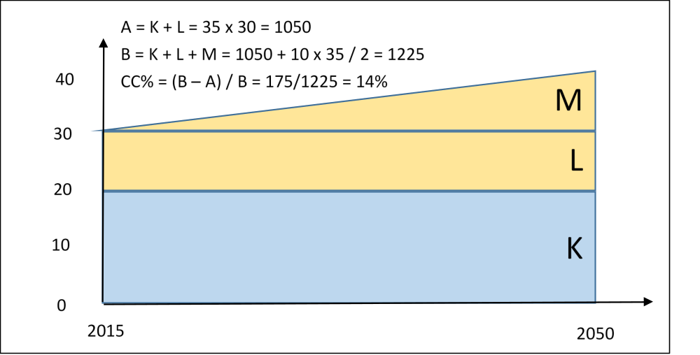

The CC% indicator should not be used as the primary indicator of performance as it shows only how the performance changes with CC. It should always be used with other indicators that give evidence on the absolute level of performance (eg from MCA or CBA).

Time Period
CC happens relatively slowly and becomes increasingly more serious over the long term. The implications of CC therefore increase as the timescale of the CCIA is extended. Governments and businesses are more interested in the results in the short term (eg 5 years) than in the long term. Economics deals with this by discounting future net benefits. However, if the main interest is in the short term, it may also be useful to present one CCIA for the short term and another for the longer term.

Conventional IA often considers a period of 20 or 25 years. Many CCIAs consider a time period that extends to 2050, since this is the date that is often used for CC model projections. For analysis that uses 2015 as the base year, this means that the CCIA would consider a period of 35 years, which is a bit longer than normal. The impact of CC is not necessarily linear, but it is a reasonable working assumption that it will be linear and so CCIA for the next 20 years would simply assume that the CC impact is 25/35ths of the impact projected for 2050.

Consider a programme that delivers protection from rainfall variability that has a value of 100 units, with current levels of rainfall variability (ie flood, drought and unseasonal patterns). If there was no CC, then the total benefits from 2018 to 2050 would be 3300 units. If the SREX doubling rule of thumb is used, and L&D increases by about 3% each year (see Box 2), then the average annual L&D from rainfall variability in the first five years is 9 units higher than at present. In the second five years, it is 24 units higher and it increases by 15 units every 5 years. Over the next 35 years, the additional CC related benefits (ie the adaptation benefits) are 1683 units. The adaptation benefits in the first 5 years account for only 2.7% of the total adaptation benefits and any analysis that relies only on the first 5 years will, thus, greatly understate the significance of CC for the programme.

This example excludes discounting. If a discount rate of 5% is used, then the total benefits over the period are discounted to 1600 units and the adaptation benefits are discounted to 612 units. The adaptation benefits account for 6.2%, which is more significant that when discounting is ignored, but still greatly understates the significance of CC for the programme.

As with other forms of IA, CCIA may also consider the balance of incentives for those institutions involved in the programme, especially where these are motivated by the need to make a profit: there is little point in supporting a programme with impressive total benefits if one of the key institutions has insufficient incentives to participate.

Scale and Optimising Allocations
Most programmes can be undertaken at a wide variety of scales. For example, a new agricultural technique can be introduced to 50, 500 or 5000 farmers. Or a programme may build 10, 100 or 1000 check dams. In these cases, it is useful to focus the main assessment on a single unit (eg a farmer, structure, village or district). This established the underlying performance of the innovation.

Once the underlying performance is clear, the second step is to consider the appropriate scale. This is likely to be determined by several factors.

- The funds available, given other competing demands on finance.
- The costs of managing the programme, which may deliver significant economies of scale, if they are spread over more beneficiaries.
- Whether the benefits decline as the programme is expanded into less attractive locations (eg agroecological zones where new farming techniques are less useful, rivers where flow characteristics are less amenable to storage or districts where population density is more sparse and public services more expensive).

This approach is particularly useful when institutions are considering a range of different alternatives and need to decide whether to spread limited resources over a number of small programmes or to concentrate them into a few larger programmes.

Keeping Analysis Realistic
CCIA aims to introduce objectivity into the appraisal of CC programmes. However, in most cases, there are some key parameters for which evidence is weak and that could take on quite a wide range of assumed values. The general principle for all IA is to make relatively conservative assumptions and this also applies for CCIA.

In practice, it is unlikely that new or revised programmes will deliver dramatically higher net benefits than most other programmes. If such benefits were achievable, then it is likely that some version of the programme would already be in operation and would be showing strong success. For example, if government uses the BCR as the indicator of net benefits, then most programmes are likely to have BCRs of between about 1.5 and about 4. The ‘realism first’ approach involves first attempting to set the assumptions for key parameters at levels that will deliver BCRs within this typical range. If, given the best available evidence, it seems fairly certain that the BCR is outside this range, then a higher or lower BCR can be presented as the headline scenario. If it is less clear, then the headline scenario should be within this range and a high or low scenario can be used to show why it is quite possible that a different BCR could be achieved.

The purpose of the ‘realism first’ approach is to encourage the analysis to really question whether some assumptions are more optimistic or pessimistic than they should be. It is a way of approaching sensitivity analysis that aims to produce conservative results whilst also accepting that some programmes may be able to exceed expectations or are exposed to major risks. As with all impact analysis, the primary role of a realism first approach is not to approve or reject a programme, but to encourage an exploration of the robustness of the plans for a programme in order to be able to improve the design.

CCIA aims to introduce objectivity into the appraisal of CC programmes. However, in most cases, there are some key parameters for which evidence is weak and that could take on quite a wide range of assumed values. The general principle for all IA is to make relatively conservative assumptions and this also applies for CCIA.

Scenarios and Sensitivity. Where there is uncertainty about key parameters, it may be informative to present scenarios and/or sensitivity analysis. However, this supplementary analysis of variability needs to be used sparingly to avoid overloading policy makers with information. The following general rules can be useful in working with sensitivity and scenarios.

- Present one clear headline analysis, which should be in the middle of the conservative range of possibilities.
- Set up the analysis so it is possible to explore the sensitivity of the results to a wide range of assumptions, in different combinations, but do not present the full results of the exploration.
- Instead, combine the ranges of assumptions into no more than two additional scenarios (eg one high and one low), to that policy makers can get an immediate overall view of the sensitivity of the headline results.
- In addition to the scenarios, it may also be useful to select no more than a handful of key assumptions that have a particularly important effect on the results and show the individual effects of these assumption as a sensitivity analysis.

The Five Levels of CCIA
This chapter considers five different ‘levels’ of CCIA. Screening is used to check which actions will benefits from CCIA. Classification is used to provide a rapid estimate of CC% across all actions. Qualitative CCIA is done when evidence and time/skills are limited or when actions are not amenable to more quantitative analysis. Fuller CCIA relies on more quantitative analysis and includes use of valuation techniques. Finally, hybrid CCIA incorporates some elements of valuation but also accepts some more qualitative evidence.

Screening
Screening is typically used to assess whether further work on CCIA is justified. The screening typically involves three key questions.

- Is the programme sufficiently large and/or politically important to justify investing in CCIA? The answer to this is usually guided by thresholds that indicate whether CCIA is justified and, potentially, whether this should be rapid CCIA or fuller CCIA.
- Are the implications of CCIA sufficiently serious to justify further CCIA. This may involve an assessment of objectives (see Box 3), both explicit and implicit.
- Does the programme feature in any positive lists that may exist, such as the programmes already selected (ie screened) for inclusion in a CC Action Plan or in the CC% reference table presented below.

CCIA is mostly done for programmes that become more beneficial when adaptation and mitigation are taken into consideration. For such programmes, CCIA improves the chance of obtaining funds in the budget or from other sources. Line ministries may also be interested in CCIA for programmes that are negatively affected by CC (eg ‘maladaptation’), in order to understand and respond to the CC risks and ensure that these risks are not overstated. CCIA may apply to investment projects, but also to policies that reform services and provide incentives to influence household, private sector and parastatal behaviour.

The CC benefits may come from adaptation (ie reducing the L&D arising from CC) or from mitigation (ie reducing GHG emissions to contribute to the global efforts to stop CC itself). The guidelines apply to programmes that are justified primarily by adaptation and mitigation as well as to programmes that are justified primarily by sustainable development benefits, but which have secondary CC benefits. Examples of different combinations of CC and sustainable development benefits are shown in the table below.

Classification
Governments often need a broad review of the CC relevance of all their expenditure, notably as part of an exercise similar to a CPEIR or CCFF. In this case, it is not practical to undertake individual CCIA on each item of expenditure, although the review may include individual CCIA on selected items. To assist with this type of work, it is useful to refer to a reference table of the likely levels of CC%s for each type of activity. Table 3 presents a reference table and gives ranges for the likely level of benefits of different kinds, including adaptation and mitigation. The evidence comes mostly from ongoing CPEIRs and CCFFs in S & SE Asia. The table presents the various types of benefits as five dimensions of green development. The types of benefits add up to 100% to avoid exaggeration of benefits. Adaptation benefits are generated by avoiding loss in economic, social and environmental benefits.

Table 3: Likely Ranges for Climate Change Benefits Compared with Other Benefits
 | Sustainable Development |  |  | Climate Change CC%
 | EC% | SO% | EV% | MI% | AD% | Total
Highest CC Relevance
CC Planning, Management, Capacity, Studies | 0 | 0 | 0 | 100 |  | 100
Hydrometeorology, Early Warning | 40-50 | 10-20 | 0 | 0 | 33 | 33
Livelihoods for CC Vulnerable Households | 40-50 | 10-20 | 0 | 0 | 33 | 33
Coastal Protection from Sea Level Rise | 0 | 0 | 0 | 0 | 100 | 100
Protection from Saline Intrusion | 20-50 | 10-30 | 5-10 | 0 | 25-75 | 25-75
Irrigation and Drainage | 50-70 | 5-20 | 0-5 | 0 | 10-33 | 10-33
Flood Protection/Proofing | 40-50 | 10-20 | 0 | 0 | 33 | 33
Disaster Risk Reduction and Management | 25-50 | 25-50 | 0-10 | 0 | 33 | 33
Middle CC Relevance
Agriculture, Rural Development, Food Security | 40-50 | 10-20 | 0-10 | 0-5 | 5-20 | 5-25
Forestry Protection | 5-10 | 5-10 | 60-95 | 5-15 | 0-10 | 5-25
Forest Management | 20-50 | 5-20 | 30-50 | 5-20 | 5-20 | 10-40
Renewable Energy | 70-90 | 0-10 | 0-10 | 5-20 | 0-5 | 5-25
Energy Efficiency | 70-90 | 0-10 | 0-10 | 5-20 | 0-5 | 5-25
Lower CC Relevance
Livelihoods for General Households | 50-70 | 20-30 | 0 | 0 | 5-10 | 5-10
General Infrastructure (roads, urban …) | 90-99 | 0-10 | 0 | 0-1 | 1-5 | 1-5
Sanitation and Waste | 20-30 | 20-30 | 50-75 | 0-5 | 5-15 | 5-20
Water Quality | 50-70 | 20-30 | 0 | 0 | 5-10 | 5-10
Public Health for Climate Sensitive Diseases | 30-50 | 30-50 | 0 | 0 | 5-10 | 5-10
Public Transport | 60-80 | 10-20 | 5-10 | 1-5 | 0 | 1-5
Uncertain
Fisheries, Aquaculture | 40-50 | 10-20 | 0-10 | More research needed
Biodiversity, Wildlife, Eco-tourism | 0-25 | 0-10 | 75-100 | Variable/site specific
Notes: EC% = economic growth; SO% = social development; EV% = environment; MI% = mitigation; and AD% = adaptation.
Source: Based on experience from CPEIR and CCFF work in South East and South Asia over the last 4 years.

When using the table, assessments should normally fall within the ranges given, although it may be possible to justify a figure outside the range, if there are exceptional circumstances. The precise figure chosen within the range will depend on the local circumstances. For example, in a country that already has agricultural systems that are well adjusted to flood and/or drought, the AD% for agricultural programmes is likely to be closer to 5% than 20%, especially if there is evidence that the severity of CC is less than the doubling rule of thumb. Or, for countries that are expecting to experience much higher than average L&D, the CC%s will be towards (or even above) the high end of the ranges.

The above classification is different to the objectives-based classification used by OECD/DAC. The two play different roles and should not be seen as competing alternatives. The objectives based classification provides one easy and rapid method of looking at trends in expenditure and revealing how widely CC is being taken into account by government. The CCIA classification provides more balanced and objective assessment and encourages managers to provide evidence based appraisal of how CC affects their programmes. Actions that are clearly dedicated to CC are scored 100% in both systems. For actions that generate a mix of development benefits and adaptation or mitigation benefits, the OECD/DAC system tends to produce scores that are about 3 times higher than the benefits based classification. This rule of thumb can be used to compare results for weighted expenditure that are derived from the OECD/DAC classification and the benefits based classification.

Qualitative Methods
For most programmes, CCIA will be a rapid exercise, with a variety of sources of evidence. The resources and time available will be limited, possibly to only a few hours. Simply telling the CC story clearly is an important first step, framing the analysis and clearly defining the net benefits without CC and how CC affects these benefits.

Qualitative methods require experts (which may include beneficiaries) to estimate the relative size of the costs and benefits and of how CC affects these. Ideally, these qualitative estimates should be structured around the use of MCA techniques, where the criteria act as proxies for the main costs and benefits (CIFOR 1999, DCLG 2009). Example 1 provides an example of the use of qualitative CCIA.

Example 1 Qualitative CCIA
The example below presents the results for a water efficiency project in Assam. The instructions for using the table are presented below.

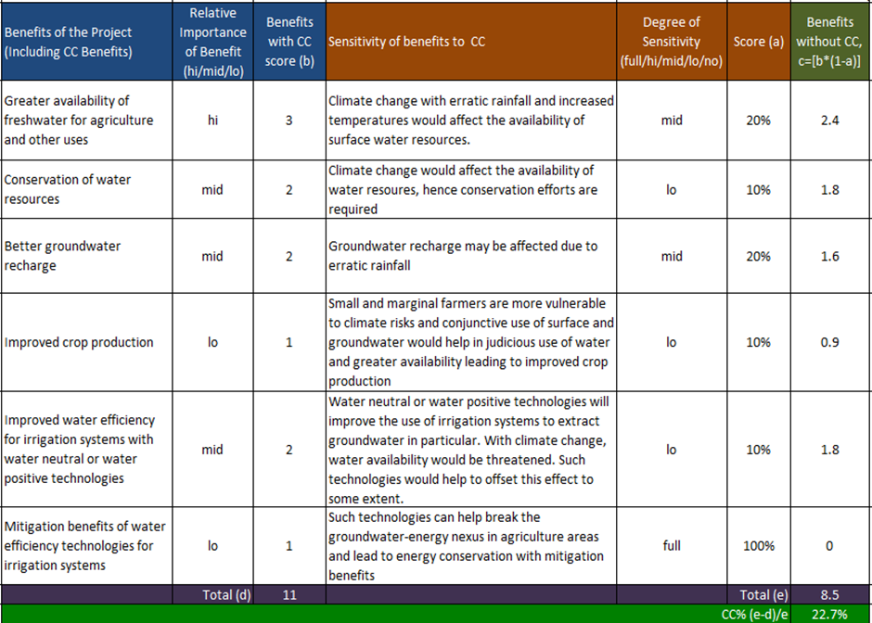

- List the economic, social or environmental benefits. These should be tangible benefits for people or ecosystems. Avoid duplication of benefits.
- Rate the relative importance of each benefit (hi/mid/lo) and enter scores (3/2/1 respectively). Avoid scoring all benefits high.
- For each benefit, describe how CC could impact that benefit, by asking to what extent does the benefit increases (or decrease) as a result of CC?
- Rate the potential impact of CC as full/hi/mid/lo/no and enter weights of 100%/30%/20%/10%/0%, respectively.
- Calculate CC weighted benefit (benefit score*CC relevance weight) for each individual benefit listed.
- Calculate the CB% relevance for the programme as a whole as (B-A)/B, where B is the benefits with CC and A is the benefits without.
Source: Assam SAPFIN Phase 2 guidance document

Qualitative CCIA may also include participatory appraisal to learn from the expertise of beneficiaries. There are many guides, manuals and sourcebooks for participatory appraisal (ODI 2001, World Bank 2003, Care 2009, IUCN, IISD et al. 2012). These describe a very wide range of techniques that are available for eliciting views in an informative and objective manner. Some have been specifically adapted to address CC, including: community maps; timelines; causal flow diagrams; climate analogues, which take people to other climates (Chaudhury, Kristjanson et al. 2012); and the ‘community-based risk screening tool – adaptation and livelihoods’ (IUCN, IISD et al. 2012). Some general principles for use of participatory MCA in CCIA are presented in Box 4.

Box 4 Good Practice in Participatory CCIA
- Participants must understand the scientific evidence on CC and bio-physical sensitivity.
- Clarify the difference between CC and current climate variability.
- Ask participants to comment on changes in climate over the last few decades and on whether these changes are consistent with future projections.
- Ask participants to explain how past changes in climate have affected their livelihoods.
- Ask participants to define how CC affects the various benefits of a programme.
- Ask participants to score the relative importance of each benefit without CC.
- Ask participants to score how much they expect each benefit to change with CC.
- Estimate the CC% and discuss whether this matches their intuitive and subjective views.
- Discuss the implications for any CC policies (eg Community Based Programmes or Local Adaptation Programmes of Action (LAPAs).
- Review the key features of vulnerability and whether the participatory CCIA addresses these and, if not, how to improve it.
- Discuss whether there should be changes in systems to manage climate programmes.

Most participatory techniques use a version of Multi-Criteria Analysis (MCA) to compile and structure the evidence from participatory appraisal. Participatory CCIA also uses MCA, but the criteria are the benefits generated by the programme and the MCA is done by subjective assessment of the relative value of the benefits and how this changes with CC.

Local communities in many countries have already received capacity building in climate resilient local planning. This provides a good basis for participatory CCIA, but the CCIA takes the work a step further and asks people to be explicit about how CC will affect the action they are proposing. When trends in climate (eg floods/droughts) over recent decades are similar to those for projected CC, stakeholders find it easy to understand and assess the implications of CC. However, most participatory CCIA requires a significant investment in capacity building before consultation can be structured and objective.

There are various techniques for trying to ensure that the results are as reliable as possible. For example, one option is to analyse the separate scores for each key informant to get an indication of how consistent the qualitative response is.

‘Hybrid’ CCIA
It is legitimate to conduct CCIA relying entirely on qualitative methods, for programmes that are small and/or where the implications of CC are not critical to the viability of the programme. But, in most cases, there will also be some quantitative evidence available and experts can share this evidence to improve the quality of the assessment. This additional evidence may come from case studies, existing surveys and other research. Ideally, the evidence will be local, but international evidence may also be useful for validating key assumptions, though it may need adjusting to local conditions. When the evidence is less clear, and especially when experts are making judgements that are outside their core areas of expertise, it may be sensible to conduct sensitivity analysis to clarify which assumptions have the biggest impact on the results. Examples of analysis that may allow some quantitative evidence to be mobilised include the following:

- Experienced agronomists will normally have good experience from a range of local conditions and will be able to provide guestimates for key parameters (eg change in yields, soil water balance, change in disease risk). This can be supplemented by crop models, which may be published in extension manuals or by research stations.
- Experts will have views on the value of flood protection, based on experience with businesses and households (eg on property damage, bankruptcies, loss of earnings …). Government compensation schemes (and related survey work) and insurance claims may add evidence, although they typically under-report the full costs.
- Analysis of energy programmes (eg on energy savings, conversion efficiency, costs of generation …) can often rely on the opinion of experts for key technical parameters.
- For health programmes, doctors will often have experience to estimate the increased threat of climate sensitive diseases and health information systems will typically provide supporting data.
Experience of changes over recent decades is often a powerful source of evidence. However, it needs to be used with caution since, even when reliable data is available, past trends are not necessarily good indicators of future trends and are confused by other factors, like changes in technology and policies. This is particularly true for agriculture. Ideally, evidence from recent decades should be used in conjunction with downscaled CC projections to give greater confidence, if they are consistent, and to suggest caution, if they are not.

Ricardian analysis uses variations in space as a proxy for how changes in time will happen. For example, if District B is currently 2ºC hotter than District A, then the conditions in B give some indication of what they will be in A, after CC increases temperature by 2ºC. But this type of analysis also needs to be very carefully designed, to ensure that there are no other variables that are influencing the variation in space.

Example 2 Hybrid CCIA – Planting High Value Species
High value forest species are planted by Joint Forest Management Committees (JFMCs). It is expected that, with an investment of Rs 1 crore, the programme will cover 100 villages and 20,000ha of forests. Surveys from similar work in other districts suggests that, after 3 years of establishment, the benefits of selling Non Timber Forest Products (NTFPs) from the forest gradually rise over 5 years to Rs 3 crore and there will also be tourism related earnings of Rs 0.15 crore by year 8. There are also 4 types of indirect benefit (soil and water conservation, biodiversity, food security and gender benefits) and some mitigation benefits. Adaptation benefits are from ecosystem resilience and alternative sources of incomes. The indirect benefits are assessed as high, mid or low and valued at 30%, 20% or 10% of economic benefits, respectively.

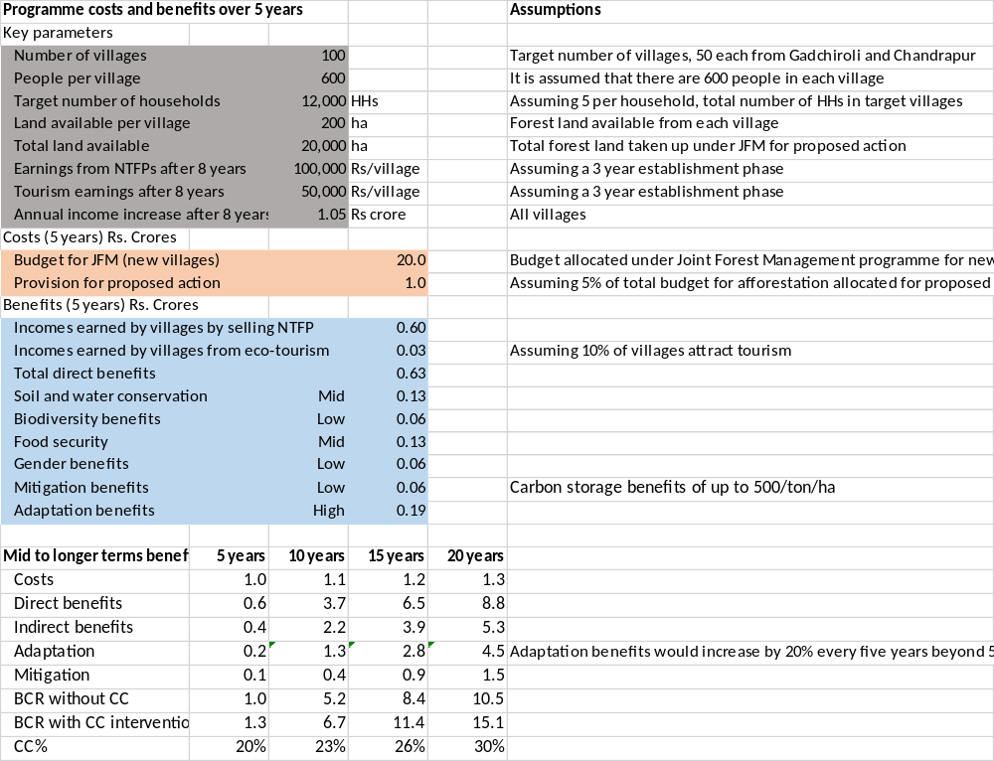

The BCR for the first 5 year period is low, at 1.0 without taking CC into account and 1.3 when CC is taken into account, giving a CC% of 20%. The BCR then rises dramatically as the trees mature and full benefits are achieved. The adaptation benefits also become gradually more important as the severity of CC takes hold and rise to 30% by the end of the period, which is near the highest level normally achieved.

Key issues that affect the results include the following: the costs per hectare of planting high value species compared with the benefits per hectare from NTFPs; and the way CC threatens forest biodiversity and NTFP.
Source: Maharashtra SAPFIN Phase 2

CCIA using Cost Benefit Analysis
Fuller CCIA differs from hybrid CCIA in that all key variables are quantified, in one way or another. It normally uses extended CBA (ie CBA including valuation of non-market costs and benefits), although there are also some other techniques, including some that focus on uncertainty (eg Robust Decision Making and Real Options Analysis).

Fuller CCIA is justified for larger programmes that are seeking significant funding and/or are strongly affected by CC. Such programmes would anyway be subject to IA that often requires several person-weeks of expertise and the CC dimension to the appraisal would add another week or two of CCIA expertise. In practice, fuller CCIA is often done when the existing IA is insufficient and therefore requires a more significant effort.

Where possible, fuller CCIA assesses the monetary value of benefits, using the techniques of CBA, since this is often respected by funders. There are many guides on CBA and these CCIA guidelines do not aim to duplicate these (World Bank 2009, World Bank IEG 2010, HMG 2011, UNFCCC 2011, ADB 2013). If evidence is limited, or if benefits are not easily converted into monetary value, CCIA may involve other performance indicators, such as a Multi-Criteria Analysis (MCA) score. More technical details are provided in Annex 1.

Example 3 Example of Fuller CCSE
In 2011, floods devastated a large area of Thailand, causing more than 800 deaths and loss and damage of about $ 40bn, especially in the manufacturing sector, but also in urban infrastructure and agriculture. In response, the government reviewed options to reduce flooding in future, including diversion canals, improvements in information and controlled flooding of some land.

An initial economic analysis was undertaken without taking CC into account. This considered several options and recommended the largest, costing $15bn, including construction, land and resettlement. This option protected against floods up to the 2011 level, which past records suggested would have a return period of 43 years (ie the probability of occurring in any one year is 2.3%). The analysis estimated that the reduction in L&D to property had a Net Present Value (NPV) of $15bn, using a discount rate of 12% over 38 years. The average annual benefits start at $1.2m and grow at 5% a year, in line with real economic growth. The BCR is 1.1, showing that benefits are slightly higher than costs, but below the level (eg 1.5) required for approval. Public funding for the investment is therefore rejected.

A CCIA is undertaken to take into account the effect of CC. New analysis is commissioned to include downscaled CC and hydrological modelling and this concludes that the watershed is highly sensitive to the projected increase in rainfall intensity and that the return period of a 2011 flood will gradually reduce from 43 years to 7 years by 2050. This has a dramatic impact on the benefits, which are closely related to the probability of flooding. The NPV of benefits rises from $15bn to $44bn and headline BCR rises to 3.1 which makes the case for public funding strong. The CC% is therefore about 65%, which is very high.

The CCIA also assesses the wider costs of flooding, which were not included in the original economic analysis. This is done using a ‘willingness to pay’ survey of social costs (ie health issues, lost work days and family stress) and Disability Adjusted Life Years to value loss of life. Reducing these wider costs add 29% to the benefits of flood protection and so increases the BCR to 4.0.

The CCIA also reviews the private sector response to flooding (or ‘auto-adaptation’), that has taken place since 2011. This involves protecting high value manufacturing locations with local flood barriers and offers an alternative strategy to flood protection. Local officials estimate that this auto-adaptation reduces flood costs by 5% to 10% and the headline BCR of the government investment falls to 3.5 because some of the most high value protection is no longer required.

The CCIA follows recent international practice and argues that long term public policy decisions should use a discount rate of 5% or less, which is above the rate of interest that government pays when borrowing money. This sensitivity analysis has dramatic implications and increases BCR to over 9, which makes the economic case for the public investment very strong.

Box 6 The Distinction Between Financial and Economic CCIA
CBA can be undertaken both from the perspective of an enterprise, in which case it is a financial CBA, or for a country as a whole, as assessed by a national planner, when it is an economic CBA. This also applies for CCIA, which may be done primarily from the perspective of private investment or from the perspective of broader public good. For financial CCIA, the value of inputs and outputs is determined by market prices. For economic CCIA, the market prices may need to be adjusted to reflect additional concerns and some parameters may have no market prices and require other methods of valuation (eg biodiversity and social benefits). In addition, economic analysis excludes transfers within the country (eg taxes, duties, fees and subsidies).

Box 8 Accommodating Poverty and Gender in CCIA
There are various ways of recognising the additional value that may arise from a programme if its benefits are concentrated amongst relatively poor and/or disadvantaged groups. In routine Impact Analysis, the most common option is to provide separate estimates for general economic benefits (eg increasing incomes or GDP) and for reductions that are specific to certain groups (eg number of poor people, women, children etc that are made resilient to CC). This option is the best way of exploring the full range of implications, both qualitative and quantitative and leaves the policy maker to make judgements about the relative importance of the economic benefits and the social benefits.

It may also be useful to define a ‘poverty premium’ which reflects the extra value that society places on increasing incomes for disadvantaged groups. This premium can be applied to any disadvantaged group (eg women, children etc) as well as to poor people generally. For example, if the premium is 2, then any benefits received by poor or disadvantaged people are considered to be twice as valuable to society as other benefits. This approach has the advantage of simplifying the message to policy makers who may otherwise get lost in the range of social evidence. It is particularly useful when comparing relatively similar programmes that present alternative ways of achieving similar goals.

Bibliography

ADB (2013). "Cost Benefit Analysis for Development: A Practical Guide."
Care (2009). Climate Vulnerability and Capacity Analysis Handbook.
Chaudhury, M., et al. (2012). Participatory gender-sensitive approaches for addressing key climate change related research issues: evidence from Bangladesh, Ghana, and Uganda. C. R. P. o. C. C. Working Paper 19, Agriculture and Food Security (CCAFS).
CIFOR (1999). "Guidelines for Applying Multi-Criteria Analysis to the Assessment of Criteria and Indicators."
DCLG (2009). "Multi-criteria analysis: a manual."
ECOFYS and World Bank (2014). State and Trends of Carbon Pricing.
Fozzard, A. and P. Steele (2014). "Climate Change Public Expenditure Review Sourcebook: Overview."
GEF (2002). "Operational Guidelines for Expedited Funding for the Preparation of National Adaptation Programs of Action by Least Developed Countries."
HM Treasury (2011). "The Green Book: Appraisal and Evaluation in Central Government."
HMG (2011). Impact assessments: guide for government officials.
House of Lords (2005). "The Economics of Climate Change."
IPCC (2007). "Climate Change 2007 Synthesis Report."
IPCC (2012). "Managing the Risks of Extreme Events and Disasters to Advance Climate Change Adaptation: Summary for Policy Makers."
IPCC (2014). "Fifth Assessment Report: Summary for Policy Makers."
IUCN, et al. (2012). Community-based Risk Screening Tool - Adaptation and Livelihoods: Users Manual Version 5.
Limskul, K., et al. (June 2012). Thailand Climate Public Expenditure and Institutional Review.
Nicholson, K. (2015 unpublished). "The Cumulative Economic Impact of Climate Change."
Nordhaus, W. D. (2007). A Review of the Stern Review on the Economics of Climate Change. Journal of Economic Literature. Vol. XLV (September 2007), pp. 686–702.
ODI (2001). Participatory Poverty Assessment - a Rough Guide to PPAs.
OECD (2011). "Handbook on the OECD-DAC Climate Markers."
Stern, N. (2006). "Stern Review on The Economics of Climate Change."
UNFCCC (2011). "Assessing the Costs and Benefits of Adaptation Options: an Overview of Approaches."
Vivid Economics (2010). Promoting Economic Growth when the Climate is Changing.
World Bank (2003). A User's Guide to Poverty and Social Impact Analysis.
World Bank (2009). "Povery and Social Impact Analysis: Reviewing the link with in-country policy and planning processes - Synthesis Report."
World Bank (2010). "Economics of Adaptation to Climate Change: Synthesis Report."
World Bank IEG (2010). Cost Benefit Analysis in World Bank Projects.

A BCR of 1.5 is roughly equivalent to an IRR of 15%, and this is typically the threshold for approving programmes for public funding.
The term scenario is also used to refer specifically to CC projections (eg the RCP2.6 scenario from the IPCC AR5 or the B1 scenario in IPCC AR4).

